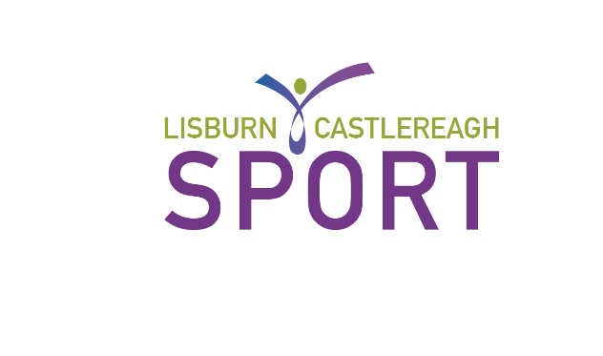
CARD NUMBER

Office use only

VITALITY ELITE ATHLETE CLUB

APPLICATION FORM

A. | PERSONAL INFORMATION
 | Name: |  | __________________________________________________
 | Address: |  | __________________________________________________
 |  |  | __________________________________________________
 |  |  | _______________________ Postcode: _______________
 | Tel No: |  | ________________ (home) |  | __________________ (work)
 | Name of Employers (if any): |  |  | _________________________________
 | Current University/School (if any): |  |  |  |  | ________________________
 | Age: | ____________ DOB: ____________
 | Email: | ___________________________________

B. | SPORTING INFORMATION
 | Sport: | ________________________________________
 | Club represented: | ________________________________________
 | Club address/Training Venue: |  | ____________________________________  ____________________________________  ____________________________________
 | Governing Body: | ________________________________________
Do you receive support as an Elite Athlete?
Yes /No (Please circle)

If yes what form does this support entail?
_____________________________________________________________________
_____________________________________________________________________

_____________________________________________________________________
_____________________________________________________________________
Please give details of your current position in your sport e.g. ranking, squad etc:
______________________________________________________________________
______________________________________________________________________

______________________________________________________________________
Please detail your competition results in the last twelve months:
______________________________________________________________________

______________________________________________________________________

______________________________________________________________________

If you have previously availed of the Elite Athlete Club, how has the membership benefited you in the past?
______________________________________________________________________

______________________________________________________________________

______________________________________________________________________

______________________________________________________________________

I certify that the above information is correct.

Signed (individual): ____________________________________________________
Date: _____________________________
Signed (Governing Body): ________________________________________________
Position within Governing Body: _________________________________________
Date: _______________________________

I would like to receive email and texts on exciting news, programmes and events from Lisburn & Castlereagh City Council, including details relating to my Vitality Membership.

This information is not shared with third parties, and you can unsubscribe at any time via phone, email or by post.
Yes I would like to receive EMAILS from Lisburn & Castlereagh City Council, including exciting developments on my Vitality membership
Yes I would like to receive TEXTS from Lisburn & Castlereagh City Council, including exciting developments on my Vitality membership
No I don't wish to receive any marketing details

Your Personal Data:
What we need
Lisburn & Castlereagh City Council is the ‘Controller’ of the personal data that you provide to us. We only collect basic personal data, this does not include any special types of information, it does however include name, address, email, mobile number etc.
Why we need it
We need to know your basic personal data in order to provide you with Lisburn & Castlereagh City Council Information/Promotions. We will not collect any personal data from you we do not need in order to provide and oversee this service to you.
What we do with it
All personal data that we process is processed by our staff in the UK however for the purposes of IT hosting and maintenance this information is located on servers within the European Union and no Third Parties will have access to your personal data unless the law allows them to do so. We have a Data Protection regime in place to oversee the effective and secure processing of your personal data.
How long we keep it
We are required under UK law to keep your basic personal data (name, address, contact details) until you notify us you no longer want to be contacted by us after which time it will be destroyed. Information that you provide for marketing purposes will be retained until you notify us that you no longer wish to receive this information.
What are your rights?
If at any point you believe the information we process on you is incorrect you may request to see this information and even have it corrected or deleted. If you wish to raise a complaint on how we have handled your personal data, you can contact our Data Protection Officer who will investigate the matter. If you are not satisfied with our response or believe we are processing your personal data not in accordance with the law you can complain to the Information Commissioner’s Office (ICO). The Lisburn & Castlereagh City Council Data Protection Officer can be contacted via Email at data.protection@lisburncastlereagh.gov.uk
Full details of can be found on the Lisburn & Castlereagh City Council website: https://www.lisburncastlereagh.gov.uk/information/freedom-of-information

Application forms should be returned to:-

The Honorary Secretary
Sport Lisburn & Castlereagh
C/o Leisure & Community Wellbeing Department
Sports Development Office
Lisburn & Castlereagh City Council
Lagan Valley Leisureplex
18 Lisburn Leisure Park
LISBURN
BT28 1PL

