
Development Plan
Position Paper 5: Transportation
November 2019

Contents Page

Executive Summary 2

1.0 Introduction 3

2.0 Regional Policy Context 3

3.0 Existing Development Plan and
Transport Plan 13

4.0 Transport Proposals from BMAP/BMTP 15

5.0 Transportation Profile 25

6.0 Other Key Documents 33

7.0 Key Findings and Conclusion 39

Appendix 1: The Regional Strategic Transport
Network Plan (RSTNP) 41

Appendix 2: Belfast Metropolitan Transport Plan
(BMTP) Lisburn and Castlereagh 42

Executive Summary

This Position Paper provides an overview of the transportation position and proposals identified for the Lisburn & Castlereagh City Council area, to assist in the preparation of the Local Development Plan 2032.

The Local Development Plan is made within the context of a Sustainability Appraisal under the provision of Planning (Northern Ireland) Act 2011. This paper is therefore intended to provide a baseline on which policy and proposals for transport infrastructure in the Local Development Plan can be shaped over the plan period.

It is important to stress that in compiling the Position Paper the best information available has been used however further revisions may be required in light of the release of any new data or updated policy, advice or information.

This paper provides an update on the previous Position Paper which was produced as part of the preparation of the Preferred Options Paper and has been informed by consultations with the relevant statutory consultees including the Department for Infrastructure (DfI) who have responsibility as the statutory authority for providing the Local Transport Study to support the Local Development Plan.

The aims of the paper are:

- To provide baseline information which will inform the Local Development Plan;

- To assess in conjunction with Transport NI as the key stakeholder and statutory authority the requirements of a transportation study and future transport plan for Lisburn & Castlereagh City Council;

- To assess the current status of the transport assets within the Council area; and

- To provide the spatial representation of the Council’s Community Plan and having regard to other plans and strategies being undertaken by the Council.
- INTRODUCTION

  - This position paper sets out the regional context for transportation and examines the existing transportation baseline across the Council area.

  - Chapter 2 sets out the regional policy context for transport, which is formulated within the context of the Regional Development Strategy (RDS) 2035, the Strategic Planning Policy Statement for Northern Ireland (SPPS) and regional Planning Policy Statements (PPSs).

  - Chapter 3 outlines the current policy approach in the existing Plan context.

1.4 Chapter 4 examines the main transport proposals stemming from the previous Belfast Metropolitan Area Plan and Transport Plan. Chapter 5 provides an overview of the transportation profile of the Council area along with an evaluation of the need for future transport infrastructure across the Council area up to 2032.

  - Other key documents are outlined in Chapter 6 including the transportation proposals outlined in the Council’s West Lisburn Development Framework and City Centre Masterplan.

  - The key findings and conclusion are provided in Chapter 7.

  - It should be noted that the responsibility for strategic transportation funding and implementation lies with the Department for Infrastructure (DfI). It is intended that the detail of specific schemes will be addressed at the Local Policies Plan Stage.

2.0 REGIONAL POLICY CONTEXT

2.1 The regional policy context is provided by the Regional Development Strategy (RDS) 2035, Strategic Planning Policy Statement for Northern Ireland (SPPS) and regional Planning Policy Statements (PPSs) where relevant. A summary of these documents in relation to plan making and transport policy is provided in the following paragraphs. In addition, the RDS was supported by the Regional Transportation Strategy 2002-2012 (RTS) which identified strategic transportation investment priorities over the 10 year period and was implemented by a number of Transport Plans. This was replaced by the DRD (now the Department for Infrastructure DfI) publication ‘Ensuring a Sustainable Transport Future – A New Approach to Regional Transportation’ which guides decisions on strategic interventions beyond 2015. A summary of these documents is provided in the following sections.

Regional Development Strategy 2035
2.2 The Regional Development Strategy 2035 (RDS) describes how the Regional transportation Strategy (RTS) is an integral part of it and sets the vision:
‘to have a modern, sustainable, safe transportation system which benefits society, the economy and the environment and which actively contributes to social inclusion and everyone’s quality of life’.

2.3 The aims of the RDS specifically include the following in relation to transportation infrastructure:
- Improve connectivity to enhance the movement of people, goods, energy and information between places;
- Take actions to reduce our carbon footprint; and
- Strengthen links between north and south, east and west, with Europe and the rest of the world.

2.4 The RDS provides a framework for strong sustainable economic growth across the region and recognises that a growing regional economy needs a co-ordinated approach to the provision of services, jobs and infrastructure. Regional Guidance RG 1. is to ensure an adequate supply of land to facilitate sustainable economic growth Land should be accessible and located to make the best use of available services, for example water and sewerage infrastructure, whilst avoiding, where possible, areas at risk of flooding from rivers, the sea or surface water run-off.

2.5 Regional guidance RG2: strives to deliver a balanced approach to transport infrastructure. The focus is on managing the use of road and rail space and how we can use our network in a better, smarter way. The new approach to regional transportation will develop this further to:
- Improve connectivity.
- Maximise the potential of the Regional Strategic Transport Network.
- Use road space and railways more efficiently.
- Improve social inclusion.
- Manage the movement of freight.
- Improve access to our cities and towns.
- Improve safety by adopting a ‘safe systems’ approach to road safety.

2.6 Regional guidance RG9 is to reduce our carbon footprint and facilitate mitigation and adaptation to climate change whilst improving air quality.
Climate change is increasingly seen as one of the most serious problems facing the world. The guidance relates to Mitigation and Adaptation. In relation to transportation the following mitigation measures are identified:
  - Reduce greenhouse gas emissions from transport.
  - Reduce noise and air pollution from transport.
  - Use more energy efficient forms of transport.
  - Utilise local production of heat and/or electricity from low or zero carbon energy sources
  - Develop strong linkages between policies for managing air pollution and climate change.
  - Protect Air Quality Management Areas: Where local air quality fails to meet the required standard, the local authorities must declare an air quality management area (AQMA), covering the geographical area where a problem has been identified for the pollutant that exceeds its permitted standard. Development should be consistent with the AQMA action plans. NI departments also have a responsibility to ensure limit values, target values and alert thresholds for specified pollutants are not exceeded.

2.7 In terms of Spatial Framework Guidance, SFG4 he RDS seeks to manage the movement of people and goods within the BMUA by
  - Managing travel demand within the BMUA;
  - Improving the public transport service;
  - Integration of Land Use and Transportation;
  - Introduction of a Rapid Transit system;
  - Managing the efficient movement of freight; and
  - Improving facilities for walking and cycling which is co-ordinated with infrastructure investment.

Regional Transportation Strategy (RTS)
2.8 An integral part of the RDS was the preparation of a Regional Transportation Strategy (RTS) to cover a 10-year period from 2002-2012. Implementation of the RTS is through the transport plans listed below:
• The Regional Strategic Transport Network Transport Plan (RSTNTP) (see Annex 1);
• The Belfast Metropolitan Transport Plan (BMTP) (see Annex 2); and
• The Sub-Regional Transport Plan (SRTP).

2.9 The former Department for Regional Development published the document, ‘Ensuring a Sustainable Transport Future - A New Approach to Regional Transportation’ in 2012 which supersedes the Regional Transport Strategy, setting out how the Department would develop regional transportation beyond 2015.

2.10 The ‘new approach’ to Regional Transportation complements the Regional Development Strategy 2035 and aims to provide a transportation network that supports economic growth while meeting the needs of all in our society and reducing environmental impacts.

2.11 It outlines the High Level Transport Aims and Strategic Objectives for transportation in Northern Ireland. These are driven by the Executive’s Programme for Government priorities of growing a sustainable economy while building communities and protecting the environment and link to the eight aims of the Regional Development Strategy. These aims are:
A) Support strong, sustainable Growth of the Economy for the benefits of all parts of Northern Ireland
B) Strengthen Belfast as the regional economic driver and Londonderry as the principal city of the North West
C) Support our towns, villages and rural communities to maximise their potential
D) Promote development which improves the health and well-being of communities
E) Improve connectivity to enhance the movement of goods, energy and information between places
F) Protect and enhance the environment for its own sake
G) Take actions to reduce our carbon footprint and facilitate adaptation to climate change
H) Strengthen links between north and south, east and west, with Europe and the rest of the world

2.12 The ‘new approach’ provides a number of Strategic Objectives for each of the High Level Aims to address the specific challenges identified during the review:
A. Support the Growth of the Economy
1: Improve connectivity within the region
2: Use road space and railways more efficiently
3: Better maintain transport infrastructure
4: Improve access in our towns and cities
5: Improve access in rural areas
6: Improve connections to key tourism sites

B. Promote the health and well-being of communities7: Improve Safety
8: Enhance Social Inclusion
9: Develop transport programmes focussed on the user

C. Protect and enhance the environment for its own sake10: Reduce Greenhouse gas emissions from transport
11: Protect biodiversity
12: Reduce water, noise and air pollution

2.13 It sets out an approach to decision making through a ‘Policy Prioritisation Framework’ which will be used to identify the priority strategic transportation interventions that most closely align more readily with the strategic direction set by the Executive’s Programme for Government and the Regional Development Strategy 2035.

Connectivity Review 2014 (Department for Regional Development)
2.14 Connectivity, for the purposes of transportation, refers to the degree to which people and goods are able to reach a range of destinations. This is achieved in the Lisburn & Castlereagh City Council area by road and rail. The two local airports (Belfast International and Belfast City) are in relatively close proximity to residents within the new Council area however there is a degree of reliance on the road and rail network to achieve access to them.

2.15 There are 5 Key Transport Corridors (KTCs) in Northern Ireland. These are the top-tier of transport routes. The Eastern Seaboard and South Western KTCs flow directly through Lisburn. The Eastern Seaboard KTC is the North-South corridor, connecting Larne, Belfast to the Republic of Ireland by road and rail. The South Western corridor links Belfast to Enniskillen and beyond.

Figure 1: South Western and Eastern Seaboard Corridors
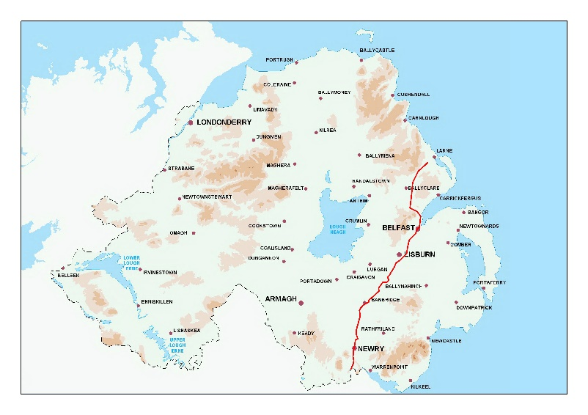
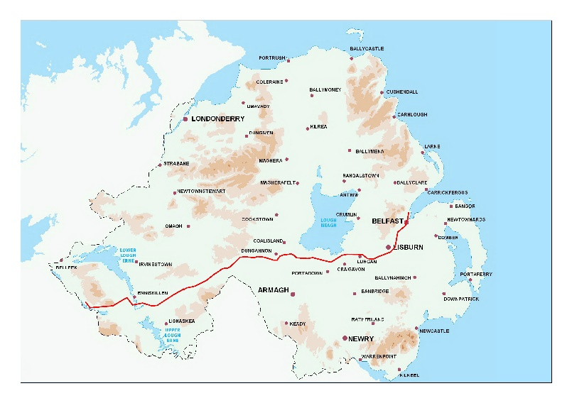

2.16 In August 2015 the Department for Regional Development published the document ‘Changing Gear; A bicycle strategy for Northern Ireland’. This was a high level vision over a 25 year horizon. The vision is:
“A community where people have the freedom and confidence to travel by bicycle for every day journeys”

2.17 The objectives to deliver the strategy include:
- Making urban areas in NI more accessible for people using a bicycle
- Improve opportunities for social inclusion
- Improvements in public health, and
- Increase safety for people using the bicycle

Strategic Planning Policy Statement for Northern Ireland (SPPS)
2.18 The SPPS was published by the former Department of the Environment in September 2015. The aims of the SPPS with regard to transportation are to secure improved integration with land-use planning, consistent with the RDS; and to facilitate safe and efficient access, movement and parking.

2.19 The Regional Strategic objectives for transportation and land-use planning are to:
  - promote sustainable patterns of development which reduce the need for motorised transport, encourages active travel, and facilitate travel by public transport in preference to the private car;
  - ensure accessibility for all, with the needs of people with disabilities and others whose mobility is impaired given particular consideration;
  - promote the provision of adequate facilities for cyclists in new development;
  - promote parking policies that will assist in reducing reliance on the private car and help tackle growing congestion;
  - protect routes required for new transport schemes including disused transport routes with potential for future reuse;
  - restrict the number of new accesses and control the level of use of existing accesses onto Protected Routes; and
  - promote road safety, in particular for pedestrians, cyclists and other vulnerable road users.

Role of the Local Development Plan
2.20 The SPPS states that the LDP is an opportunity to access transport needs, problems and opportunities within the council area. Ensuring the integration of transport modes and land use with appropriate allocation of land for future development. To assist in this process a local transport study should be prepared. It should be noted that Transport NI are the statutory transport authority in Northern Ireland and therefore this must be done either in conjunction with Department for Infrastructure, or by them.

2.21 The SPPS identifies issues to be addressed in LDPs as follows:
  - Land use allocations and associated transport infrastructure (including bus and rail infrastructure)
  - New Transport Schemes, Walking and Cycling
  - Disused Transport Routes
  - Car Parking
  - Protected Routes

Planning Policy Statements
PPS3 Access, Movement and Parking
2.22 This statement revised in Feb 2005 sets out the planning policies for vehicular and pedestrian access, transport assessment, the protection of transport routes and parking. It forms an important element in the integration of transport and land use planning and should be read in conjunction with PPS13 and DCAN15. The purpose of Development Control Advice Note 15 (DCAN15) is to give general guidance to intending developers, their professional advisors and agents on the standards for vehicular access referred to in PPS3 and is a material consideration for planning applications and appeals.

PPS13 Transportation and Land Use
2.23 The primary objective of PPS13 is to integrate land use planning and transport by:
- Promoting sustainable transport choices;
- Promoting accessibility for all; and
- Reducing the need to travel, especially by private car.

2.24 This will be achieved particularly through the preparation of development plans and transport plans, (previously prepared by DOE Planning and DRD Roads Service). This PPS contains a series of general principles which are to be applied to the planning and delivery of transport and development. The first General Principle of this PPS states the integration of transportation policy and land use planning should be taken forward through the preparation of development plans and transport plans informed by transport studies.

2.25 Development plans and transport plans have a complementary role to play in promoting greater integration of transportation and land use planning. This will help to ensure that the land use allocations, key site requirements and policies of a development plan are closely linked with the policies, proposals and investment priorities for transportation identified in the transport plan.

2.26 General Principle 2 states Accessibility by modes of transport other than the private car should be a key consideration in the location and design of development. The process of Accessibility Analyses can identify appropriate sites where integration with all modes of transport can be best achieved.

2.27 General Principle 7 is pertinent to the Local Development Plan and states that “Park and Ride and Park and Share sites should be developed in appropriate locations to reduce the need to travel by car and encourage use of public transport”.

2.28 General Principle 8 also speaks directly to future land use planning, stating: “Land required to facilitate improvements in the transport network should be afforded protection”.

2.29 General Principle 12, promotes the integration of transport and land use planning that seeks to create a more accessible environment for all.

Transitional Period

2.30 A transitional period will operate until such times as a Plan Strategy for the Lisburn & Castlereagh City Council area has been adopted. During the transitional period planning authorities will apply existing policy contained within the above mentioned Planning Policy Statements together with the SPPS. Any conflict between the SPPS and any policy retained under the transitional arrangements must be resolved in the favour of the provisions of the SPPS.

3.0 EXISTING DEVELOPMENT PLAN AND TRANSPORT PLAN
3.1 The Belfast Metropolitan Area Plan 2015 (BMAP) was prepared under the provisions of Part 3 of the Planning (Northern Ireland) Order 1991 by the former Department of the Environment (DOE). The Plan covers the City Council areas of Belfast and Lisburn and the Borough Council areas of Carrickfergus, Castlereagh, Newtownabbey and North Down. The Plan was adopted on 9th September 2014, however the Court of Appeal declared the adopted plan unlawfully adopted on the 18th May 2017.

3.2 As a result, the existing Development Plans covering the Council area are as follows:
- Belfast Urban Area Plan (BUAP) 2001
- Lisburn Area Plan (LAP) 2001
- Carryduff Local Plan 1988-1993
- Ballymacoss Local Plan
- Lisburn Town Centre Plan
- Lagan Valley Regional Park Local Plan 2005

3.3 BMAP in its post-inquiry form was at an advanced stage and therefore remains a material consideration. Draft BMAP (November 2004) in its pre-inquiry form also remains a material consideration in conjunction with recommendations of the Planning Appeals Commission Public Local Inquiry Reports.

3.4 Volume 3 and Volume 5 of BMAP 2015 sets out policies on the former Lisburn and Castlereagh Districts respectively (“District Proposals”). These policies have been developed in the context of the Plan Strategy and Framework contained in Volume 1 of the Plan and are in general conformity with the RDS.

3.5 BMAP was accompanied by the Belfast Metropolitan Transport Plan (BMTP) for the Plan Area, and was prepared by DRD (now the Department for Infrastructure DfI). Close liaison at this time between the BMAP Plan team and the Transport Plan team within DRD ensured that these Plans were mutually supportive and land use and transportation proposals and strategies were co-ordinated and integrated.

3.6 The components of the 2015 Belfast Metropolitan Transport Plan are described according to four modal themes, as follows;
- Provision for Walking and Cycling – such as walking corridors and cycle routes;
- Public Transport measures – such as bus and rail schemes;
- Highway measures – such as road schemes; and
- Management measures such as parking controls or traffic management used to control traffic and influence travel demands and patterns.

3.7 The BMTP identified various transportation schemes which were included within BMAP’s Plan Strategy & Framework Volume 1 and District Proposals Volume 3 Lisburn and Volume 5 Castlereagh (see Annex 2). These are addressed in detail under Chapter 4.

3.8 In addition, the BMTP proposed policies for demand management as a means of reducing the number of car journeys made during peak periods (Policy TRAN 1 Plan Strategy & Framework Volume 1):
Parking Standards within Areas of Parking Restraint: Within designated Areas of Parking Restraint the following parking standards will be applied:-
Lisburn City Centre -
  - 1 Space per Dwelling
  - 1 Non-operational space per 50sqm of commercial floorspace
  - 1 Operational space per 930sqm of commercial floorspace

3.9 The BMTP also sought to address the issue of publicly owned ground level car parking in city and town centres where it is desirable to have an appropriate form of built development to reinstate the streetscape (Policy TRAN 2 Plan Strategy & Framework Volume 1).
- TRANSPORT PROPOSALS IN BMAP/BMTP

Belfast Metropolitan Area Plan – Lisburn

4.1 Lisburn’s location on the main Belfast to Dublin transportation corridor makes it a favourable location (the strategic highway comprising the M1, A1, A3 and A49).

4.2 Lisburn’s road network is characterised by an inner ring road which operates one-way and forms the perimeter of the mainly pedestrianised city centre and a high capacity southern orbital road made up of Thiepval Road, Governor’s Road, Laganbank Road and Queen’s Road.

4.3 Paid car parking is in good supply in the city centre, most of which is surface parking and much of which is accessed off the one-way system. Parking is however also one of the main sources of city centre traffic congestion.

4.4 Proposal LC 17/01: M1 between Blacks Road and Sprucefield (Strategic)
Widening of the M1 between Blacks Road and Sprucefield to dual 3-lane motorway and a new link between the M1 and A1 at Sprucefield.

4.5 The M1 motorway forms a key part of the Regional Strategic Transport Network, running south-west of Belfast to Lisburn and onwards to the west. It is anticipated that peak traffic levels on the section of the M1 between Blacks Road and Lisburn will approach or exceed available road capacity. The proposal allows for the protection and detailed planning for the widening of the M1 between Blacks Road and Sprucefield from a dual 2-lane motorway to a dual 3-lane motorway, and improving the connection between the M1 and A1. The Department has completed a high level feasibility study on how best to maximise the potential of motorway hard shoulders as running lanes. The study report confirms that both carriageways of the M1 from Junction 1 (Broadway) to Junction 8 (Blaris) would benefit from the introduction of hard shoulder running or ‘Smart Motorways’ as it is more formally known.
4.6 The Department for Infrastructure have indicated that currently there is no timescale for the commencement of the M1/Sprucefield Bypass scheme. TransportNI have options for the route of the M1/A1 link, but no decision has yet been made at this time as to which is preferred. The Regional Development Strategy (RDS) identified the M1 and A1 as a key transport corridor and the Belfast Metropolitan Transport Plan (BMTP) recognised the strategic significance of this route and the existing congestion problems on the M1 and at the M1/A1 junction. The proposed scheme will provide a high standard link between the M1 motorway and the A1. It is intended that the proposal will reduce journey times by avoiding delays in the Sprucefield area and congestion at the roundabout junction on the A1 at Hillsborough. TransportNI commissioned consultants to consider a range of options for capacity enhancement along this route. A report was published in 2011 which determined 2 route corridors within which further options will be examined. Since then there has been insufficient funding to continue with the development of this scheme. TransportNI is progressing the development of new Transport Plans in line with The New Approach to Regional Transportation, and this will set out a long-term programme of investment. Development of these plans will provide an opportunity for all strategic roads projects, including the M1/A1 link, to be considered for funding.
Figure 2: Proposed M1-Sprucefield Bypass (Strategic)
Source: M1/A1 Sprucefield Bypass Scheme BMAP

4.7 Proposal LC 17/02: Knockmore – M1 Link (Non-Strategic)
The Knockmore Link (LC 17/02) will provide access to the Major Employment Location at West Lisburn as identified in accordance with the RDS.

4.8 Proposal LC 17/03: North Lisburn Feeder Road (Non-Strategic)
The North Lisburn Feeder Road (LC 17/03) will facilitate new housing developments to the north east of Lisburn and will provide an alternative orbital route around Lisburn. Developers will be responsible for funding both LC17/02 and LC17/03 either in full or in a substantial part. Phases 1 and 2 of the North Lisburn Feeder Road are already constructed and Phase 3 will be built by developers to support the ongoing development in this area.

4.9 Proposal LC 18: Relocation of Rail Halt/Station
A scheme to relocate the rail halt/station from Knockmore to West Lisburn will facilitate the employment zonings at West Lisburn / Blaris. The BMTP proposes that the existing Lisburn – Belfast services are extended to start and end from the West Lisburn station and that the Portadown service also stops there. A new stop at West Lisburn on the Belfast – Dublin Enterprise is also proposed.

4.10 Proposal LC 19: Park and Ride Site Lisburn City
A Park and Ride Site is identified at West Lisburn, adjacent to the proposed West Lisburn rail halt/station and will encourage travel by train.

Belfast Metropolitan Transport Plan 2015
4.11 The Belfast Metropolitan Transport Plan 2015 proposes a number of transportation initiatives to enhance Lisburn’s accessibility and role as a strategic location within the region, i.e:
  - The improvement of rail services between Lisburn and Belfast
  - Development of a Quality Bus Corridor between Lisburn and Belfast City Centre;
  - Provision of park-and Ride facilities at key locations
  - The introduction of Intelligent Transport Systems (ITS) solutions including Variable Message Signs (VMS) in conjunction with parking provision; and
  - The widening of the M1 and junction improvements on the Westlink.

4.12 Each of these projects are ongoing, but no definite time line for implementation delivery or completion has been provided due to funding streams. It is considered that:
  - The improvement to rail services between Lisburn and Belfast needs reviewed and new targets agreed.
  - A development strategy and time line to reflect funding created for the development of a Quality Bus Corridor between Lisburn and Belfast City Centre;
  - Development of ITS ad VMS is ongoing; and
  - Some bus lanes have been introduced on the M1 and further works are to be designed. Junction improvements on the Westlink are complete and hard running is partially introduced with an extension planned.
  - Park and ride facilities have been provided

4.13 In relation to the M1/A1 Link contained in BMAP, the BMTP states that its implementation may be outside its time period; however it further states that development pressures at Sprucefield area or the Maze area may require these schemes to be implemented earlier with developers responsible for their funding either in full or in a very substantial part.

4.14 In order to encourage greater use of public transport and more walking and cycling (thereby reducing car dependency) a range of measures are included:
- The development of an integrated network of Quality Walking Routes and cycle routes and improved links to bus and rail stations
- Improvements to local bus services and inter urban bus services including bus priority measures
- A contra-flow bus lane enabling buses to access the bus station thereby avoiding the one way system.

4.15 Some work has already been undertaken since the BusTrak contract to implement bus priority measures as a TICC contract; however costs are shared 50:50 with Translink. Deployment of bus priority needs careful consideration to the impact on junction efficiency and other road users.

4.16 The BMTP also identifies the need to retain the option of re-instating the Antrim-Lisburn rail line as part of a potential passenger circle line which could serve the Belfast International Airport.

Belfast Metropolitan Area Plan - Castlereagh
4.17 Belfast Rapid Transit (EWAY)
The Belfast Rapid Transit scheme (EWAY) was identified by DRD as one of the four new Rapid Transit schemes to be implemented (Volume 1 Plan Strategy & Framework, Volume 1, BMAP). The first phase of the BRT network, is now completed linking East Belfast, West Belfast and Titanic Quarter via the city centre.
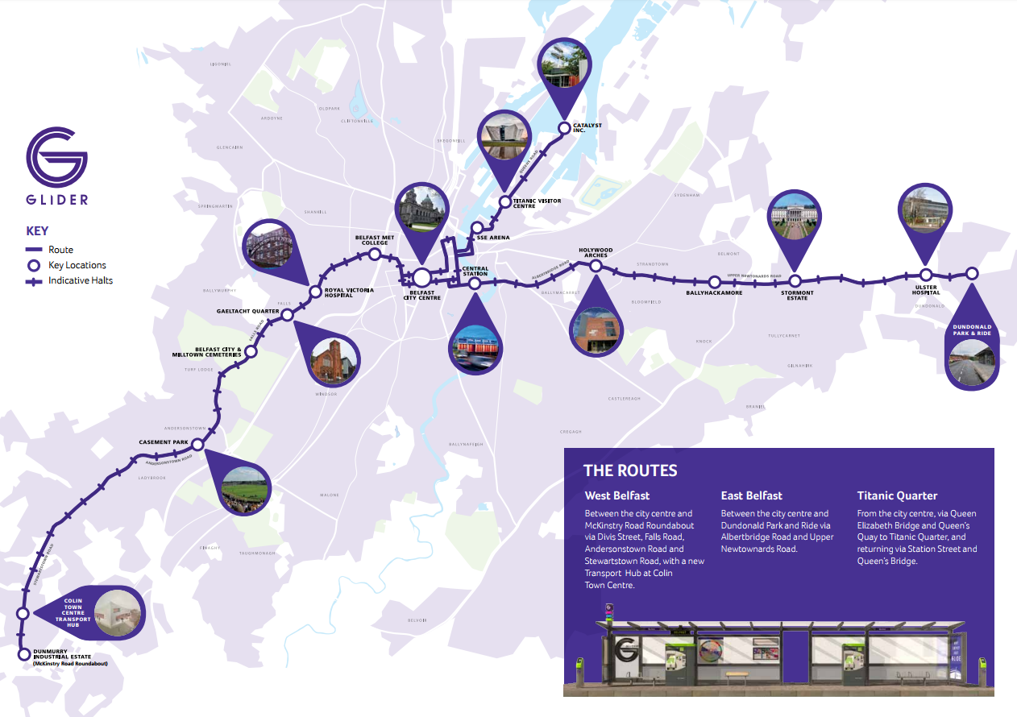
Figure 3: Glider Route Map
Source: Department for Infrastructure Website

4.18 The Department for Infrastructure’s Belfast Rapid Transit project (Glider) was to create a new and dynamic public transport system. Belfast Rapid Transit now offers a high quality service providing people with better access to jobs, hospitals, shops, schools, colleges, and entertainment. The Belfast Rapid Transit system uses high quality rapid transit vehicles which provide a modern, comfortable environment for passengers in terms of space, security and on-board information. The vehicles run on dedicated bus lanes for the vast majority of the routes. The system incorporates high quality halts with easy access to vehicles, real time information systems for easier journey planning and off-vehicle ticketing to speed up the boarding process. The speed, reliability and comfort of the Belfast Rapid Transit services is providing an attractive alternative to private car use on the current routes. The first phase of the Belfast Rapid Transit network links Dundonald with West Belfast and Titanic Quarter via the city centre. The route in East Belfast links the city centre with Dundonald Park & Ride via the Albertbridge Road and Upper Newtownards Road. The route in West Belfast terminates at McKinstry Roundabout.

4.19 Dundonald Park-and-Ride
Dundonald Park-and-Ride (Dunlady Road) now forms part of the new Belfast Rapid Transit System. The 520 space Dundonald Park-and-Ride site was completed in November 2014. The Park & Ride is also served by a new dedicated limited stop Metro 4X service during peak hours and by existing Translink and Ulsterbus services at other times. The dedicated Metro service uses environmentally friendly Euro 6 double-deck vehicles. Bicycle parking facilities are also provided The Department for Infrastructure’s initial proposals for Phase 2 of the Belfast Rapid Transit system include the possibility of a route to south Belfast. It is likely that this route would connect to the existing 700 space Cairnshill Park & Ride site to the city centre. The extension to the Belfast Rapid Transit System is subject to reviewing the first phase of the system, which has been implemented, and the future availability of funding.

Figure 4: Belfast Rapid Transit Route
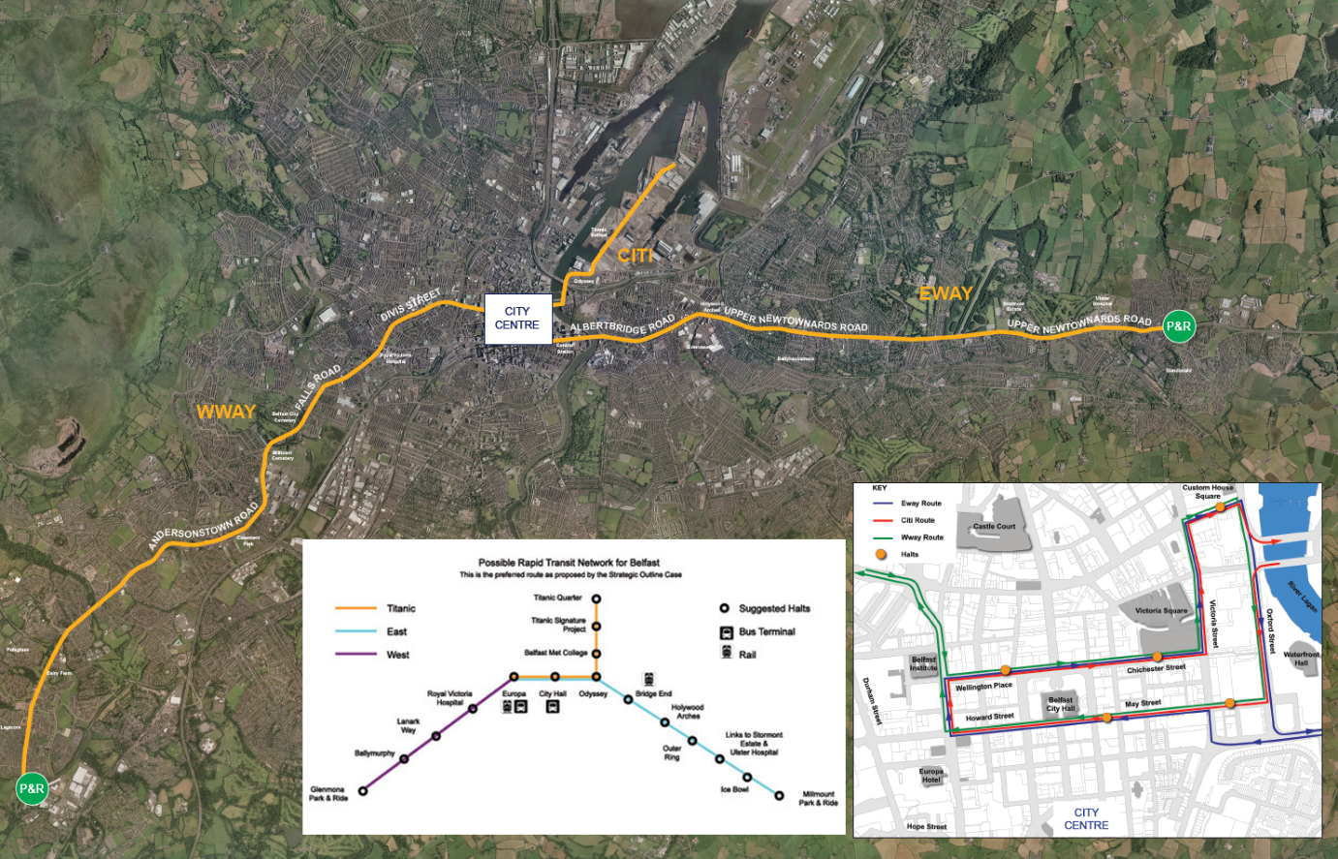
Source: Department of Regional Development Website

4.20 Proposal MCH 14/02: Quarry Corner-Comber Road (Non-Strategic)
This non-strategic road scheme provides access from the A22 Comber Road to the A20 Upper Newtownards Road transport corridor. BMAP states that developers will be responsible for funding this road proposal either in full or in a substantial part

4.21 Proposal MCH14/01: A24 Saintfield Road Relief Road (Strategic)
This proposal allows for the construction of a new link between the A24 at Cairnshill and the A55 at Newtownbreda to provide relief to the existing A24 Saintfield Road and Outer Ring junction.

Figure 5: A24 Saintfield Road Relief Road (Strategic)
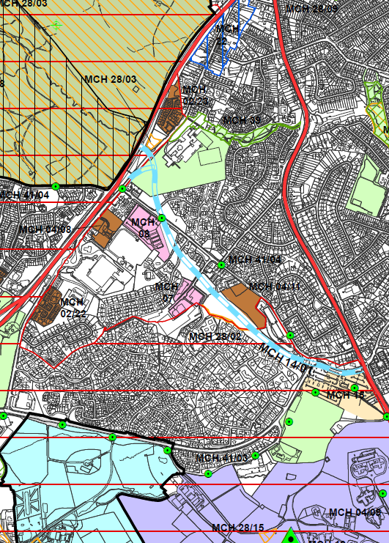
Source: BMAP Volume 5 District Proposals Castlereagh

4.22 MCH 15: Cairnshill Park-and-Ride
The Cairnshill Park-and-Ride scheme was completed in July 2010. Bus services operated by Translink commenced in November 2010. Cairnshill Park & Ride provides over 700 free car parking spaces along with a terminal building on the A24, Saintfield Road at its junction with Purdysburn Road. Access is via two locations on the Purdysburn Road and by a new signalised junction on the Saintfield Road. The site is served by a dedicated bus service operating to and from the city centre every fifteen minutes at peak times. Customers may also avail of bus services passing the site which serve the wider area and beyond.

Belfast Metropolitan Transport Plan
4.23 In addition to the proposed road improvements and the implementation of the Rapid Transit Scheme, the BMTP also proposes a number of transportation initiatives to benefit Castlereagh, namely:
• The development of a Quality Bus Corridor (QBC) route to / from Belfast City Centre that would serve the Castlereagh Road and Cregagh Road corridors.
• The provision of an informal Park and Ride at Carryduff; and
• The roll-out of a Route Management Strategy along the A55, A24 and the A20 comprising a series of measures that would improve the safety and efficiency of the strategic network serving Castlereagh.

4.24 In order to encourage greater use of public transport and more walking and cycling, thereby reducing car dependency, a range of measures are proposed
which include:
• The development of an integrated network of Quality Walking Routes and cycle routes; and
• Improvements to local bus services including the QBC network and improved frequencies on core local routes to Carryduff.
These will be defined and reviewed as part of the transport planning process.

4.25 BMTP also proposes a number of measures aimed at improving the quality of the urban environment in the Castlereagh area. This includes proposals for traffic calming on the non-strategic road network to discourage traffic, where appropriate from using local roads, improve road safety and reduce the impact of traffic.

- TRANSPORTATION PROFILE IN LISBURN & CASTLEREAGH CITY COUNCIL

5.1 This section provides an overview of transportation in the Lisburn & Castlereagh City Council area within the broader regional context.

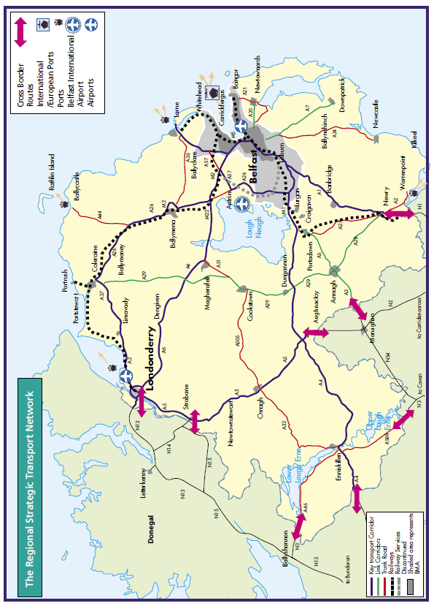
Figure 6: The Regional Strategic Transport Network

Source: Taken from Regional Strategic Transport Network Transport Plan 2015

Bus/Rail
5.2 Department for Infrastructure (DfI) has responsibility for public transport policy and transport in Northern Ireland. As well as the responsibility for the safety and operating standards of road passenger transport providers, Driver & Vehicle Agency and licensing of bus routes. The majority of public transport services in Northern Ireland are provided by subsidiary companies of the Northern Ireland Transport Holding Company (NITHC), a public corporation established under the Transport Act (Northern Ireland) 1967 to oversee the provision of public transport.

5.3 The principal NITHC bus companies - Metro and Ulsterbus operate a comprehensive network throughout the Council area. Private operators provide a limited number of scheduled bus services. Rail services are operated by the NITHC subsidiary, Northern Ireland Railways. Metro, Ulsterbus and Northern Ireland Railways operate under the brand name Translink.

5.4 A new Bus Centre operated by Translink was opened in Lisburn in June 2008 at the corner of Smithfield Street and the Hillsborough Road.

5.5 Within the Lisburn area there is one railway station in Lisburn City and a number of rail halts:
- Lisburn Rail Station (which links the city directly with Belfast, Portadown, Lurgan, Moira and Bangor, as well as the Enterprise Service to Dublin)
- Hilden Rail Halt;
- Derriaghy Rail Halt;
- Lambeg Rail Halt;
- Moira Rail Halt.

5.6 There is a disused section of existing railway track which leads to Antrim and the Belfast International Airport at Aldergrove. The Lisburn–Antrim railway line is a 20-mile (32 km) line of Northern Ireland Railways. It links Knockmore Junction on the Belfast-Newry railway line with Antrim on the Belfast-Derry railway line. It has been closed to passenger service since 2003. There is also a disused station at Ballinderry (photo below).

Figure 7: Former Ballinderry Station
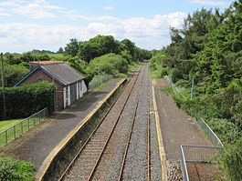
Source: wikipedia.org

Figure 8: Disused Railway line between Lisburn and Antrim
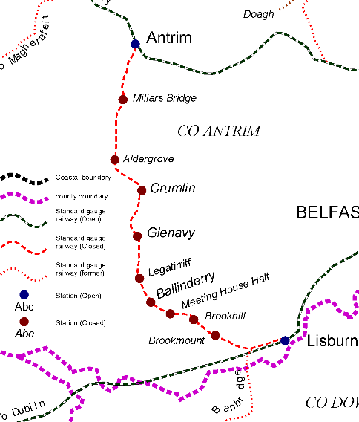
Source: Industrial Heritage Survey Ireland
5.7 The only railway which ran through Castlereagh Borough, was dismantled in the 1950s and now operates as the Comber Greenway – a 7-mile tranquil cycleway/green corridor from Comber to the heart of East Belfast along the former Belfast-Comber railway line.

5.8 Highways
Transport NI (formerly Roads Service) is a Business Unit within the Department for Infrastructure and operates within the context of the Department’s strategic objectives to maintain, manage and develop Northern Ireland’s transportation network. Lisburn benefits from its favourable position on the Belfast/Dublin corridor being connected with the M1 to the north and A1 to the South. There is an extensive road network throughout the Council area, with strong linkages to Belfast. The remainder of the road network comprises both ‘B’ class and minor roads – both classified and unclassified. However roads linking ‘across’ the Council area (east to west) are generally more constrained. Castlereagh is connected with the A23 north to Belfast City Centre and A55 to the M1.

5.9 Protected Routes
The Lisburn & Castlereagh City Council area contains a numbers of Protected Routes. Where appropriate, development plans will identify and prepare local policies for those stretches of a Protected Route which may be subjected to further access restrictions beyond those set out in Policy AMP 3 of Planning Policy Statement 3, for instance due to a history of traffic collisions, high volumes of traffic or speed of vehicles.

5.10 The Protected Routes in Lisburn & Castlereagh City Council area are listed as follows:

Route | Number
Nutts Corner - Lisburn | B101
Antrim - Moira | A26
Belfast - Newtownards | A20
Belfast - Downpatrick | A22
Belfast - Ballygowan | A23
Belfast | A55
Belfast – Clough | A24
Carryduff - Downpatrick | A7
Belfast - Dungannon | M1
Lisburn | A519
Lisburn | A520
Belfast - Lisburn | A1
Lisburn | A101
Lisburn – Belfast | A512
Lisburn – Belfast | A 512 ( A1)
Lisburn | A513
Lisburn – Belfast | B23/ B205
Lisburn - Ballynahinch | A49
Lisburn – Saintfield | B6
Lisburn – Craigavon | A3

5.11 The 2018-19 transport statistics show the Council Area has 1,360km of total road network, which accounts for only 5.2% of Northern Ireland’s total of 25,735km. However, the Council’s 25.6km of Motorway accounts for approximately 22.3% of the Northern Ireland total of 114.9km.

5.12 Private Car Ownership
The private car is the most commonly used main mode of transport for both men and women in Northern Ireland. Therefore road travel is set to remain the dominant mode of transportation over the Plan period. The figures for owning at least one car/van are in excess of the Northern Ireland average, with the figure for no car/van is 8% lower than NI average which indicates an over-dependence on the car as the primary mode of transport.

Table 1: Percentage of Households with access to one or more Private Vehicles Ownership
 | LCCC | Northern Ireland
No access to car | 11% | 19%
Access to 1 or more cars | 89% | 81%
Source: NISRA 2018-2019 Car Ownership Access (administrative geographies)

5.13 The Census 2011 showed that 72.4% of residents in Northern Ireland travelled to work by car or van including travelling as a passenger/as part of a car pool. This is marginally lower than the Lisburn & Castlereagh Local Government District (LGD) where 75% travelled to work by car/van (this includes those driving (61.4%), travelling as a passenger/as part of a car pool (13.6%)).

5.14 Cycling
With the staged implementation of the National Cycle Network (NCN), significant progress is being made towards improving facilities for cyclists in Northern Ireland. In August 2015, the Minister for Regional Development (now the Department for Infrastructure DFI) published a Bicycle Strategy which sets out how it’s planned to make Northern Ireland a cycling community over a 25 year horizon. The Bicycle Strategy for Northern Ireland aims to promote increased cycle use by identifying a range of measures that will seek to improve conditions for cyclists and establish a pro-cycling culture.

5.15 The National Cycle Network throughout Northern Ireland has a total proposed length of over 1,400 kilometres of which more than 1000 kilometres have been constructed to date. There are currently three national routes which travel through the LCCC area. National Route 99 of the National Cycle Network travels around Strangford Loch providing a link between Belfast, Comber, Downpatrick and Newcastle. The route includes a section between Belfast's new Titanic Quarter development and Comber which is along the newly developed greenway passing through Dundonald. Route 9 will eventually connect Belfast and Dublin. The route is currently open and signed between Queen Elizabeth Bridge in Belfast and Slieve Gullion (south of Newry) via Lisburn, Craigavon, Portadown and Scarva. The Route follows the River Lagan towpath south west from Belfast to Lisburn through the Lagan Valley Regional Park. A section of Route 94 runs through the council area and circumnavigates Lough Neagh Such routes are updated online and promoted by www.sustrans.org.uk. The Census 2011 showed that 0.93% of residents in the Lisburn & Castlereagh Local Government District (LGD) travel to work by bicycle. This is marginally higher than the Northern Ireland average where 0.85% of residents travel to work by bicycle.

Figure 9: The Lisburn to Belfast Lagan Cycle Way
Source: Sustrans Website

Figure 10: National Cycle Network Routes
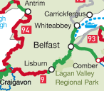
Source: Sustrans Website

5.16 Walking
The Northern Ireland Walking Action Plan, published in December 2003, identified a series of actions that will help guide the delivery of walking measures in the Regional Transport Strategy. The plan introduces the concept of Quality Walking Routes which will have:
- Good surfaces;
- Appropriate widths;
- Minimum of clutter and obstructions;
- Pedestrian facilities at crossings; and
- Good signage

5.17 Websites such as www.outdoorrecreationni.com and www.walkni.com actively promote walking, and are government-funded. In 2001, 5.95% of residents in the Lisburn & Castlereagh City Council area walked to work compared to 7.74% of residents in Northern Ireland walking to work.

5.18 Inland Waterways
The Lagan Canal passes through Lisburn. Prior to WW11 the canal was an important transportation route for goods, averaging over 307,000 tons of coal per year in the 1920s. Following competition from road transport, the canal was formally closed to navigation in 1958. A short stretch and lock in front of the former Lisburn Council offices was restored to use in 2001.

6.0 Other Key Documents

West Lisburn Development Framework
6.1 Listed below are some of the key objectives proposed for the West Lisburn Area, which include Sprucefield and the A1.

6.2 A – KNOCKMORE LINK ROAD
WLDF Objective 1 – Prioritise the development of the Knockmore Link Road as the key piece of infrastructure required to unlock the development potential of West Lisburn
Given the current rural environment that dominates West Lisburn, primacy must be given to developing a suitable road infrastructure network in order to realise the development potential of the area. The Link Road is an important element of the overall Masterplan, as there is a significant link between infrastructure investment, economic growth and other public policy goals. It will also provide a more direct connection to the M1 motorway and A1 dual carriageway for those existing employment areas within the Masterplan area. Finally, it has the potential to provide new links into the Maze Long Kesh site.
Whilst the Knockmore Link Road is not identified as a strategic road scheme by the Department for infrastructure; it should be considered as being of ‘strategic importance’ to the Lisburn area.

6.3 B – LOCAL DISTRIBUTOR ROADS
WLDF Objective 2 – Improve existing and develop new integrated multi-mode transport infrastructure into and throughout West Lisburn, including improved sustainable transport links such as the provision of ‘strategic greenways’ and rail links
Transport plays an important role in land use planning, and integrating transport with land use is an essential criterion for the development of the Council’s LDP and any related Strategy. The Department for Infrastructure (DfI), as the statutory transport authority, is responsible for bringing forward a Local Transport Study to accompany the LDP Plan Strategy. This forms part of the wider Belfast Metropolitan Strategy which is currently under development and takes cognisance of the wider transportation and land use interrelationships.

6.4 The local distributor roads are proposed to be taken off the Knockmore Link road and provide the main access into and service of the Blaris and Maze Long Kesh lands. There are currently two options for a local distributor road into the Maze Long Kesh lands, with the final decision to be determined by Lisburn and Castlereagh City Council in association with the Maze Long Kesh Development Corporation.

6.5 In the extant Transport Plan (BMTP), DfI identified a new motorway link between the M1 (between junctions 6 and 8) and the A1 (south of Hillsborough Roundabout). Two route corridors were considered and are shown on the Masterplan. The first is a central route runs to the east of the existing A1 around the rear of the Sprucefield Shopping Centre ‘landing’ to the south of the A1/Hillsborough Roundabout. The second is the Culcavy East Route that runs from the M1/A101 junction to the same location south of the A1/Hillsborough Roundabout.

6.6 C – POTENTIAL TRAIN HALT AND PARK & RIDE FACILITIES
WLDF Objective 2 – Improve existing and develop new integrated multi-modal transport infrastructure into and throughout West Lisburn, including improved sustainable transport links such as provision of strategic greenways and rail links.

The location of a new rail halt/station in West Lisburn will facilitate employment/industry/leisure opportunities in the area. This new halt/station will also require feeder bus connections that serve the West Lisburn area, the Maze Long Kesh site and wider area, thus creating a transport interchange between bus and rail. The Park and Ride site adjacent to the proposed West Lisburn rail halt/station will encourage travel by train.

6.7 It is envisaged that this rail halt will facilitate an operational service that could accommodate passenger trains to allow further connections north to the International Airport, Coleraine and Derry/Londonderry. The combination of a train service and bus connections would be a significant asset for major public events in the area, such as the Balmoral Show at the Maze Long Kesh site.

6.8 D - INTEGRATED SUSTAINABLE TRANSPORT ROUTES/GREENWAYS WLDF Objective 2 – Improve existing and develop new integrated multi-modal transport infrastructure into and throughout West Lisburn, including improved sustainable transport links such as provision of’ strategic greenways and rail links.

Currently, the majority of pedestrian and cycle routes follow an east-west path. There is a need to provide further routes along the north-south axis that have the potential to connect key features in the study area (such as Sprucefield to the south to the relocated train halt to the north). These connections could align with the Knockmore Link road.

6.9 A series of walking/cycling infrastructure provision can be developed through a range of routes connecting into other facilities around the site, including sections on the National Cycle Network (NCN) (The NCN 9 runs through the study area (east-west) connecting Lisburn to Moira). The route of this walkway/cycleway should include a section along the riverside, which can link existing and proposed recreational facilities in the area.
A Strategic Greenway at West Lisburn has been identified in the DfI ‘Exercise, Explore, Enjoy: A Strategic Plan for Greenways’. Collaborative work is required between the Department and the Council to progress this key development. There is also potential to create a (Blue) Greenway route along the proposed route of the re-opened Lagan Navigation, which could be part of the larger route above or move in and out of it. This Blueway/Greenway has potential to link into Waterways Ireland’s overall strategy for the waterways for which they have responsibility (not just the River Lagan).

Lisburn City Centre Masterplan revised 2019-2023
6.10 In 2009, the former Department for Social Development (DSD) commenced a programme of developing and updating masterplans for city/town centres across Northern Ireland. The masterplans, which have a non-statutory status, were intended to assist in the planned development of city/town centres and to support their sustainability. The former Lisburn City Council worked in partnership with DSD to produce the Lisburn City Centre Masterplan which was launched in September 2010. Following the formation of Lisburn & Castlereagh City Council in April 2015, the Council completed a review of the Masterplan 2010 which was published in June 2015.

6.11 Within the previous Masterplan a Transport Assessment of Lisburn Town Centre was carried out. The main features of the findings are as follows;
- Necessary junction redesigns required to support the delivery of the Laganbank Development Proposals;
- The redesign of the gyratory and the realignment of Linenhall Street;
- Necessary junction redesigns to Antrim Street to accommodate development within the Jordan’s Mill and Bow Street Mall development areas.
- Proposed conversion from a one-way to a two way traffic system.

6.12 In August 2019 Lisburn City Council put out for consultation a second public consultation draft of the masterplan entitled ‘Lisburn City Centre Masterplan 2019-2023’. Consultation on this plan closed on the 29th August 2019

6.13 In relation to impacts of highway infrastructure and parking it was still recognised that parts of Lisburn City Centre remain dominated by transport infrastructure and surface car parking.

6.14 Within the Car Parking Strategy rationalisation of parking is proposed. This will be complemented by further phases of public realm works which will increase the connectivity within and beyond the city centre. This is referred to as moving towards a walking and cycling city. There is a shift in the priority and distribution of spaces within the city centre to improve the overall quality of the urban environment.

6.15 DFI undertook a Lisburn and Castlereagh Local Transport Plan Transport Study to inform the plan making process. The full report can be found in technical supplement 8 published in conjunction with the draft Plan Strategy on the council’s web site. This provides a transport evidence baseline with accompanying documents. This then leads into the interpretation of the evidence and identification of transport issues and opportunities going forward.

6.16 The study dealt with each of the following issues in turn:
• Regional connectivity from Lisburn City, Castlereagh Greater Urban Area, Moira, Carryduff and Hillsborough by road and public transport
• Accessibility to essential local services by public transport from across the Council area
• Urban walking and cycling infrastructure and bus services in Lisburn City, Castlereagh Greater Urban Area, Moira, Carryduff and Hillsborough
• Modal choice for journeys to work and education across the Council area
• Road network speeds at peak and off-peak time periods
• Road collision history in Lisburn City, Castlereagh Greater Urban Area, Moira, Carryduff and Hillsborough
• Parking provision in Lisburn City, Castlereagh Greater Urban Area, Moira, Carryduff and Hillsborough
• Legacy Road Alignments

6.17 From this seven draft transport study objectives have been developed considering all the strategic policy documents whilst also reflecting the themes of the council’s POP and Community Plan. This ensures that these objectives are in alignment with the wider aims and objectives of these documents. The objective based approach is considered consistent with the “New Approach to Regional Transportation” and is an outcomes based approach

6.18 The Transport Study is purposely composed of measures rather than schemes (as previously indicated in plans) as this provides flexibility in the definition of schemes in order to integrate with land-use opportunities in the plan policies stage of the LDP. With this in mind 10 measures are proposed and confirmed against the previously indicated objectives. This provides an indication of the strength of each measure on the stated objective.

6.19 The study concludes that the following 11 measures should assist in the future development of the council area.
1: Improved inter-urban roads on
2: Improved ‘limited-stop’ bus services to key hubs.
3: Integration of passenger transport services including innovative transport models such as ‘ride-share’.
4: Maintained and improved rail services and connections.
5: New urban road links and supporting sustainable transport infrastructure to facilitate key development funded by developer
6: Town Centre Parking Strategies including integrated management of long and short-stay spaces
7: Provision of improved walking facilities in towns
8: Provision of a network of attractive radial cycling routes in towns and greenways between towns
9: Traffic management schemes in urban areas to re-balance modal
10: Safety measures to reduce collisions
11: Transport infrastructure to be designed, provided and maintained to ‘best practice’ standards to maximise performance at all times.
7.0 KEY FINDINGS AND CONCLUSION

7.1 A summary of the key findings are as follows:-
- The Local Development Plan has an important role to play in terms of developing and improving the future transportation requirements across the Council area. Lisburn & Castlereagh City Council benefits from many important transport routes, and Lisburn’s strategic location on the M1/A1 Belfast-Dublin corridor. The future Local Development Plan should seek to maximise from this advantageous location to facilitate future growth and investment.

- The Plan should aim to be innovative in its approach to the integration of transportation and land use, recognising the opportunities which any future improvements can provide for the economy and society as a whole.

- Castlereagh has an important role in maintaining and strengthening public transport routes to and from Belfast and has the potential to prosper through the development of the Rapid Transit System and the potential to expand this service into the Castlereagh area of the council.

- A modal shift to more sustainable forms of transport will be promoted, including walking, cycling and public transport in keeping with the thrust of regional policy. Further consideration should be given to promoting these and the requirement for additional Park and Ride sites.

- Opportunity exists to explore the future potential of the Lagan Canal in terms of future viability for movement of people (which may enhance tourism/recreation potential) and goods.

- Consideration should be given to the potential opportunity for the redevelopment of the disused railway to Belfast International Airport and the benefits this could provide the Council area for tourism/business growth.

- The transportation needs of those living in rural areas will also need taken into account in any future proposals.

- Co-operation with DFI Transport NI as the statutory Transport authority will be critical in terms of taking forward the measures at the Local Policies Plan stage. The role of the Regional Strategic Transport Network through the entire LCCC area will be of vital importance going forward. In addition, accessibility analyses will identify areas well served by public transport and walking and cycling.

7.0 CONCLUSION

7.1 Following on from the original Position Paper published in October 2015, the purpose of this paper has been to update the baseline information regarding the transportation profile within the Lisburn & Castlereagh City Council area. This baseline will support the preparation of the Plan Strategy and Local Policies Plan, and as the process evolves the paper will be updated/amended as necessary taking account of all relevant new information made available.

7.2 Co-operation with DfI as the statutory transport authority is critical as the Plan is taken forward from Plan Strategy to Local Policies Plan Stage. Likewise the Local Transport Study for the Plan Strategy will need to be taken into account in the preparation of the revised BMTP, in conjunction with the Councils which make up the Belfast Metropolitan Area.

Appendix 1: The Regional Strategic Transport Network Transport Plan 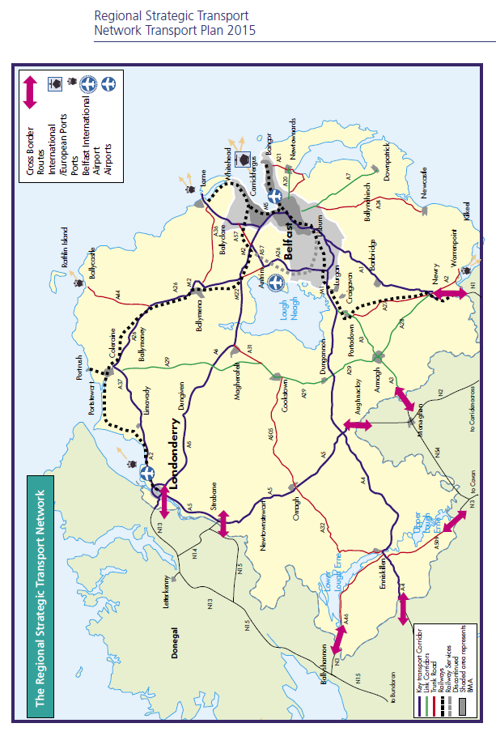
Appendix 2 BMTP Extract: Lisburn and Castlereagh
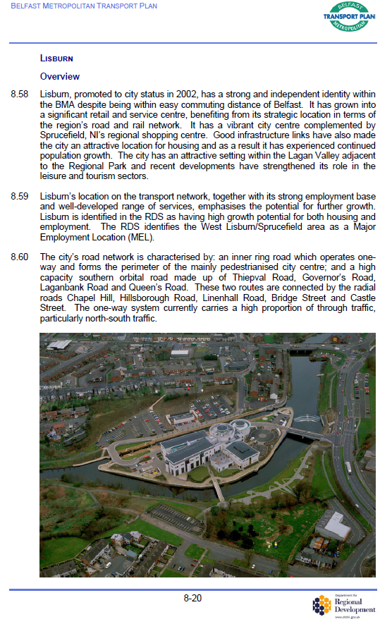

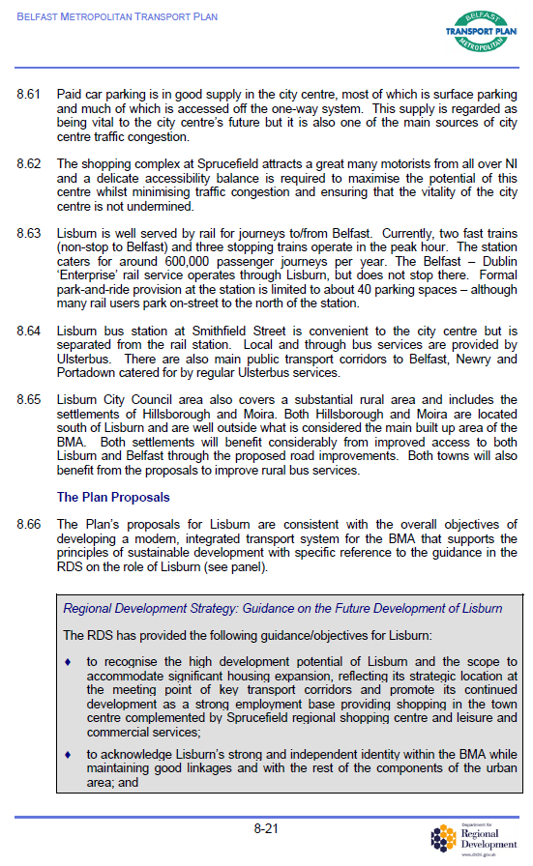

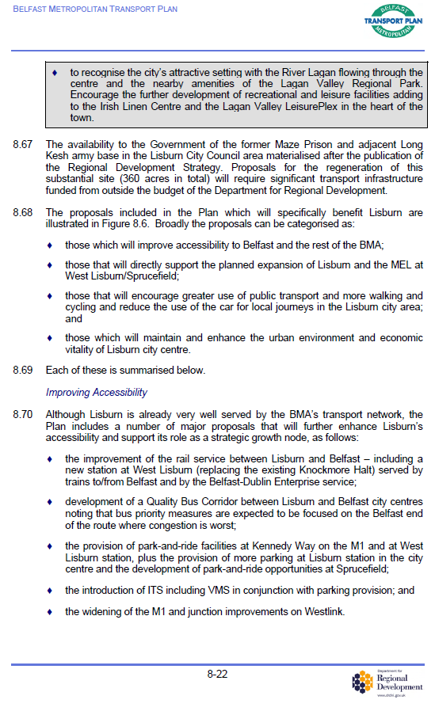
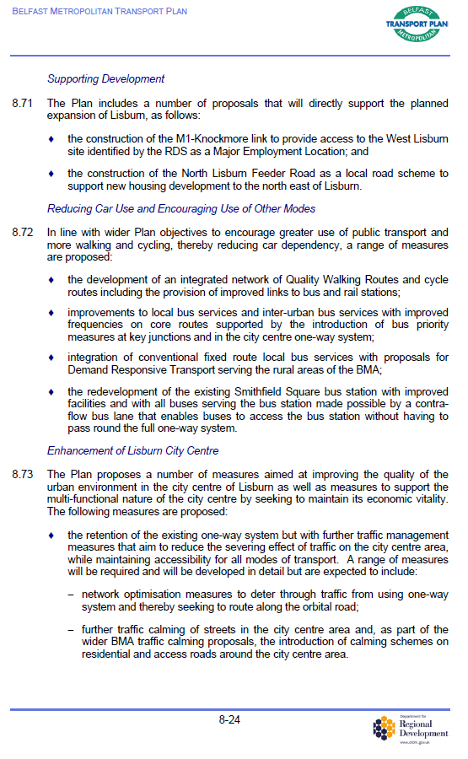

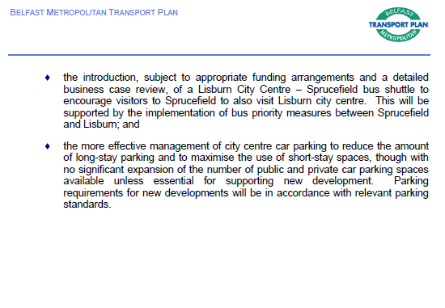

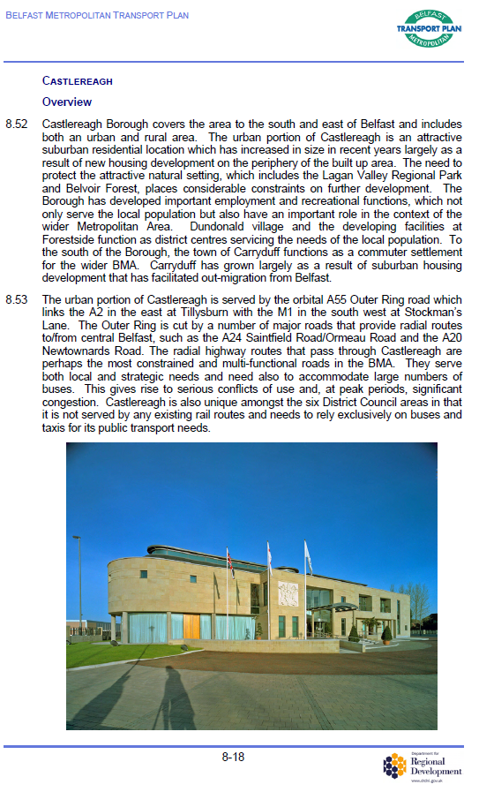

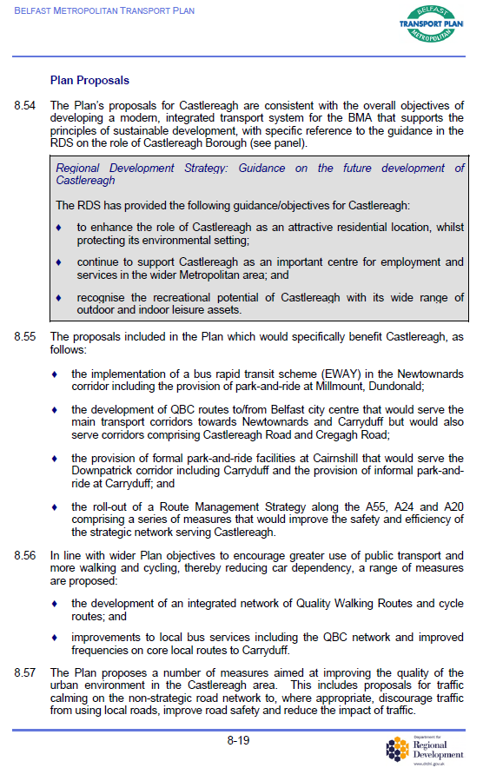

The Local Transport Plan Transport Study has been subsequently carried out by DfI for the Lisburn and Castlereagh City Council area

