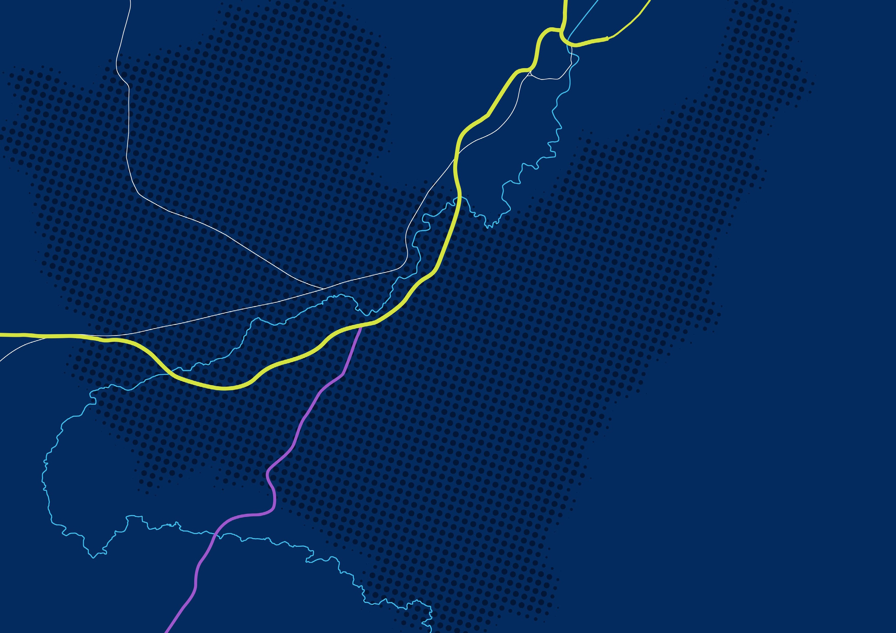


Annual Housing Monitor Report
2020-2021

www.lisburncastlereagh.gov.uk
Contents
- Introduction
- Purpose of the Annual Housing Monitor
- Methodology
- Monitored Sites
- Summary Statistics for Settlements

Appendix A: Individual Statistics and Maps for Settlements 2020-2021

- Introduction
This paper contains the findings of the Annual Housing Monitor (HM) for the survey year 01/04/2020 to 31/03/2021. It also provides information on the purpose of the HM, the methodology involved in carrying out the HM, a summary table of results as well as statistics and maps for each individual settlement as defined in the current Area Plan.
The former Department for Regional Development published the revised RDS 2035 in March 2012. The purpose of the RDS is to provide an overarching spatial framework to influence the future distribution of activities throughout the Region to 2035. It aims to provide context and evidence, as well as a framework and guidance, for where development should happen.

As part of the preparation of a new Local Development Plan (LDP) for Lisburn & Castlereagh City Council, the Strategic Planning Policy Statement for Northern Ireland (SPPS, September 2015, page 73) outlines a ‘plan, monitor and manage’ approach to ensure that, as a minimum, a 5 year supply of land for housing is maintained. It states that monitoring should be an ongoing process with annual reporting and review. As a minimum, it states that monitoring must include:
- The housing land supply at the beginning and end of the annual reporting period;
- The number of net additional units built during the annual reporting period; and
- The number of net additional housing units built in the period since adoption of the local policies plan.
- Purpose of the Annual Housing Monitor
The primary purpose of the Housing Land Availability Monitor (referred to as the ‘Housing Monitor’) is to inform the housing allocation of the Council’s new LDP. However, it will also help the Council identify where a shortfall in potential land supply might exist and can inform house-builders on the availability of land that may be suitable for housing. This will provide valuable information on annual building rates, housing output relative to planned densities, and will also give an indication of the windfall predictions.
The purpose of the annual Housing Monitor is: -

- To monitor progress of housing development in settlements with regard to the Regional Development Strategy and the provisions of the current Development Plan;

- To inform the preparation of the Council’s Local Development Plan with regard to the allocation of land for housing; and
- To provide information on the available potential for further housing development in settlements.
The SPPS states that it will also be necessary to monitor and assess housing development in the rural area in order to ensure that the total housing growth can be assessed against the plan’s housing allocation.

- Methodology
Prior to the transfer of planning powers to Council in April 2015, the Department was responsible for providing a Housing Monitor for all of Northern Ireland. The process involved methodology based on information derived from Building Control Completion Certificates provided by District Councils.
With the assistance of Land and Property Services (LPS), a Geographical Information System (GIS) based approach was used to estimate housing completions across Northern Ireland over a specified period and housing land availability at a given point in time.
Under the reform of Local Government in April 2015 Planning was integrated into the Local Councils. The Housing Monitor is aligned with the new Lisburn & Castlereagh City Council Area and information is supplied directly from Building Control to the Planning Unit.
The Housing Monitor covers all settlements as defined in prevailing development plans. It identifies the number of dwelling units completed and the area of land developed and assesses the available potential of land and dwellings that remains undeveloped on monitored sites within settlements in the Council Area. It should be noted that apartments are included in the Housing Monitor as dwellings.
A separate study was carried out for dwellings completed in the countryside under the new Council using Building Control Completion Certificates. During the period from 1st April 2020 to 31st March 2021 a total of 81 single rural dwellings were completed in the countryside in the Council Area. The report excludes replacement dwellings as these have no net gain.

- Monitored Sites
- The Housing Monitor sites are those identified as potentially suitable for residential development in the current Development Plan through zonings and any other urban sites that have been granted planning permission for residential development by means of a planning application or approved through the planning appeals process.
- Sites where planning approval has expired will continue to be monitored where it is considered that potential for residential development still exists i.e. through renewal of a planning approval. Other land within settlements that is not included in the housing monitor will become a monitored site once identified as suitable for residential development as set out above.
- In the survey, the number of dwellings built on each of the monitored sites and the total area developed at the time of the survey is recorded. The area remaining and the potential dwellings remaining are also identified. Please note that the potential number of dwellings on the housing monitor sites can change as new or amended planning applications are approved.
- In order to calculate the number of dwellings available in situations where only the site area is known, an estimate of likely density is used. This is based, where possible, on characteristics such as site location, landform or adjacent development form and density. Where this approach has not been considered reasonable, an average density has been applied to the site depending on the location and other relevant planning considerations specific to the wider area. Where actual development densities vary from that assumed, adjustments will be made and reflected in the next annual Housing Monitor.
- A previously monitored site will be removed from the Monitor where any non-residential development commences or where a new Local Development Plan removes its potential for residential development.
- It is also acknowledged that some of the potential for housing development in settlements might not be realised due to other constraints, including the refusal of landowners to release their land for development.
- It is required practice in undertaking the Housing Monitor to record net housing gain as opposed to the gross total housing output from sites. This involves taking account of fit housing that is lost to make way for new housing. While this is generally followed it is acknowledged that it is not always possible in every instance.
- It should also be noted that there may be a lag period between dwellings appearing to be complete on the ground and the issuing of a building control completion certificate. Consequently on some sites, it may appear that more dwellings are complete than are reflected in the figures for that site. It is the position of this Council that the use of building control completion certificate information is the most appropriate mechanism to assess the status of each monitored site.
- A summary table is provided in Section 5 for the Housing Monitor for the 2020-2021 year. Appendix (A) provides the associated individual tabular statistics and maps for each settlement, detailing the monitoring status within each settlement as of 31 March 2021.

- Summary Statistics for Settlements 2020-2021

Settlement | Units/Dwellings Complete 2020-2021 | Potential (Units/Dwellings) Remaining 2020-2021 | Area Developed (Ha) 2020-2021 | Area Remaining (Ha) 2020-2021
Lisburn City | 262 | 3,546 | 9.8 | 122.7
Lisburn Greater Urban Area | 52 | 47 | 0.9 | 1.4
Castlereagh Greater Urban Area Including Dundonald | 131 | 1,715 | 6.9 | 77.6
Carryduff | 45 | 1,227 | 1.7 | 56.7
Hillsborough & Culcavy | 26 | 303 | 2.1 | 19.1
Moira | 31 | 432 | 1.2 | 19.5
Total for City, Greater Urban Areas and Towns | 547 | 7,270 | 22.6 | 297
Total for villages | 78 | 741 | 3.25 | 34.4
Total for small settlements | 55 | 228 | 2.64 | 12.5
Overall Total | 680 | 8,239 | 28.5 | 343.9

Table 1: Units Complete, Potential Units Remaining, Area Developed and Area Remaining 2020-2021 in Settlements

Figure 1: Housing Units Complete 2020-2021 in Settlements
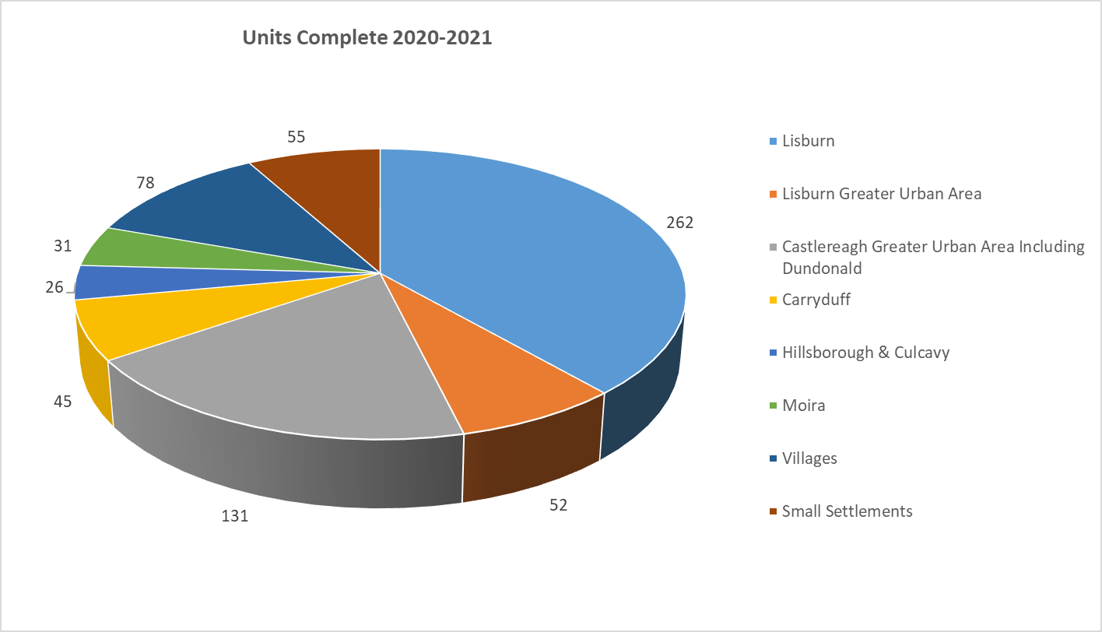

Figure 2: Potential Housing Units Remaining 2020-2021 in Settlements
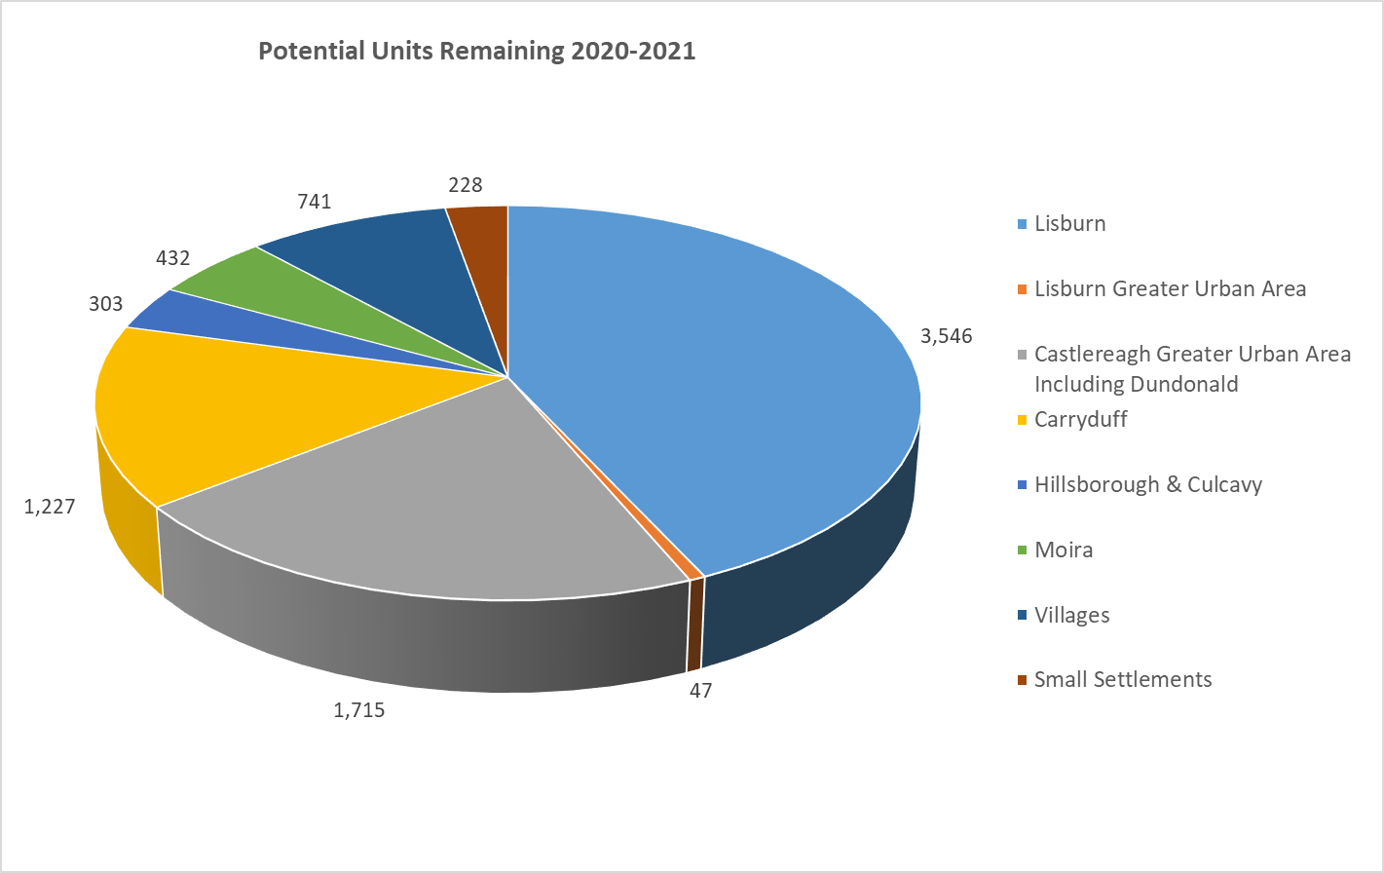

Appendix A: Individual Statistics and Maps for Settlements
Settlement Hierarchy | Lisburn & Castlereagh City Council Area
City | Lisburn
Lisburn Greater Urban Area | Lisburn Greater Urban Area
Castlereagh Greater Urban Area | Castlereagh Greater Urban Area – Dundonald  Castlereagh Greater Urban Area – Cairnshill/Newtownbreda Area
Towns | Carryduff  Hillsborough & Culcavy  Moira
Villages | Aghalee; Annahilt; Dromara; Drumbeg; Drumbo; Glenavy; Lower Ballinderry; Maghaberry; Milltown; Moneyreagh; Ravernet; Stoneyford; Upper Ballinderry
Small Settlements | Ballyaughlis; Ballycarn; Ballyknockan; Ballylesson; Ballynadolly; Ballyskeagh; Boardmills; Carr; Crossnacreevy; Drumlough; Drumlough Road; Dundrod; Duneight; Feumore; Halfpenny Gate; Halftown; Hillhall; Kesh Bridge; Lambeg; Legacurry; Long Kesh; Lower Broomhedge; Lurganure; Lurganville; Lurgill; Magheraconluce; Morningside; Purdysburn; Ryan Park; St James; The Temple; Tullynacross; Upper Broomhedge

Settlements in blue text have no Housing Monitoring sites (Zoned Housing Land or Land with Planning Permission for Housing)

For the purposes of this HM the current Area Plan refers to Draft BMAP which was purported to be adopted and not the pre-examination draft published in 2004.
Completion Certificates are issued when all works appear to be in compliance with the requirements of the Building Regulations following a satisfactory completion inspection.

