Provision of Event Infrastructure to Community Groups and Outside Organisations by Lisburn & Castlereagh City Council, Leisure and Community Wellbeing – Parks and Amenities
2021-2022

It has been a long standing policy of Lisburn City Council and subsequently Lisburn and Castlereagh City Council to provide infrastructure support to community led events, free of charge, providing it meets certain criteria. The policy was most recently approved at the Leisure & Community Development Committee on 11 May 2016. It was agreed to provide infrastructure support by way of loan of equipment to community / voluntary organisations for events who are using Council facilities or who are in receipt of Council grant aid for that event or a Council decision relating to assistance for the event.
The level of infrastructure support or loan of equipment must be commensurate with the scale of the event and the level of grant funding being awarded.
The Parks & Amenities Unit is charged with implementation of this policy, thus creating a welcoming community, through the accessibility of infrastructure for outside organisations. Through this policy, we can grow relationships with our local community and through supporting local groups encourage them to take ownership of events and the use of our parks and open spaces.
Parks & Amenities within the council endeavours to loan equipment without charge to all types of groups, for events. All sections of the community are encouraged to participate in events to showcase their talents, culture and interests etc. This is in line with the Council Corporate Plan and the remit to invest in people in order to reinforce a sense of belonging and public identity. These qualities are essential to the general health and wellbeing of our community and our society as a whole.
Lisburn Castlereagh City Council – Parks & Amenities, endeavours to assist and support all groups, individuals, and sections of the community. Community groups from all sections of society are encouraged to contribute to social cohesion through common interests and goals. This is in line with Council Corporate Plan as stated in Strategic Theme No. 5 – Our Community.
‘Outcome: We live in confident, harmonious, safe and welcoming communities. We want to grow a sense of citizenship, social cohesion, self-help and capacity of all our communities, increasing social, economic and environmental wellbeing’.
‘Corporate Actions - We will
- Lead and facilitate the next phase of Community Planning, working effectively with our partners to grow community wellbeing.
- Promote volunteering and participation in public and community life (arts, culture and sport) developing community ownership and management of local assets and facilities.
- Work with partners to create the social conditions and environments that will strengthen community confidence and provide support for people who need it.
- Encourage inclusivity and equality of opportunity across our community, promoting the benefits of a diverse society, celebrating culture and good relations between people of different backgrounds and identities’.
In conclusion, Parks and Amenities are aware that everyone is unique, each with different needs and priorities. By provision of event infrastructure, these events can welcome all sections of the community, with facilities available for all requirements. Participating in cross community events provides opportunities to promote good relations between all.

Our aims and objectives are as follows:
- Supplying event infrastructure facilities, without charge, to all groups and sections of the community to encourage community capacity and participation.
- To enable groups to host their own events
- Integrating equal opportunity principles and practices when delivering the service
- To ensure the provision of adequate welfare facilities and thus lessen the risk of inappropriate behaviour.
- Encourage Leadership within the Community
- Encourage good practice when organising events in line with Health & Safety and Equality and assist in the delivery of a safer event
- The provision of infrastructure will, it is considered facilitate inclusion of all groups within events held

Lisburn & Castlereagh City Council

Equality and Good Relations Screening

Part 1. Policy scoping

Information about the policy

Name of the Policy
Provision of Event Infrastructure to Community Groups and Outside Organisations by Lisburn and Castlereagh City Council, Leisure and Community Wellbeing – Parks and Amenities

Background

The Council aims to help facilitate organisations within the council area in their events by the hire, without charge, of equipment. This service is open to all sections of the community who are encouraged to take leadership roles and participate in events to showcase their culture, talents, interests etc. Community groups, Sports Activities and Schools are regularly involved in events within the council area.

Is this policy
An existing policy? | Yes | A revised policy? |  | A new policy?

The aim of this policy is to ensure that the council provides all sections of the community with the same service and support. Our objectives below list how the council will aspire to achieve this goal.
- Supplying event infrastructure facilities, without charge, to all groups and sections of the community to encourage community capacity and participation
- Integrating equal opportunity principles and practices when delivering the service
- Providing transparency of procedure, openness and accountability, as per the agreed criteria Appendix 1: Council minutes, event on council property, or organisation is in receipt of Council’s financial assistance, eg. Community Festivals Fund

- To ensure the provision of adequate welfare facilities and thus lessen the risk of inappropriate behaviour, spread of disease and germs
- Encourage Leadership within the Community
- Encourage good practice when organising events in line with Health & Safety and Equality and assist in the delivery of a safer event
- The provision of infrastructure will, it is considered facilitate inclusion of all groups within the events held

Are there any expected benefits to the Section 75 categories/groups from this policy? If so, please explain
This service is extended to all community groups and individuals who may benefit from the provision of event infrastructure no matter their gender, religious beliefs, political opinion, racial group, disability, dependency, etc.

Benefits include
- Outside groups and individuals can use services without additional costs
- Groups and individuals can benefit from ease of operation
- Developing sustainable relationships
- Encourages local groups to build community
- The provision of infrastructure will, it is considered, facilitate inclusion of all groups within the events held

Who initiated or wrote the policy?
Owned by Lisburn & Castlereagh City Council (The Council)
Written by Leisure & Community Wellbeing – Parks & Amenities

Who owns and who implements the policy?
Lisburn and Castlereagh City Council (The Council) owns the policy, Leisure & Community Wellbeing - Parks & Amenities implements the policy.

Implementation factors

Are there any factors which could contribute to/detract from the intended aim/outcome of the policy/decision?

If yes, are they

Financial? | Yes | Legislative? |  | Other? | Yes

If other, please detail below

The cost to Community Groups to access these facilities from other funding sources is prohibitive, and therefore have a bearing on community accessibility to essential event infrastructure due to budget constraints resulting in a negative impact on Health & Safety of Community events and the wellbeing and welfare of attendees. This could also impact the number of Community run events and negatively affect the Community and society as a whole and not fulfil the Council’s aims and objectives as set out in this document.

Main stakeholders affected

Who are the internal and external stakeholders (actual or potential) that the policy will impact upon?

Staff | 
Service Users
Other Public Sector Organisations such as…
Voluntary/Community/Trade Unions
Other

If other, please detail below
- Local residents
- General Public
- Enthusiasts of Cars, Sports, Music etc.

Other policies with a bearing on this policy

Name of policy | Who owns or implements policy?
Organisation and running for all the ‘Public Events’ within Leisure & Community Wellbeing – Parks & Amenities. | Lisburn & Castlereagh City Council owns this policy, Parks & Amenities implements.
Our Plan For Growth & Connecting – Corporate Plan, 2018/2022 and beyond. | Lisburn & Castlereagh City Council
Community Plan 2017/2032 | Lisburn & Castlereagh City Council
Development Plan 2019 | Lisburn & Castlereagh City Council
H&S Events Safety | Lisburn & Castlereagh City Council –Environmental Health
Lisburn & Castlereagh City Council Safety Advisory Group Policy | Lisburn & Castlereagh City Council
Children & Adults at Risk Safeguarding Policy | Lisburn & Castlereagh City Council
Available evidence

A list of this service users is maintained. This list informs the council of infrastructure required on an annual basis and to ensure stock is available. It also provides a basis to compare from year to year in evaluating that the service is growing, fit for purpose and successful.

Sec 75 Category | Details of evidence/information
Religious Belief | The 2011 Census/2014 LGD boundary data indicates that 23.95% of the LCCC population were brought up in the Catholic religion while 66.9% were of the Protestant & Other Christian religion
Political Opinion | There would be a generally accepted link between religion and political opinion. In this instance the majority political opinion being Unionist
Racial Group | Using the same Census/boundary data indicates that just over 2% of the population were from an ethnic minority group
Age | We are aware that different age groups may have different needs including caring, mobility, disability etc. Consideration has been given to these different needs by providing event infrastructure which can help to accommodate these needs.  The population at June 2019 totalled 144,381:  29,126 (0-15 years)  42,555 (16-39 years)  47,748 (40-64 years)  24,952 (65+ years)
Marital Status | For the 16+ population in relation to marital and civil partnerships:  30.65% single  53.78% married  0.10% same sex partnership  3.27% separated  5.52% divorced  6.68% widowed
Sexual Orientation | The Continuous Household Survey in 2019 indicated that 1.8% of the household population in NI identified as Lesbian, Gay, Bisexual or Other.
Men & Women Generally | The LCCC population (2018) was 50.9% female and 49.1% male. This reflects the overall NI position.  It is recognised that in relation to events men and women may have different needs, such as different toilet facilities. These needs are given careful consideration when supplying any infrastructure.
Disability | It is recognised that individuals with any disability will have different needs to those without a disability. The same boundary/census data as above indicates that 18.29% of the population had a long-term health problem or disability in 2019.  Previous events have included those with a broad range of disabling conditions. Disabled parking, viewing areas, toilet facilities and access are taken into account.  By providing event infrastructure all Community groups can plan for these scenarios
Dependants | Dependants would generally include three main categories:  - The care of a child or children  - The care of an elderly relative/person  - The care of someone with a disability  By providing event infrastructure Community groups can plan for these scenarios

Needs, experiences and priorities

Taking into account the information referred to above, what are the different needs, experiences and priorities of each of the following categories, in relation to the particular policy/decision? Specify details for each of the Section 75 categories

Sec 75 Category | Details of needs/experiences/priorities
Religious Belief | It is considered that there are no different needs in respect of events for this group – the service is available to and is used by people of all religious backgrounds and none.
Political Opinion | It is considered that there are no different needs in respect of events for this group – the service is available to and is used by people of different political opinions and none.
Racial Group | We already ensure that our free support is publicised to different groups. We may need to ensure that new groups are aware of what we offer.
Age | We are aware that different age groups may have different needs, be it in respect of caring, mobility, disability etc. By providing event infrastructure Community groups can consider the needs of these groups at the planning stage.
Marital Status | It is considered that there are no different needs in respect of this service for this group.
Sexual Orientation | It is considered that there are no different needs in respect of this service for this group.
Men & Women Generally | It is recognised that in relation to this service and events generally men and women may have different needs, including caring responsibilities and toilet facilities. Women may need a space for breast feeding. By providing event infrastructure Community groups can consider the needs of these groups at the planning stage.
Disability | We are aware of the various types of disability and potential needs around accessibility and the needs of those with invisible disabilities, such as those with autism.
Dependants | This can cover adults looking after children, carers looking after an older relative/family member or indeed caring for someone with a disability. As all events aim to include everyone in the above range, by providing event infrastructure Community groups can consider the needs of these groups at the planning stage such as accessible toilet facilities.

Part 2. Screening questions

1 What is the likely impact on equality of opportunity for those affected by this policy, for each of the Sec 75 equality categories? (minor/major/none)

Sec 75 Category | Details of policy impact | Level of impact (minor/major/none)
Religious Belief | Provision of event infrastructure means groups with limited resources can provide a better event to meet the needs of all attendees. | Minor - positive
Political Opinion | Provision of event infrastructure means groups with limited resources can provide a better event to meet the needs of all attendees. | Minor - positive
Racial Group | Provision of event infrastructure means groups with limited resources can provide a better event to meet the needs of all attendees. | Minor - positive
Age | Provision of our service ensures that organisers can provide a better event which meets the needs of children and older people. | Minor - positive
Marital Status | No differential impact identified | None
Sexual Orientation | No differential impact identified | None
Men & Women Generally | Provision of event infrastructure means groups can provide a better event to meet the needs of all attendees. | Minor - positive
Disability | Provision of our service means that specific actions are taken to facilitate the attendance of those with a disability at events, e.g. Charity fundraising events for worthy causes | Minor - positive
Dependants | Provision of our service means that specific actions can be taken to facilitate those with dependants, eg, families. Some actions for those with a disability may also benefit some people with dependants. | Minor - positive

2 Are there opportunities to better promote equality of opportunity for people within the Sec 75 equality categories?

Sec 75 Category | IF Yes, provide details | If No, provide details
Religious Belief |  | No, because the service is already used by all sections of the community
Political Opinion |  | As above
Racial Group | Only in relation to ensuring that newcomers and new groups are aware of our services
Age |  | No, because our service already supports groups and individuals across all these groups
Marital Status
Sexual Orientation
Men & Women Generally
Disability
Dependants

3 Are there opportunities to better promote good relations between people of different religious belief, political opinion or racial group?

Good Relations Category | IF Yes, provide details | If No, provide details
Religious Belief |  | None identified at present
Political Opinion |  | None identified at present
Racial Group |  | None identified at present

It is considered that there are no better opportunities to promote good relations as cross community groups and schools from both main communities are included in the participation of events.

4 To what extent is the policy likely to impact on good relations between people of different religious belief, political opinion or racial group? (minor/major/none)

Good Relations Category | Details of policy impact | Level of impact (minor/major/none)
Religious Belief | Our service will enable some groups to organise events that will bring people together which may contribute to the promotion of good relations | Minor - positive
Political Opinion |  | Minor - positive
Racial Group |  | Minor - positive

Additional considerations

Multiple identity

Provide details of data on the impact of the policy on people with multiple identities. Specify relevant Section 75 categories concerned.

Council is aware that no one individual is exclusive to any one designated group. Multiple identity therefore has been given consideration within this screening exercise. In providing infrastructure support there will be benefits to those groups that support people with multiple identities, eg, older women or young people who are disabled etc

Part 3. Screening decision

If the decision is not to conduct an equality impact assessment, please provide details of the reasons.
The screening decision is to screen out without the need for mitigation as no negative impacts have been identified and all impacts are minor and positive.

The reasoning for this includes:

-Profiling the demographic background of the area, means the council has a general idea of types of attendees attending Community events.

-Having made regular amendments to cater for many multiple identities through the lending of event infrastructure.

-Equipment already being lent out to a wide variety of different types of events and organisations, therefore being open to all within the community.

-Supplying event infrastructure facilities, without charge, to all groups and sections of the community

-Integrating equal opportunity principles and practices when delivering the service

-Providing transparency of procedure, openness and accountability, as per the agreed criteria: Council minutes, event on council property or organisation is in receipt of Council’s financial assistance eg. Community Festivals Fund

-Ensuring quality and continuity of service

- Community Services who are in close contact with local community groups are aware of the facility and pass this information on to relevant groups

However, the service will be reviewed on an annual basis and changes made if necessary.

If the decision is not to conduct an equality impact assessment the public authority should consider if the policy should be mitigated or an alternative policy be introduced.

If the decision is to subject the policy to an equality impact assessment, please provide details of the reasons.

Mitigation

When the public authority concludes that the likely impact is ‘minor’ and an equality impact assessment is not to be conducted, the public authority may consider mitigation to lessen the severity of any equality impact, or the introduction of an alternative policy to better promote equality of opportunity or good relations.

Can the policy/decision be amended or changed or an alternative policy introduced to better promote equality of opportunity and/or good relations?

If so, give the reasons to support your decision, together with the proposed changes/amendments or alternative policy.

Timetabling and prioritising – Not applicable

Factors to be considered in timetabling and prioritising policies for equality impact assessment.

If the policy has been ‘screened in’ for equality impact assessment, then please answer the following questions to determine its priority for timetabling the equality impact assessment.

On a scale of 1-3, with 1 being the lowest priority and 3 being the highest, assess the policy in terms of its priority for equality impact assessment.

Priority criterion | Rating (1-3)
Effect on equality of opportunity and good relations
Social need
Effect on people’s daily lives

Relevance to a public authority’s functions

Total Rating Score

Is the policy affected by timetables established by other relevant public authorities?

If yes, please provide details
N/A

Part 4. Monitoring

This policy will be reviewed on an annual basis whereby a search of our system will be conducted to see how many community events have been assisted with infrastructure and that list will be analysed and broken down into categories in order to make a full assessment and action taken accordingly.

Part 5 - Approval and authorisation
Screened by: | Position/Job Title | Date
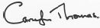 Carolyn Thomas | Events Officer Parks & Amenities | 13/10/2021
Reviewed by Mary McSorley | Equality Officer | 13/10/2021
Approved by:
Ross Gillanders | Head of Service | 30/11/2021

Note: A copy of the Screening Template, for each policy screened should be ‘signed off’ and approved by a senior manager responsible for the policy, made easily accessible on the public authority’s website as soon as possible following completion and made available on request.

References

Lisburn & Castlereagh City Council (2018) Our Plan For Growth & Connecting – Corporate Plan, 2018/2022 and beyond.
Lisburn & Castlereagh City Council (2017) Community Plan 2017/2032
Lisburn & Castlereagh City Council (2019) Development Plan Position Paper 1: Population and Growth
Northern Ireland Statistics and Research Agency (NISRA) https://www.nisra.gov.uk/statistics
Census 2011 Population Statistics for Lisburn and Castlereagh Local Government District (2014) https://www.ninis2.nisra.gov.uk/public/AreaProfileReportViewer.aspx?FromAPAddressMulipleRecords=Lisburn%20And%20Castlereagh@@Lisburn%20And%20Castlereagh@22?#1253

Appendices

Appendix 1 - Outdoor Events Booking Request Form

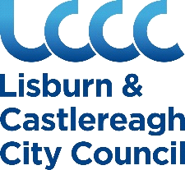
LISBURN & CASTLEREAGH CITY COUNCIL
Leisure & Community Wellbeing
Parks & Amenities
Outdoor Events Booking Request Form
Booking details (Please complete in Block Capitals)

1. Venue and Address (please specify the location of the proposed event)

2. Date and Time (please specify the proposed date and time of the event)

3. Describe the proposed Event in as much detail as possible (please describe the event; anticipated numbers attending etc)

4. Purpose of proposed Event (Social, Recreational, Private Party, Fund Raising, Commercial etc)

5. Facilities Required (please specify what exactly you require eg is it a grassed area on which to hold an event; approx. how much space; or is it a function room for an internal event)

6. Your Details
Organisation (Organisation/Club/Team etc. If it a private booking go directly to ‘Applicant’s Contact Details’)
Organisation Name

Commercial / Profit Making | Yes / No
Charity | Yes / No (if Yes please provide NI Charity Commission Registration Number
Community Group | Yes / No

Applicant’s Contact Details
Name

Address

Email Address

Mobile Number

7. Safety Advisory Group. If your event booking is approved then it is a requirement of the Council that you notify S.A.G (Safety Advisory Group) of your event. The link below provides you access to the necessary forms:

https://www.lisburncastlereagh.gov.uk/business/health-safety-at-work/event-safety

8. Insurances and Risk Assessments. If your event booking is approved then you may be required to provide Public and if relevant Employers Liability insurance to the Council Insurance Officer. You will also be asked to provide a Risk Assessment for the event.

9. Contact. Please email this form to event.request@lisburncastlereagh.gov.uk once completed. Your request will be considered and you shall be contacted shortly to advise on availability and costs. No booking has been made until such times as this has been clarified and confirmed by the Council in email.
You are advised NOT to make any commitments re your event until such time as your request has been approved and confirmed.

10. Privacy Notice.
Your Personal Data:
What we need
Lisburn & Castlereagh City Council is the ‘Controller’ of the personal data that you provide to us. We only collect basic personal data, this does not include any special types of information, it does however include name, address, email etc.
Why we need it
We need to know your basic personal data in order to proceed with your event booking. We will not collect any personal data from you we do not need in order to provide and oversee this service to you.
What we do with it
All personal data that we process is processed by our staff in the UK however for the purposes of IT hosting and maintenance this information is located on servers within the European Union. No 3rd parties have access to your personal data unless the law allows them to do so. We have a Data Protection regime in place to oversee the effective and secure processing of your personal data.
How long we keep it
We are required under UK law to keep your basic personal data (name, address, contact details) in line with Lisburn & Castlereagh City Council Retention and Disposal Policy after which time it will be destroyed.
What are your rights?
If at any point you believe the information we process on you is incorrect you may request to see this information and even have it corrected or deleted. If you wish to raise a complaint on how we have handled your personal data, you can contact our Data Protection Officer who will investigate the matter. If you are not satisfied with our response or believe we are processing your personal data not in accordance with the law you can complain to the Information Commissioner’s Office (ICO). The Council Data Protection Officer can contact at data.protection@lisburncastlereagh.gov.uk
Full details of can be found on the Lisburn & Castlereagh City Council websiwww.lisburncastlereagh.gov.uk

Appendix 2 - Background demographic data collected by NISRA about population estimates by Local Government District (mid-2018)

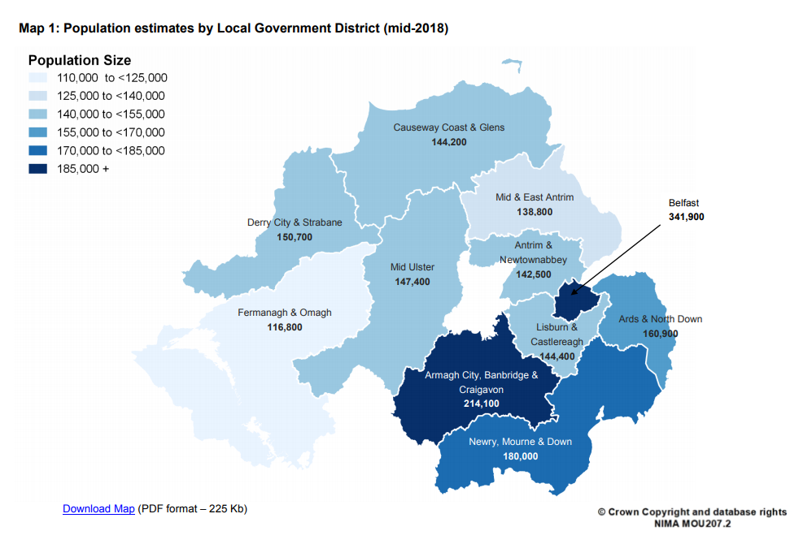
https://www.nisra.gov.uk/sites/nisra.gov.uk/files/publications/MYE18-Bulletin.pdf

