Organisation and delivery of all ‘Public Events’ by Parks & Amenities Service Unit (Leisure & Community Wellbeing)

Background
LCCC has a policy of promoting our parks and open spaces as shared spaces that are welcoming and inclusive for all.
On an annual basis, LCCC Parks & Amenities Service Unit organises a programme of events that are designed to be inclusive and encourage all sections of the public to visit and use parks and amenity facilities. Through such events, we hope to support community cohesion as well as increase social, economic and environmental wellbeing.
Parks & Amenities endeavours to include a wide variety of attractions/entertainment that will be of interest and encourage involvement of all groups, individuals and members of society. Events are free and open to all. This is in line with the Council Corporate Plan (Our Plan For Growth & Connecting – Corporate Plan, 2018/2022 and beyond) and Interim Corporate Plan 2021-2023 and the remit to invest in people in order to reinforce a sense of belonging and public identity. These qualities are essential to the general health and wellbeing of our community and our society as a whole.
Aims and Objectives of Parks & Amenities events include:
- to promote and encourage the use of our parks and open spaces
- to encourage local people and communities to take ownership of their local amenities and discourage vandalism and anti-social behaviour
- to promote current local and worldwide issues such as biodiversity, sustainability and climate change
- To support the local community.
We also want to:
- Ensure a consistently high standard of service across all events hosted by Parks & Amenities.
- Build good relationships with contractors to ensure a professional service is provided
- Deliver value for money
- Have transparency in our procedures
- Ensure accountability – identifying responsibility for design, management and participation
- Ensure the format and content of events do not present any barriers to participation for any section of the community, including the Section 75 equality groups.

Benefits of council hosted events include:
- Developing sustainable relationships strengthened by diversity and acceptance of others where cultural expression is celebrated and embraced.
- Encouraging young people to mix freely which can address prejudices or fears and encourage intercultural and cross community relations.
- Encouraging local groups to work together and connect people with common interests and goals such as biodiversity, local conservation and heritage, sport and local arts in order to build community and encourage participation in any events.
- Encouraging local people to take ownership and control of their open space, which has the beneficial effect of sending a positive message to the wider community, resulting in a reduction in vandalism and antisocial incidents. This can create a safer environment which everyone can enjoy for active living and recreational purposes and thus improve the quality of life for the people of the council area.

Events to be hosted by Parks & Amenities include:
‘Christmas at the Castle’
This styled event on the theme of Christmas will take place in Castle Gardens and is designed to particularly attract families with young children to celebrate Christmas.
‘Mayors Family Fun Day’
This is a long standing event held in Wallace Park in conjunction with the ‘Mayor’s Parade’ featuring a range of attractions and activities to attract family groups and suit all age groups and abilities. Local entertainment and attractions are encouraged to attend to showcase local talent and promote a sense of local pride, belonging and citizenship.
‘Park Life’ programme of events
The Park Life programme of events runs over the summer period from Wallace Park, Moat Park and Moira Demesne. The programme has been rolled out over recent years to offer the same service delivery to more urban and rural areas of the Council. The programme offers attractions and entertainment to attract families with young children.
‘Royal Hillsborough Community Fun Day’

This is a one off event planned for 26 March 2022 for the local community to celebrate the Royal status awarded to the Village.

‘Queens Platinum Jubilee’ events

As part of the celebrations to mark Her Majesty’s Platinum Jubilee, Parks & Amenities will be tasked within 2022 with running several small scale cross community events.

Parks & Amenities are aware that everyone has different needs and priorities in relation to events. Each event will therefore have its own event management plan where the needs of particular groups are taken into account in the detailed planning and delivery.

Updated January 2022

Lisburn & Castlereagh City Council

Equality and Good Relations Screening

Part 1. Policy scoping

Information about the policy

Name of the Policy
Organisation and delivery of ‘Public Events’ by Parks & Amenities Service Unit (Leisure & Community Wellbeing)

Background

The Parks & Amenities Unit organises a programme of well-established events throughout the year, including the Mayor’s Family Fun Day, Park Life Programme and the Lisburn Christmas Lights Switch On, in addition to a number of standalone events such as Armed Forces Day and the Royal Hillsborough Community Fun Day. Various community groups are involved in these events as well as schools and local businesses.

These events are free and open to all sections of the community. We aim to offer a wide range of attractions and entertainment facilities to cater to all age groups. Community groups from all sections of the community are encouraged to participate in all events to showcase their talents, interests etc. and are regularly involved.

Questionnaires are created and circulated at these events to gather demographic information as well as gather feedback on the delivery of each event.

Is this policy

An existing policy? |  | A revised policy? |  | A new policy? | Yes

What are the intended aims/outcomes the policy is trying to achieve?

- to promote and encourage the use of our parks and open spaces

- to encourage local people and communities to take ownership of their local amenities and discourage vandalism and anti-social behaviour

- to promote current local and worldwide issues such as biodiversity, sustainability and climate change
- To support the local community.

- Ensure continuity of delivering a high standard of service across all events hosted by Parks & Amenities.
- Building good relationships with contractors to ensure a professional service is provided.
- Delivering value for money.
- Transparency of procedure.
- Accountability – identifying responsibility for design management and participation.
- Ensure all contents and itineraries at events have a wide appeal to attract attendees of all capabilities from all sections of the Community.

Are there any expected benefits to the Section 75 categories/groups from this policy? If so, please explain

Parks & Amenities endeavours to include a wide variety of attractions /entertainment to appeal to all groups, individuals and members of society. The events are free and open to all sections of the community, who are encouraged to participate in all events to showcase their talents interests etc. The events programme overall is intended to appeal to all groups.
Some events will be targeted more specifically at certain groups, for example, children and/or families. It is intended that all groups should benefit from participation and attendance at council events. This is in line with the Council Corporate Plan (Our Plan For Growth & Connecting – Corporate Plan, 2018/2022 and beyond), and Interim corporate Plan 2021-2023.

Within the Council Corporate Plan, one will find the explanation of:

Our Purpose
‘Working together to deliver better lives for all.’

Our Vision
To be ‘a progressive, dynamic and inclusive council, working in partnership to develop our community and improve the quality of people’s lives’ and the values we operate by.’

One of our core values being Equality
Acting inclusively and with fairness; promoting equality of opportunity and protecting people from discrimination.

We will achieve this by
• Delivering a range of high quality, cost effective local services to meet the needs of people and enhance their quality of life.
• Working collaboratively with our partners to secure improvements in social, economic and environmental wellbeing throughout our area.
• Leading and engaging with people to provide added value/quality services.
• Providing local government, advocacy and advice for people.
• Planning and delivering a better future for our area.

Strategic Theme No 5 - Our Community
Outcome: We live in confident, harmonious, safe and welcoming communities.
We want to grow the pride, social cohesion, self-help and capacity of all our communities, increasing social, economic and environmental wellbeing.

Corporate Actions - We will
i. Lead and facilitate the next phase of Community Planning, working effectively with our partners to grow community wellbeing.
ii. Promote volunteering and participation in public and community life (arts, culture and sport) developing community ownership and management of local assets and facilities.
iii. Work with partners to create the social conditions and environments that will strengthen community confidence and provide support for people who need it, including developing a series of Community Hubs as a focus for active citizenship, local volunteering and civic activity.
iv. Encourage inclusivity and equality of opportunity across our community, promoting the benefits of a diverse society, celebrating culture and good relations between people of different backgrounds and identities.

Benefits include:
- Developing sustainable relationships strengthened by diversity and acceptance of others where cultural expression is celebrated and embraced.
- To encourage young people to mix freely and remove any existing prejudices or fears and to encourage intercultural and cross community relations.
- Encourage local groups to work together and connect people with common interests and goals such as biodiversity, local conservation and heritage, sport and local arts in order to build community and encourage participation in the programme of events.
- Encourage local people to take ownership and control of their open space, and has had the beneficial effect of sending a positive message to the wider community, resulting in a reduction in vandalism and antisocial incidents, thus creating a safer environment which everyone can enjoy for active living and recreational purposes and improving the quality of life for the people of the council area.
- Engaging children in a positive way, creating memories and developing a sense of belonging and identity and responsible citizenship.

The remit of the Council is to invest in people in order to develop, encourage and nurture local community, to reinforce a sense of belonging and public identity. These qualities are essential to the general health and wellbeing of our community and our society as a whole.

Who initiated or wrote the policy?

Parks & Amenities Service Unit (Leisure & Community Wellbeing)

Who owns and who implements the policy?

Owned by Lisburn & Castlereagh City Council (The Council)
Implemented by Parks & Amenities (Leisure & Community Wellbeing)

Implementation factors

Are there any factors which could contribute to/detract from the intended aim/outcome of the policy/decision?

If yes, are they

Financial? | Yes | Legislative? |  | Other?

If other, please detail below

If an event is not adequately financed, it will have a detrimental effect on its content and could have a negative impact on the community’s perceptions, through failing to meet the public’s expectations. It should be noted that H&S will not be compromised by financial constraints and compliance with Covid-19 public health guidance has to be taken into account.

Main stakeholders affected

Who are the internal and external stakeholders (actual or potential) that the policy will impact upon?

Staff | 
Service Users
Other Public Sector Organisations
Voluntary/Community/Trade Unions
Other

If other, please detail below
Elected Members
Schools
Community Groups
Contractors
Local residents and visitors

Other policies with a bearing on this policy

Name of policy | Who owns or implements policy?
Health & Safety Events Safety | Environmental Health
Our Plan For Growth & Connecting – Corporate Plan, 2018/2022 and beyond. | Lisburn & Castlereagh City Council
Community Plan 2017/2032 | Lisburn & Castlereagh City Council
Development Plan 2019 | Lisburn & Castlereagh City Council
Provision of event infrastructure to community groups and outside organisations by Lisburn City Council, Leisure and Community Wellbeing – Parks and Amenities | Parks & Amenities (Leisure & Community Wellbeing)
Children & Adults at Risk Safeguarding Policy | Lisburn & Castlereagh City Council
Lisburn & Castlereagh City Council Safety Advisory Group Policy | Lisburn & Castlereagh City Council

Available evidence

What evidence/information (both qualitative and quantitative) have you gathered to inform this policy? Specify details for each of the Section 75 categories.

In developing/planning the programme of events, we have considered demographic data and experience from previous events.

The participants/contractors making up the fabric of the all events would cover all aspects of Section 75. The events are free and open to all within the community.

Example of background demographic data collected at council events such as Mayor’s Parade and Family Fun Day 2019 and Christmas Switch On 2019 can be found in (Appendix 2)

Sec 75 Category | Details of evidence/information
Religious Belief | The 2011 Census/2014 LGD boundary data indicates that 23.95% of the LCCC population were brought up in the Catholic religion while 66.9% were brought up in the Protestant & Other Christian religion. Although LCCC has a majority of residents from a Protestant community background, events are attended by people of all religions and none.
Political Opinion | There would be a generally accepted link between religion and political opinion. In this instance the majority political opinion being Unionist. Council events will be attended by people of all political opinions and none.
Racial Group | Using the same Census/boundary data indicates that just over 2% of the population were from an ethnic minority group. Events are targeted at all groups including LCCC’s minority populations and one event – the mini Mela - particularly targets BME communities.
Age | The population at June 2019 was 144,381:  29,126 (0-15 years)  42,555 (16-39 years)  47,748 (40-64 years)  24,952 (65+ years)  Questionnaire results from previous events confirm that all age groups attend our events
Marital Status | Census data for the 16+ population in relation to marital and civil partnerships:  30.65% single  53.78% married  0.10% same sex partnership  3.27% separated  5.52% divorced  6.68% widowed
Sexual Orientation | The Continuous Household Survey in 2019 indicated that 1.8% of the household population in NI identified as Lesbian, Gay, Bisexual or Other. Support groups estimate that the percentage is very low due to reluctance to declare.
Men & Women Generally | The LCCC population (2018) was 50.9% female and 49.1% male. This reflects the overall NI position.  Previous events have included both men and women, although generally a higher proportion of women than men would attend.
Disability | Census data as above indicates that 18.29% of the LCCC population had a long-term health problem or disability.  Similar previous events have included those with a broad range of disabling conditions. Disabled parking, viewing areas, toilet facilities and access are routinely taken into account at the planning stage of all events.
Dependants | Dependants would generally include three main categories:  - The care of a child or children  - The care of an elderly relative/person  - The care of someone with a disability  Similar previous events have included dependants. Primarily these have been children/young people who attend the event with their adult carer (parent/other) but also older individuals and indeed those with a disability.

Needs, experiences and priorities

Taking into account the information referred to above, what are the different needs, experiences and priorities of each of the following categories, in relation to the particular policy/decision? Specify details for each of the Section 75 categories

Sec 75 Category | Details of needs/experiences/priorities
Religious Belief | It is considered that there are no different needs in respect of events for this group other than the need to ensure that people of all religions (and none) are made to feel welcome to participate.
Political Opinion | It is considered that there are no different needs in respect of events for this group other than the need to feel welcome to participate.
Racial Group | Racial minorities may need specific promotion and encouragement to ensure their participation. Multicultural and cross- community elements are included in many events for example: Mini Mela as part of the Park Life programme.
Age | We are aware that different age groups may have different needs be it in respect of caring, mobility, disability etc. Specifically, older people may need rest facilities for outdoor events. Consideration needs to be given to these different needs at the planning stages, for example attractions and activities for all age groups.
Marital Status | It is considered that there are no different needs for this group in relation to events
Sexual Orientation | It is considered that there are no different needs for this group in relation to events.
Men & Women Generally | It is recognised that in relation to these events men and women may have different needs, for example, caring responsibilities and different need for toilet facilities. These need to be given consideration at the planning stage.
Disability | Those individuals with a disability (physical and other, visible and invisible) will have a range of different needs. We are aware of the various types of disability and their potential needs such as those within the autistic spectrum. As far as can be reasonably accounted for these varied needs are considered at the planning stages. Accessibility provision needs to be promoted to disabled people so they know their needs will be catered for.
Dependants | This can cover adults looking after children, carers looking after an older relative/family member or indeed caring for someone with a disability. As all events aim to include everyone, the above range of dependants are considered at the planning stages to proactively facilitate their inclusion.

Events are designed to welcome all sections of the community and facilities that are routinely provided include:
- Access on site for those with mobility issues
- Accessible toilets
- Designated viewing areas for attendees who are wheelchair users
- Quiet areas for those on the autism spectrum who may be impacted by noise.

Part 2. Screening questions

1 What is the likely impact on equality of opportunity for those affected by this policy, for each of the Sec 75 equality categories? (minor/major/none)

Sec 75 Category | Details of policy impact | Level of impact (minor/major/none)
Religious Belief | No differential impact identified | None
Political Opinion | No differential impact identified | None
Racial Group | Minority groups and newcomers to LCCC can potentially benefit from participation in events that help create a sense of community and belonging | Minor positive
Age | Events are designed to appeal to all ages and in particular children and young people, for example, activities such as puppet shows, face painters, bouncy castles and funfair rides for older children/ young adults. | Minor – positive
Marital Status | No differential impact identified | None
Sexual Orientation | No differential impact identified | None
Men & Women Generally | No differential impact identified | None
Disability | To encourage participation, specific actions are taken to facilitate the attendance of those with a disability at events. | Minor - positive
Dependants | As noted elsewhere this group can cover children and older people/dependants including disabled dependants. Many events are targeted at families and provide positive opportunities for families to enjoy activities in an enjoyable and inclusive environment. | Minor - positive

2 Are there opportunities to better promote equality of opportunity for people within the Sec 75 equality categories?

Sec 75 Category | IF Yes, provide details | If No, provide details
Religious Belief | As events are already designed to be inclusive to all designated groups and attract people from both council area and elsewhere, there are limited opportunities to better promote equality. However, ongoing effort can be made to ensure full inclusion and participation of all groups. Attendance can be further analysed and feedback sought to develop our events and further benefit any groups for whom access may be more challenging.
Political Opinion
Racial Group
Age
Marital Status
Sexual Orientation
Men & Women Generally
Disability
Dependants

3 To what extent is the policy likely to impact on good relations between people of different religious belief, political opinion or racial group? (minor/major/none)

Good Relations Category | Details of policy impact | Level of impact (minor/major/none)
Religious Belief | Council events are designed to encourage participation of all groups and to contribute to the development of good relations across the community. | Minor positive
Political Opinion |  | Minor positive
Racial Group |  | Minor positive

4 Are there opportunities to better promote good relations between people of different religious belief, political opinion or racial group?

Good Relations Category | If yes, provide details | If no, provide details
Religious Belief | It is considered that there are limited opportunities to better promote good relations as events already attract participation from cross community groups and schools from both main communities. However, we recognise the need for ongoing analysis, consultation and feedback to ensure that our events do in fact contribute positively to the promotion of good relations across these groups. Going forward, the programming of events will be constantly assessed to ensure quality and diversity of content to appeal to all backgrounds.
Political Opinion
Racial Group

Additional considerations

Multiple identity

Provide details of data on the impact of the policy on people with multiple identities. Specify relevant Section 75 categories concerned.

Council is aware that everyone has multiple identities. As an example, in relation to events, we take into account the needs of people who are different ages, gender, with and without disabilities, etc.

Part 3. Screening decision

If the decision is not to conduct an equality impact assessment, please provide details of the reasons.

If the decision is not to conduct an equality impact assessment the public authority should consider if the policy should be mitigated or an alternative policy be introduced.
The screening decision is that a full equality impact assessment is not required at this stage as no adverse impacts have been identified and the potential impacts are all minor and positive.

While the programme is screened out however, we propose ongoing mitigations in terms of how we promote our events to target under-represented or under-engaged groups and in terms of consultation and feedback to inform future events.

If the decision is to subject the policy to an equality impact assessment, please provide details of the reasons.

Mitigation

When the public authority concludes that the likely impact is ‘minor’ and an equality impact assessment is not to be conducted, the public authority may consider mitigation to lessen the severity of any equality impact, or the introduction of an alternative policy to better promote equality of opportunity or good relations.

Can the policy/decision be amended or changed or an alternative policy introduced to better promote equality of opportunity and/or good relations?

If so, give the reasons to support your decision, together with the proposed changes/amendments or alternative policy.

While we already take all reasonable steps to cater for different needs, we recognise that it may be that we can always do more. Detailed event planning for each event will therefore take into account feedback and previous experience as well as proactive consultation to see if we can make any improvements.

Mitigations include targeting under-represented and under-engaged groups to ensure that they are encouraged to participate in council events and that different needs are met as fully as possible. This includes proactive engagement with community groups.

Timetabling and prioritising – Not applicable

Factors to be considered in timetabling and prioritising policies for equality impact assessment.

If the policy has been ‘screened in’ for equality impact assessment, then please answer the following questions to determine its priority for timetabling the equality impact assessment.

On a scale of 1-3, with 1 being the lowest priority and 3 being the highest, assess the policy in terms of its priority for equality impact assessment.

Priority criterion | Rating (1-3)
Effect on equality of opportunity and good relations
Social need
Effect on people’s daily lives

Relevance to a public authority’s functions

Total Rating Score

Is the policy affected by timetables established by other relevant public authorities?

If yes, please provide details
N/A

Part 4. Monitoring

There will be detailed analysis and consideration of feedback from each event with efforts made to capture information on who attends by different equality group, etc.

The programme overall will be evaluated so that changes can be made to future programmes.

Part 5 - Approval and authorisation
Screened by: | Position/Job Title | Date
Carolyn Thomas | Events Officer | 12.10.21
Reviewed by Mary McSorley | Equality Officer | 13.10.21
Approved by: Ross Gillanders | Head of Parks & Amenities | 15.10.21
Reviewed and updated | As above | 26.01.22

Note: A copy of the Screening Template, for each policy screened should be ‘signed off’ and approved by a senior manager responsible for the policy, made easily accessible on the public authority’s website as soon as possible following completion and made available on request.

References

Lisburn & Castlereagh City Council (2018) Our Plan For Growth & Connecting – Corporate Plan, 2018/2022 and beyond.
Lisburn & Castlereagh City Council (2017) Community Plan 2017/2032
Lisburn & Castlereagh City Council (2019) Development Plan Position Paper 1: Population and Growth
Northern Ireland Statistics and Research Agency (NISRA) https://www.nisra.gov.uk/statistics
Census 2011 Population Statistics for Lisburn and Castlereagh Local Government District (2014) https://www.ninis2.nisra.gov.uk/public/AreaProfileReportViewer.aspx?FromAPAddressMulipleRecords=Lisburn%20And%20Castlereagh@@Lisburn%20And%20Castlereagh@22?#1253

Appendices

Appendix 1 - Background demographic data collected by NISRA about population estimates by Local Government District (mid-2018)

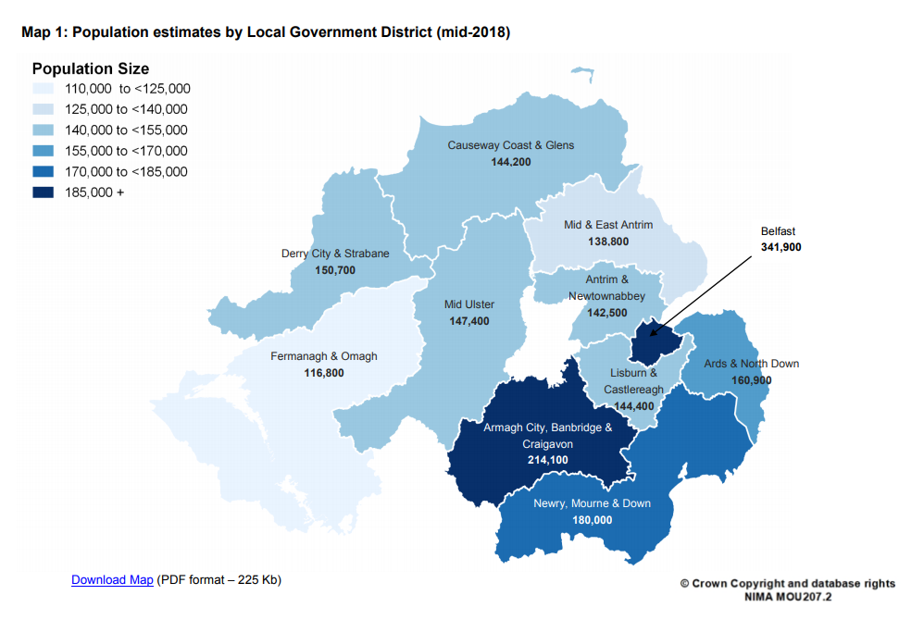
https://www.nisra.gov.uk/sites/nisra.gov.uk/files/publications/MYE18-Bulletin.pdf

Appendix 2 - Background demographic data collected at the Mayors Parade and Family Fun Day 2019 and Christmas Switch On 2019.

Mayors Parade and Family Fun Day 2019

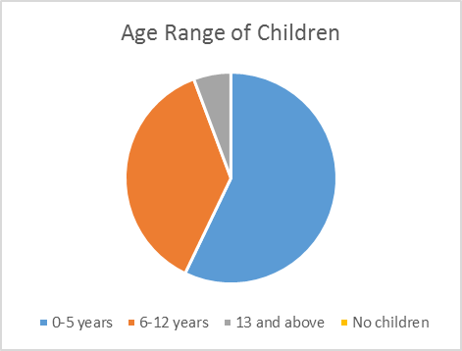

Christmas Switch On 2019

