

Lisburn & Castlereagh City Council
CLIMATE ADAPTATION PLAN
Appendix 2 to LCCC Sustainability Strategy 2026-2030



Executive Summary
The Councils Sustainability Strategy has set the scene regarding global climate change.
To address these weather extremes, some of which we are already experiencing, the Council has begun its adaptation journey by producing this Adaptation Plan which is designed to reduce the impact of extreme weather on the council’s buildings, assets, services and functions. Some actions are already being taken, but as predictions are for increasing weather extremes the council must be pro-active in looking to the future with the actions detailed within this plan designed to adapt to that climate change risk.
Gases within our atmosphere, known as greenhouse gases, trap heat from the sun, preventing its escape and increasing temperatures on earth. Globally the effects of climate change are projected to raise the earth’s temperature above
pre-industrial levels by 1.5°C within the next 5 years.
For Northern Ireland, this means in the future we will experience warmer wetter winters and hotter drier summers. However, the scientific data and projections are that we will still be susceptible to a greater range of extreme weather including flash flooding that will affect buildings, lands and rivers.

This Climate Adaptation Plan has been considered across all council services to develop an integrated and agreed action plan that creates a more resilient council. It is recognised that this Action Plan is inward looking, however council will evolve and assist in community resilience development where possible.
The Climate Adaptation Plan should be read in conjunction with the LCCC Sustainability Strategy and Climate Action Plan.

Page 02


Contents
What is Climate Adaptation? Page 04
Legislative & Strategic Context Page 06
LCCC Adaptation Plan Page 08
What Climate Effects Are We Experiencing? Page 09
LCCC Climate Adaptation Action Plan Page 10
Monitoring and Reporting Page 15
Annex 1 – Climate Adaptation Risk Register Page 16
Annex 2 – Met Office: Climate Report for Lisburn & Castlereagh Page 21

Page 03

What is Climate Adaptation?

Our response to climate change is approached in two main ways, Mitigation and Adaptation
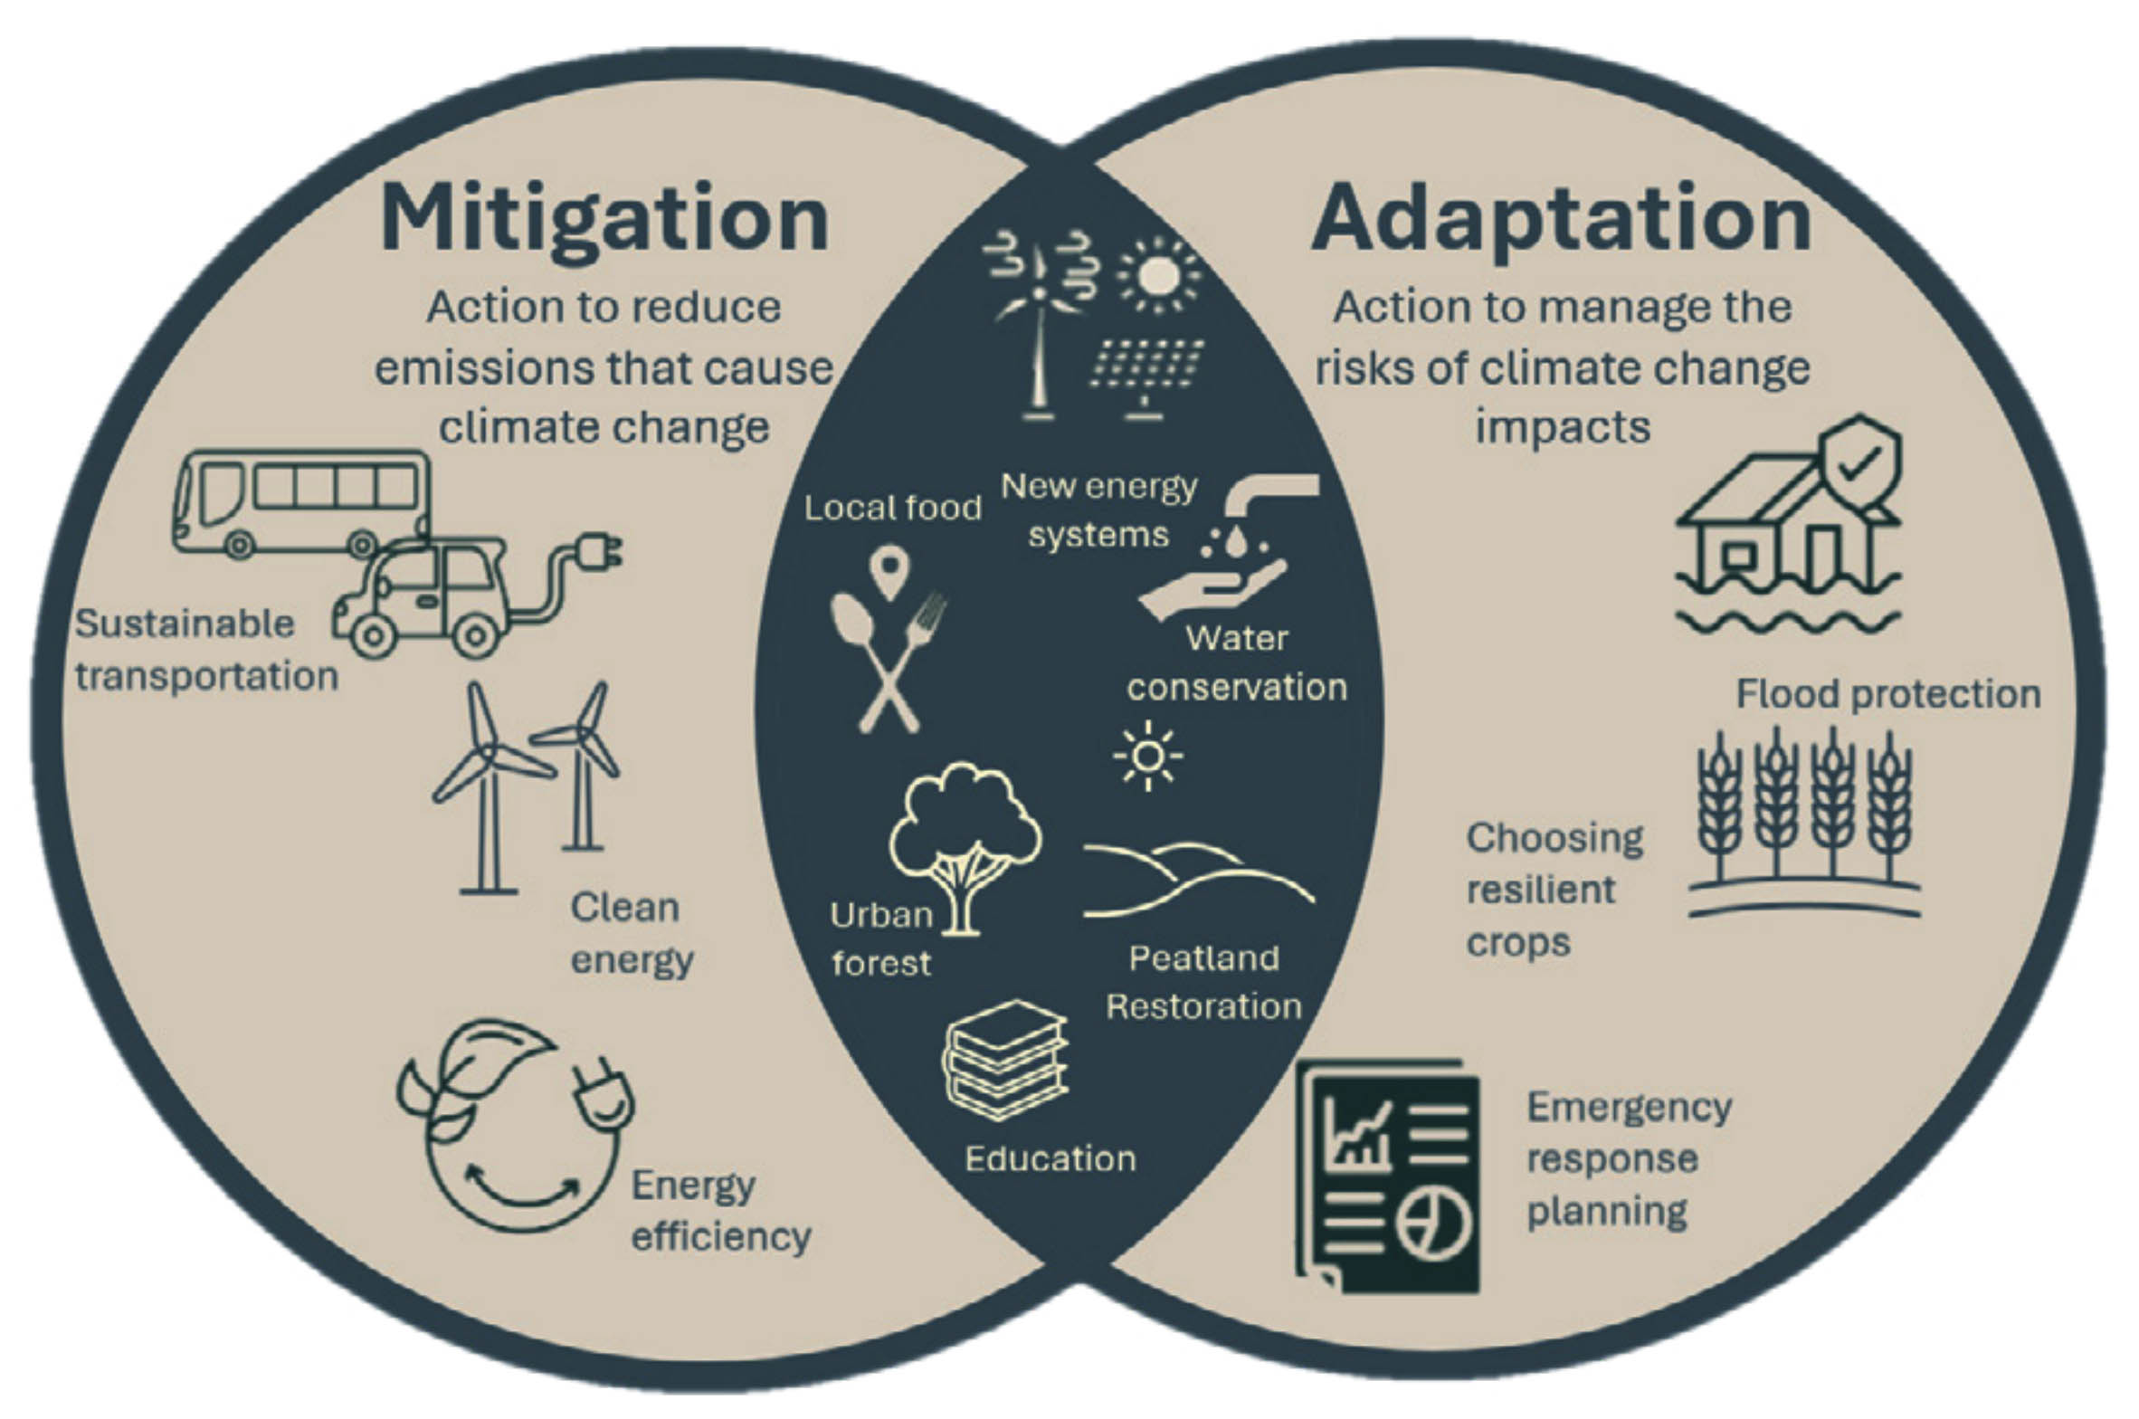

Diagram taken from DAERA NICCAP3 Consultation

Page 04

Climate Mitigation:
Mitigation is the undertaking of actions to reduce the production of greenhouse gases that cause climate change.
Northern Ireland requires urgent action on climate change. The public sector needs support to plan and deliver greenhouse gas emissions reductions. Climate NI’s work on mitigation aims to develop and pilot a coordinated and cohesive approach to net-zero planning, progress reporting, and capacity building to enable delivery of immediate and long-term climate action.
It is important to note that Climate Mitigation and Climate Adaptation are not mutually exclusive and are very much complementary in nature. This Climate Adaptation Plan is intrinsically linked to the Councils Sustainability Strategy and Climate Action Plan (Appendix 1), which details actions aimed at Mitigation.

Climate Adaptation:

Adaptation is the undertaking of actions to manage the risks of climate change impacts.
Our climate is changing. We need to reduce our emissions to limit these changes. Unfortunately, no matter how much we reduce our emissions, we are locked into a certain amount of change. Therefore, we need to take rapid action to reduce emissions, whilst preparing for the inevitable impacts of climate changes – this preparation is called climate change ‘adaptation’.
The European Commission defines adaptation as: “Anticipating the adverse effects of climate change and taking appropriate action to prevent or minimise the damage they can cause, or taking advantage of opportunities that may arise.”
Adaptation is essential to better prepare us to respond to current and future changing climatic conditions. Planning for these changes will enable NI to build resilience to the potential negative impacts of climate change, whilst allowing us to take advantage of any opportunities.
This Adaptation Plan aims to prepare for the impacts of climate change by understanding the risk and creating a plan of action.

Note: Definition of Climate Change, Adaptation and Mitigation is taken from Climate NI What is Climate Change? | Climate NI

Page 05

Legislative & Strategic Context

Legislative Context for Northern Ireland Climate Adaptation
- Sustainable Development Duty
The Northern Ireland (Miscellaneous Provisions) Act 2006 (section 25) means councils have a statutory duty to ‘carry out their functions in a way that contributes to sustainable development’.

- Climate Change Act 2008
Places a duty on the Government to assess the risk to the UK from the impacts of climate change

- Climate Change Act (Northern Ireland) 2022
Under this act the Climate Change Committee (CCC) has designated responsibility to assess progress in implementing Northern Irelands Climate Change Programme. The Committee must provide progress reports on NICCAP on a 5-year cycle.

- NICCAP3
The Northern Ireland Climate Change Adaptation Programme NICCAP3 has been published by DAERA. It replaces NICCAP2 and will run from 2024 – 2029. The Department for Agriculture, Environment and Rural Affairs (DAERA) own this adaptation plan for Northern Ireland however, councils will have contributions to make if the plan is to be successful.

- Climate Change (Reporting Bodies) Regulations (Northern Ireland) 2024
This legislation sets climate change reporting duties on specified public body organisations including councils. Clause 4 mandates that public bodies submit climate change adaptation reports to the Department for Agriculture, Environment and Rural Affairs (DAERA) starting with a 4-year period in 2026:
(1) Every reporting body must prepare reports which include -
(a) an assessment of the current and predicted impact of climate change in relation to its functions;
(b) a statement of the body’s proposals and policies for adapting to climate change in the exercise of its functions;
(c) a statement of the timescales for implementing those proposals and policies; and
(d) an assessment of the progress made towards implementing the proposals and policies set out in any previous climate change adaptation report.
(2) The first report must relate to the period of four years beginning with 1st January 2026.
(3) Subsequent reports must relate to the period of five years beginning immediately after the end of the period to which the previous report relates.
(4) Reports must be prepared and sent to the Department not later than one month after the end of the period to which the previous report relates, or in the case of the first report 31st March 2026.

LCCC Strategic Context for Climate Adaptation
The development of this Adaptation Plan is designed to support the principles and Action Areas as detailed within the Councils Sustainability Strategy and Climate Action Plan. This Plan is also integral to the aims and objectives within the Councils Corporate Plan, Community Plan and local Development Plans.
- Corporate Plan – Corporate plan and ambitions 2024/2028 - lisburncastlereagh.gov.uk
- Community Plan – Lisburn Castlereagh Community Plan - lisburncastlereagh.gov.uk
- Local Development Plan - Local Development Plan - lisburncastlereagh.gov.uk

Page 06

Page 07

LCCC Adaptation Plan

In developing this Adaptation Plan a series of Officer Workshops were held to agree the Vision, Aims, Themes and priorities to be included within the plan.

Vision:
Lisburn & Castlereagh City Council is resilient and adaptive to the effects of climate change with climate adaptation embedded into all aspects of service delivery creating a sustainable community for all.

Aims:
Aim 1 - Increase resilience of our functions and assets to respond to the impacts of climate change. ​
Aim 2 - Lead by example and work collaboratively to ensure resilience and deliver effective and measurable climate adaptation. ​
Aim 3 - Raise awareness of the impacts of climate change across the council area.

Cross – cutting themes:
- Delivery and collaboration - Ensure governance and strategic leadership of Council to put in place adequate resources to deliver integrated adaptation planning and actions across departments, and work with partners to strengthen the resilience of the LCCC area. ​
- Communication and awareness – Increase the awareness and understanding of climate change contributing to the ability of council and communities to adapt. ​
- Knowledge and information - Ensure a robust understanding of climate change impacts and Council adaptation options.
Functional themes:​
- Citizen engagement and leadership
​ Support community resilience through partnership and development of local resilience groups, engage and communicate with our citizens about climate adaptation and lead by example as a responsible organisation.
- Buildings and energy ​
Prepare for and address the identified impacts of climate change ensuring protection of council assets, property, infrastructure and energy sources.​
- Transport ​
Develop sustainable and active travel to address climate change and adaptation in the way we travel and the means we choose to make these journeys for commuting and council service delivery.
- Economy ​
Support a sustainable green economy, supply chains and businesses to prepare to become resilient to climate change and facilitate skills opportunities.​
- Waste and resource management ​
Manage our waste from council facilities, operations and households to build resilience and ensure service continuity
- Natural environment ​
Protect and enhance our natural environment through the use of green infrastructure and nature-based solutions for climate adaptation across the council estate.​

Page 08

What Climate Effects Are We Experiencing?
Page 09

Climate Impacts within Lisburn & Castlereagh City Council area
Lisburn & Castlereagh City Council is affected by climatic events that affect the wider British Isles. The Met Office names storms and has produced a timeline for storms over the last number of years.

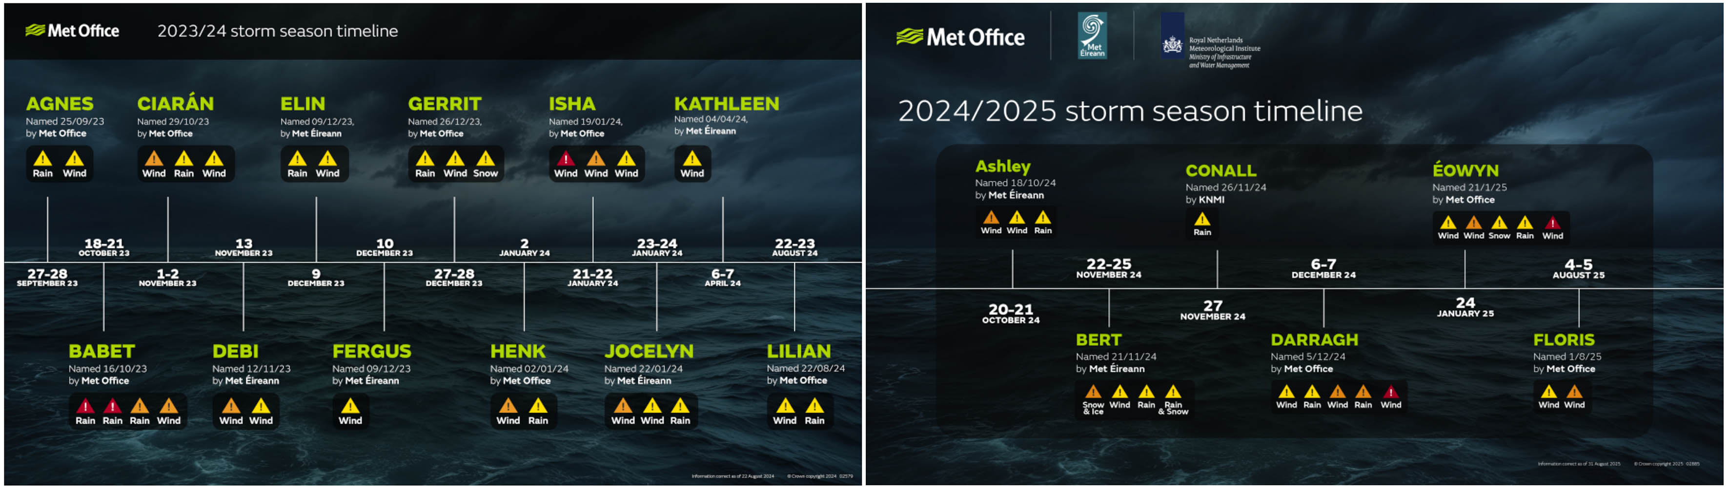

Specific climatic events to affect the LCCC area include (but not limited to):
- March 2013 – Spring blizzard
- December 2015 – Lough Neagh flooding and winter storms
- October 2017 – Hurricane Ophelia
- July 2018 – Hosepipe ban
- September 2020 – Flooding, storms Brendan, Ciara, Francis
- August 2021 – Flooding and also the hottest day on record
- November 2023 – Flooding of council assets
- October - December 2025 – Storms Amy, Claudio, Bram, flooding of council assets
- January 2026 – wettest January in 149 years, Storm Chandra
Additional to the known events that have occurred, the Met Office provides a high-level, non-technical summary of climate change projections for LCCC area. It provides projections of warmer wetter winters and warmer drier summers.
See Annex 2.

LCCC Climate Adaptation Action Plan

Definition of term: • Short term = up to 1 year • Medium term = 1 – 5 years • Longer term = 6+ years

 | FUNCTIONAL THEME 1:  Citizen engagement and leadership (Adaptation) | Performance Measure | Responsible Officer | Term | NICCAP3  Ref (where applicable):
1 | Establish a Sustainability Champions Group to review climate impacts and to report on the progress of this Adaptation Action Plan. | ﻿﻿﻿﻿Establishment of working Group.  Number of sustainability champions group meetings. | HoS Building Control & Sustainability | ﻿﻿﻿﻿Short | ST21  ST22
2 | Business Continuity Plans to be reviewed to identify and consider the impacts of current and future extreme weather events on all functions and services to increase climate resilience. | ﻿﻿﻿﻿﻿Annual review of service unit BCPs and/or after any extreme weather events. | All HoS and Emergency Planning Unit | ﻿﻿﻿﻿Short/  Medium | ST10  ST11
3 | Review and update Emergency Planning procedures to consider the effects, frequency and severity of climate events affecting the Council. Build partnerships with other Agencies – multi-agency approach. | ﻿﻿﻿﻿﻿Review emergency response plans and interdependency with other agencies. | HoS Env Health, Risk and Emergency Planning | ﻿﻿﻿﻿Short/  Medium | ST6  ST13
4 | Consider Climate Risk within Service Unit Risk Registers and Business Continuity Plans. | ﻿﻿﻿﻿﻿Establish the sustainability champions group to consider climate impacts as part of risk management. | ﻿HoS Building Control & Sustainability  HoS Env Health, Risk and Emergency Planning | ﻿﻿﻿﻿Short | ST11
5 | Community Resilience: Begin to engage with local community groups to build awareness of climate events including flood risk, to allow local groups, individuals and business to build independent resilience. Develop actions that allows communities to prepare for climate events that will build resilience and reduce the overall impact of Climate Change. | ﻿﻿﻿﻿﻿Establish engagement with groups.  Number of interactions with community groups to build and assist awareness. | ﻿﻿﻿HoS Env Health, Risk and Emergency Planning  HoS Communities | ﻿﻿﻿﻿﻿Short/  Medium | ST18

Page 10

6 | Be a conduit and signpost communities to relevant Departments, information and funding schemes, such as the Homeowner Flood Protection Scheme. | ﻿﻿﻿﻿Establish engagement with groups.  Number of interactions with community groups to build and assist awareness. | HoS Env Health, Risk and Emergency Planning  HoS Communities | ﻿﻿﻿﻿Short | ST25
7 | Make provision to capture the costs to council of weather events. Develop procedures to ensure that the financial aspects of extreme weather are collated and recorded. | ﻿﻿﻿﻿﻿Financial costs to be established and considered within ‘debrief’ reports after weather events, where available. | HoS Env Health, Risk and Emergency Planning.  HoS Finance | ﻿﻿﻿﻿Short/  Medium | ST12  ST25
8 | Provide up to date and tangible evidence to support adaptation planning. Collate key evidence such as flood risk maps, floodplains, rivers etc. Capture full impacts of extreme climate events in council area. | ﻿﻿﻿﻿Capture data and map extent of extreme weather events.  GI Layers created where possible. | HoS Env Health, Risk and Emergency Planning.  HoS Building Control & Sustainability | ﻿﻿﻿﻿Short/  Medium
9 | Develop adverse weather protocols and procedures that safeguard staff and service delivery. | ﻿﻿﻿﻿﻿ Protocols developing. | ﻿HOS HR & OD  HoS Env Health, Risk and Emergency Planning | ﻿﻿﻿﻿Short/  Medium

Page 11

 | FUNCTIONAL THEME 2:  Buildings and energy (Adaptation) | Performance Measure | Responsible Officer | Term | NICCAP3  Ref (where applicable):
1 | Develop as part of the Assets Strategy the implementation of protocols for building/ asset structural integrity assessments of critical infrastructure and buildings after extreme weather events. | ﻿﻿﻿﻿Protocols developed.  Number of condition surveys conducted after extreme weather events. | HoS Assets  HoS responsible for buildings/ assets under their control. | ﻿﻿﻿﻿Medium
2 | Review the risk of potential impacts of climate change on critical Council owned infrastructure, buildings and services.  - Identify critical infrastructure and develop plans to reduce the risk/impact from climate events.  - Consider climate events on critical infrastructure within Business Continuity Plans, analyse risk and implement plans to build resilience to climate risks.  - Consider development of plans to build resilience of critical infrastructure within Assets Strategies.  - Consider the maintenance and provision of backup power supplies.  Develop safe working protocols and adverse weather protocols for staff and contractors (Contingency Procedures, PPE, H&S etc.) | ﻿﻿﻿﻿Identify critical infrastructure.  Develop action plans as required, consider in BCP’s.  Consider the resilience of critical infrastructure in Assets Strategy.  Consider climate events within H&S procedures and safe working protocols. | HoS Assets  HoS responsible for buildings/ assets under their control.  HoS Env Health, Risk and Emergency Planning. | ﻿﻿﻿﻿ Medium
3 | Develop a Buildings Risk Register and Remedial Action Plan to be considered within the councils Asset Strategy, to include:  - A condition survey and risk assessment of council buildings and assets to identify potential hazards, impacts and risks of climate events.  - Development and implementation of a remedial action plan for building assets identified in the risk assessment  Consideration of the effects of precipitation and flooding and develop green infrastructure solutions to reduce runoff and stormwater surge. | ﻿﻿﻿﻿﻿Assets Strategy developed to:  identify risks  conduct condition surveys  conduct remedial actions as required.  Building custodians to consider the effects of precipitation. | HoS Assets  HoS responsible for buildings/ assets under their control. | ﻿﻿﻿﻿ Medium
4 | Consider Adaptation and climate impacts on all development and redevelopment projects considering assets at design, planning, construction and maintenance stages. (green infrastructure, biodiversity, water management, SuDS etc.) | ﻿﻿﻿﻿Number of considerations with projects such as Capital Plans, Minor Works etc. | ﻿HoS Assets  HoS Planning & Capital Dev.  HoS responsible for buildings/ assets. | ﻿﻿﻿﻿Medium | ST17
Page 12

 | FUNCTIONAL THEME 3:  Transport (Adaptation) | Performance Measure | Responsible Officer | Term | NICCAP3  Ref (where applicable):
1 | Risk Assessment of the potential impacts of climate on fleet activities. Develop procedures and protocols to consider impacts on operational delivery. | ﻿﻿﻿﻿Risk Assessment developed for climate impacts on fleet and operations | HoS Waste & Operational Services | ﻿﻿﻿﻿Medium

 | FUNCTIONAL THEME 4:  Economy (Adaptation) | Performance Measure | Responsible Officer | Term | NICCAP3  Ref (where applicable):
1 | Develop Tourism Strategy that considers and integrates Sustainability in its objectives. | ﻿﻿﻿﻿Development & Review of Strategy. | HoS Economic Development | ﻿﻿﻿﻿Short/  Medium
2 | Integrate climate change considerations in the planning and licensing of council events and consider contingency planning for extreme weather to protect public safety. | ﻿﻿﻿﻿Number of events that considered climate/ weather within the risk and development plans. | HoS Parks & Amenities  HoS Communities | ﻿﻿﻿﻿Short/  Medium
3 | The Local Development Plan and planning decisions to be based on and apply planning policies to reduce the vulnerability to the impacts of climate change. | Included within LDP and reviews as required. | HoS Planning & Capital Development | Short/  Medium | ST16
4 | Consider new developments are planned and built in consideration of future flood risk projections and raise awareness of climate resilient solutions at an early stage in the design process for new development in compliance with planning policy. | Included within LDP and reviews as required. | HoS Planning & Capital Development | Short/  Medium | ST15
5 | Develop a Sustainable Procurement Framework that considers Mitigation & Adaptation screening. | Development of procurement framework. | HoS Assets | Medium | ST19

Page 13

 | FUNCTIONAL THEME 5:  Waste and resource management (Adaptation) | Performance Measure | Responsible Officer | Term | NICCAP3  Ref (where applicable):
1 | Risk Assess the potential impacts of climate on Waste Management Activities. Consider impacts on operations, waste management and collection, waste collection/ disposal and facilities. | ﻿﻿﻿﻿Include risk in waste & op services risk register. | HoS Waste & Operational Services. | ﻿﻿﻿﻿Medium

 | FUNCTIONAL THEME 6:  Natural Environment (Adaptation) | Performance Measure | Responsible Officer | Term | NICCAP3  Ref (where applicable):
1 | Develop an awareness campaign and the role the natural environment plays as a positive contribution to Climate Adaptation. | ﻿﻿﻿﻿Number of awareness campaigns/ instances  Consider water extraction license at aquifer. | HoS Parks & Amenities  HoS Building Control & Sustainability  All HoS | ﻿﻿﻿﻿Short/  Medium
2 | As part of wider Capital Plans or Asset projects, explore Natural Flood Management Projects, SuDS and Green Infrastructure as part of proposals. | Number of projects that consider green infrastructure/ flood alleviation as part of wider development plan/ action. | HoS Assets  HoS Planning & Capital Development  HoS responsible for buildings/ assets under their control. | Medium
3 | Review and update the Tree and Woodland Management Strategy to include tree planting, tree health maintenance and woodland management to increase biodiversity and green canopy across the council area to enhance biodiversity, increase carbon storage and support ecosystems. | Development & Review of Current Strategy.  Number or increase in tree cover | HoS Parks & Amenities | Short/  Medium | NC93
4 | Develop an Invasive Species Management Plan and programme to monitor the spread of terrestrial and aquatic invasive species and control invasive species where required. | Development of Management Plan.  Instances of invasive species control. | HoS Parks & Amenities | Short/  Medium | NC6
Page 14

Monitoring and Reporting

The NI Adapts Planning Toolkit used to assist in the development of this Adaptation Plan, details Step 5 as Monitor, Review and Evaluate. This is the time to assess how it is working, to review the success of implementation and to review to ensure the goals are being met. It presents the opportunity to analyse new information and develop the next iteration of the plan.
This Adaptation Plan and its actions will be reviewed annually to assess progress on completed and ongoing actions, and to identify any new actions required.
The annual review of the Plan will be reported through the Councils governance process.
The Climate Adaptation Plan will be formally reviewed at the end of its 2025-2029 period and in compliance with reporting through the Climate Change (Reporting Bodies) Regulations (NI) 2024.

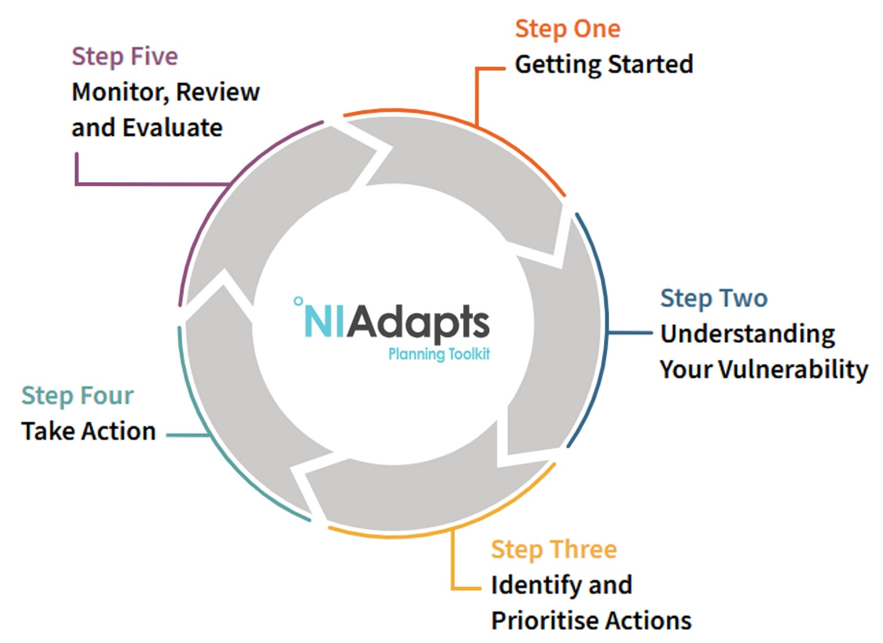

Page 15

Annex 1 – Climate Adaptation Risk Register

The Climate Risk Register has been developed after a series of workshops which were attended by key Council Officers.
The scoring Matrix and Risk Register have been developed using the NI Adapts Planning Toolkit.
Inherent Risk Score
The inherent risk score will tell you how high a priority each risk statement is:
Impact x Likelihood = Inherent Risk Score
The Impact (the level of damage caused by a climatic event or trend) ranges from very low to high.
The Likelihood is the probability of how often these risks will occur moving forward, and these range from very low to high.

Page 16

Climate Hazard: Flooding (increased precipitation and flood risk)
Projected Change: Wetter winters and potential of greater risk of localised, intense summer flooding when it does rain heavily |  |  |  |  |  |  | Link with Adaptation Plan
Risk Statement  (Impact and Consequence) | Relevant Internal Departments/  Service | Inherent Risk |  |  | Control Measures  (current & proposed policy and/or procedures) |  | Which adaptation plan actions are relevant to reduce each Risk?
Risk Statement  (Impact and Consequence) | Relevant Internal Departments/  Service | Likelihood | Impact | Risk Score
F1 – Increased frequency and intensity of rainfall resulting in flooding affecting council assets, functions and operations including buildings, pitches, cemeteries and events leading to financial losses including income and additional costs.  Points to consider: asset protection, buildings, cemeteries, pitches, financial implications, events / Safety Advisory Group, contingency plans, closing facilities. | All Departments with responsibility for assets, functions and events | 3 | 3 | 9 | - Adverse Weather Policies  - Draft Sandbag Protocol  - Contingency Plans  - Emergency Plan  - Event risk assessments/ SAG  - LDP  - Asset strategy and building risk analysis  - Pitches strategy |  | Theme 1 – 2, 3, 4, 5, 7, 9  Theme 2 – 1, 2, 3, 4  Theme 3 – 1  Theme 4 – 2, 3, 4,  Theme 5 – 1  Theme 6 – 1
F2 – Increased frequency and intensity of rainfall leading to localised flooding that degrades natural assets, planting, biodiversity and increased spread of invasive species.  Points to consider: areas of natural habitat, rivers/ banks, invasive species, seasonal working changes? | Parks & Amenities | 2 | 2 | 4 | - Invasive Species Management Plan  - Big Tree Project  - Creation of wetlands Protection |  | Theme 1 – 2, 4, 7, 8  Theme 2 – 2, 4  Theme 4 – 1  Theme 6 – 1, 2, 3, 4
F3- Increased frequency of flood events disrupting transport, energy, water and communication infrastructure, sewage issues and local communities requiring support.  Points to consider: community support, emergency plan, delivery of our functions i.e. waste collection, Business Continuity Plans. | Env Health, Risk & Emergency Planning | 3 | 2 | 6 | - Emergency volunteer list  - Emergency Plans  - EMT Structures (Multiagency)  - Business Continuity Plans & Risk Register  - Communication Plans |  | Theme 1 – 2, 3, 4, 5, 6, 7, 8  Theme 2 – 1,2  Theme 3 – 1  Theme 4 – 2, 4  Theme 5 – 1

Page 17

Climate Hazard: Storms (Increased Storms)
Projected Change: Increased frequency and intensity of extreme weather events |  |  |  |  |  |  | Link with Adaptation Plan
Risk Statement  (Impact and Consequence) | Relevant Internal Departments/  Service | Inherent Risk |  |  | Control Measures  (current & proposed policy and/or procedures) |  | Which adaptation plan actions are relevant to reduce each Risk?
Risk Statement  (Impact and Consequence) | Relevant Internal Departments/  Service | Likelihood | Impact | Risk Score
S1 – Increased frequency and intensity of storms resulting in damage to buildings and other council assets.  Points to consider: asset protection, buildings, cemeteries, pitches, financial implications, Business Continuity Plans, inspection. | Assets Parks & Amenities | 3 | 3 | 9 | - Preventative tree health surveys  - Regular inspection and maintenance of assets  - Weather alerts/monitoring and regional direction  - Closure or securing of parks / facilities  - Storm and weather protocols |  | Theme 1 – 2, 4, 7, 8, 9  Theme 2 – 1, 2, 3, 4  Theme 5 – 1
S2 – Increased frequency and intensity of storms damaging buildings and trees etc resulting in a risk to human health from falling debris.  Points to consider: condition of our own assets, emergency plan, Business Continuity Plans, community support. | Assets Parks & Amenities  Env Health,  Risk & Emergency Planning | 3 | 4 | 12 | - Preventative tree health surveys  - Regular inspection and maintenance of assets  - Weather alerts/monitoring and regional direction  - Closure or securing of parks / facilities  - Storm and weather protocols  - Risk assess – storms, council work activities & contractor management |  | Theme 1 – 1, 2, 3, 4, 5, 7, 9  Theme 2 – 1, 2, 3, 4  Theme 3 – 1  Theme 5 – 1
S3 – Increased frequency and intensity of storms leading to disruption of council services, cancellation of events, power failure and road closures affecting service delivery and creating financial impact.  Points to consider: waste, cemeteries, pitches, leisure facilities, financial implications, events / Safety Advisory Group, contingency plans, closing facilities. | All Departments with responsibility for assets, functions and events | 3 | 3 | 9 | - Weather alerts/monitoring and regional direction  - Closure or securing of parks / facilities  - Storm and weather protocols  - Risk assess – storms, council work activities & contractor management  - Back power supplies  - Business Continuity Plans (Critical services)  - Storm protocol  - Work from home protocols |  | Theme 1 – 2, 3, 4, 5, 7, 8, 9  Theme 2 – 2, 3  Theme 3 – 1  Theme 4 – 1, 2, 3, 5  Theme 5 – 1
S4 – Increased frequency and intensity of storms affecting local communities, business and the public requiring council support.  Points to consider: community support, mutual aid, emergency plan, Business Continuity Plans. | Communities  Env Health,  Risk & Emergency Planning | 3 | 3 | 9 | - Weather alerts/monitoring and regional direction  - Emergency Plan  - Support protocols & mutual aid (multi-agency) |  | Theme 1 – 1, 2, 3, 5, 6, 7, 8  Theme 2 – 2  Theme 3 – 1  Theme 4 – 2  Theme 5 – 1
Page 18

Climate Hazard: Heatwave (increased temperature/low rainfall)
Projected Change: Hotter, drier summers and warmer winters. |  |  |  |  |  |  | Link with Adaptation
Risk Statement  (Impact and Consequence) | Relevant Internal Departments/  Service | Inherent Risk |  |  | Control Measures  (current & proposed policy and/or procedures) |  | Which adaptation plan actions are relevant to reduce each Risk?
Risk Statement  (Impact and Consequence) | Relevant Internal Departments/  Service | Likelihood | Impact | Risk Score
H1 – Increased frequency of high temperatures causing drought, increased water demand, increased costs, water rationing and affecting green infrastructure, council facilities, parks, golf courses, outdoor facilities and increased risk of wildfires.  Points to consider: water supplies, building needs, cemeteries, pitches, parks, financial implications, events / Safety Advisory Group, contingency plans. | All Departments with responsibility for assets, facilities, functions and events | 3 | 3 | 9 | - Current borehole  - Communications  - Rainwater harvesting  - Developing procedures for pitches, golf courses and bedding plants to ensure continuity  - Business continuity plans |  | Theme 1 – 2, 3, 4, 7, 9  Theme 2 – 2  Theme 4 – 1, 2  Theme 5 – 1  Theme 6 – 3
H2 – Increased frequency of high temperatures impacting council assets, people/staff and business resulting in increased air conditioning use, reduced productivity, hydration requirement, sun protection, heat exhaustion and appropriate protection including PPE.  Points to consider: facility M&E needs, staff protection. | Assets  Waste & Operations  Parks & Amenities  Communities  Leisure | 3 | 3 | 9 | - Suitable staff PPE / sunscreen  - Risk assessments  - Regular communications  - Drinking water facilities  - Business continuity plans |  | Theme 1 – 2, 3, 4, 7, 9  Theme 2 – 2  Theme 3 – 1  Theme 5 – 1
H3 – Increased frequency of high temperatures impacting on species migration, growing season, invasive species, seasonal work, organic waste disposal and pest control.  Points to consider: biodiversity, species, growing & mowing seasons, waste disposal, pests. | Parks & Amenities  Leisure  Env Health, Risk & Emergency Planning | 2 | 2 | 4 | - Biodiversity Action Plan  - Invasive species management  - Business continuity plans |  | Theme 1 – 2, 4, 7, 9  Theme 2 – 4  Theme 6 – 1, 3, 4
H4 – Increased frequency of high temperatures causing significant increase of visitors to local outdoor spaces, events and council attractions with potential for anti-social behaviour, littering, ecosystem damage and strain on services.  Points to consider: facility capacities, service strain. | Parks & Amenities  Leisure  Communities | 2 | 2 | 4 | - Communications around water safety  - Consider Bye Laws as required  - Informational Signage  - Creating outdoor recreation events – Billy Neill / Glenmore.  - Increase litter bins  - Business continuity plans |  | Theme 1 – 3, 4, 7, 9  Theme 4 – 1, 2, 5  Theme 5 – 1
Page 19

Climate Hazard: Cold (Winter average temperature increase/cold snaps likely)
Projected Change: Despite overall trends towards increasing temperature, intense cold events will still happen so prepare for greater range of extremes |  |  |  |  |  |  | Link with Adaptation
Risk Statement  (Impact and Consequence) | Relevant Internal Departments/  Service | Inherent Risk |  |  | Control Measures  (current & proposed policy and/or procedures) |  | Which adaptation plan actions are relevant to reduce each Risk?
Risk Statement  (Impact and Consequence) | Relevant Internal Departments/  Service | Likelihood | Impact | Risk Score
C1 – Cold snaps or increased incidents of prolonged cold periods causing frozen pipes, damage to infrastructure, utility supply and assets or access to services.  Points to consider: utility supply to buildings, access to facilities, loss of finance, insurance costs, additional resources, water leaks at thaw, staff safety. | All Departments but particularly those with outside and asset responsibilities.  Assets | 3 | 3 | 9 | - Business continuity plans  - Hybrid working  - Adverse weather protocol  - Communications plan  - Emergency plan – prioritise service delivery |  | Theme 1 – 2, 3, 4, 7, 9  Theme 2 – 1, 2, 3  Theme 3 – 1  Theme 5 – 1
C2 - Cold snaps or increased incidents of prolonged cold periods resulting in disruption to service functions and delivery.  Points to consider: front line services, access to services, parks/ green spaces, staff travel to workplace, staff safety. | All Departments but particularly those with outside and asset responsibilities.  Waste & Op Services  Parks & Amenities  Leisure | 3 | 3 | 9 | - Business continuity plans  - Hybrid working  - Adverse weather protocol  - Communications plan  - Emergency plan – prioritise service delivery |  | Theme 1 – 2, 3, 4, 7, 9  Theme 2 – 2, 3, 4  Theme 3 – 1  Theme 4 – 5  Theme 5 – 1
C3 - Cold snaps or increased incidents of prolonged cold periods or snow events causing disruption to transport, energy, water and communications to local communities requiring council support.  Points to consider: emergency plan, community support, communications, staff travel, staff safety. | Communities  Env Health, Risk & Emergency Planning | 3 | 3 | 9 | - Business continuity plans  - Hybrid working  - Adverse weather protocol  - Communications plan  - Emergency plan  - Community resilience groups  - Ice and snow clearance in agreement with the DFI |  | Theme 1 – 2, 3, 4, 5, 6, 7, 9  Theme 2 – 1  Theme 3 – 1  Theme 5 – 1

Page 20

Annex 2 – Met Office: Climate Report for Lisburn & Castlereagh
Page 21

Page 22

Page 23

Page 24

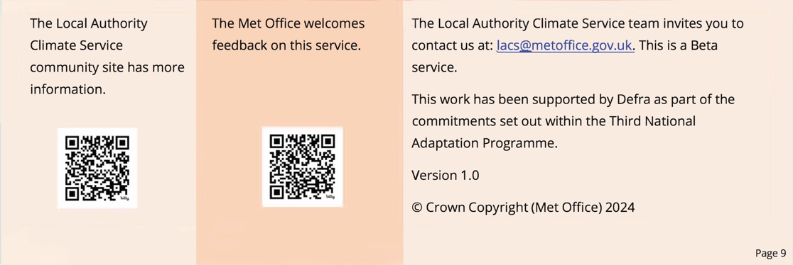

Page 25

