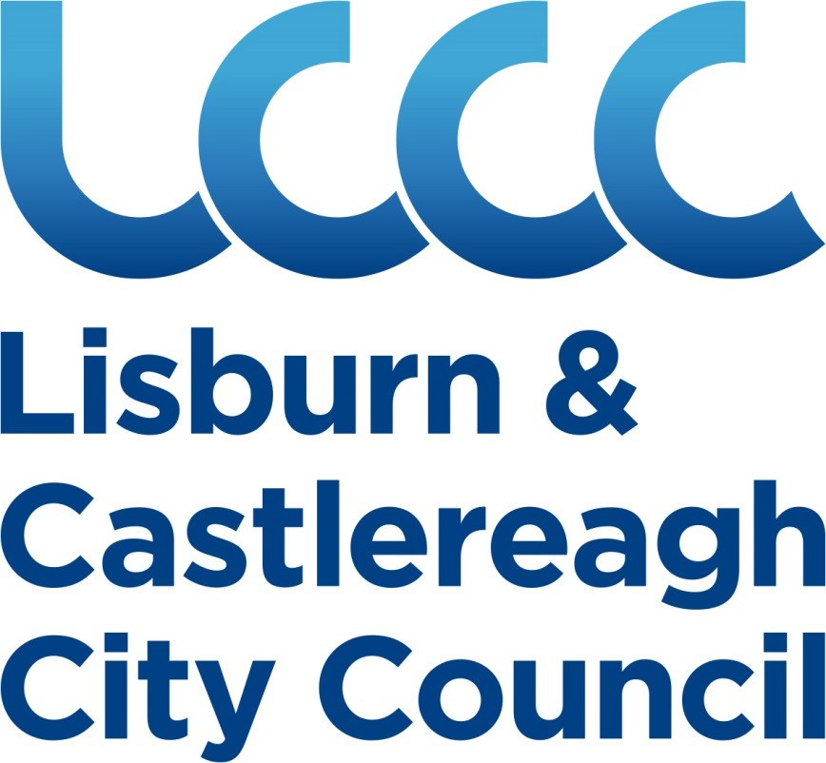

**LISBURN & CASTLEREAGH CITY COUNCIL ENFORCEMENT AND REGULATION POLICY**

**June 2020**

|  |  |  |
| --- | --- | --- |
|  | **INDEX** |  |
| **Section One**  Introduction |  | Page 3 |
| **Section Two**  Scope of the Policy |  | Page 4-5 |
| **Section Three**  Principles of Enforcement |  | Pages 6-7 |
| **Section Four**  Arrangements for Enforcement |  | Page 8 |
| **Section Five**  Types of Enforcement Action |  | Pages 9-11 |
| **Section Six**  Prosecution |  | Pages 12-13 |
| **Section Seven**  General Provisions |  | Page 14 |

**Section One**

**Introduction**

The purpose of this Policy is to secure an efficient and effective approach to all regulatory and enforcement activities carried out by Lisburn & Castlereagh City Council.

The Policy is consistent with the principles set out in the Government’s Better Regulation agenda which is intended to improve compliance with legislation while minimising the burden on businesses, individuals, organisations and the Council.

In preparing this Policy, the Council has considered the Regulator’s Code and the “Statement of Intent” between the Better Regulation Delivery Office, the Department for the Economy and district councils.

The Council supports the Government’s Making Life Simpler: Improving Business Regulation in NI and believes that effective and well targeted enforcement is essential in ensuring public protection, promoting fairness and encouraging economic progress. It also helps the Council to achieve its vision of taking a leading role in improving quality of life now and for future generations for the people of Lisburn & Castlereagh City Council by making the city a better place to live in, work in, invest in and visit.

Through this Policy the Council will adopt a positive and proactive approach towards ensuring compliance by:

* helping and encouraging those it regulates to fully understand and fulfil their legal responsibilities more easily, and;
* responding proportionately to non-compliance to avoid imposing unnecessary costs while taking firm action against those who flout the law.

Through the implementation of this Policy the Council wants to achieve the following objectives:

* Creating a safe and healthy District Council area;
* Protecting the public;
* Fulfilling our statutory duties;
* Ensuring the safety of Lisburn & Castlereagh City Council staff;
* Ensuring better care for District Council’s environment;
* Encouraging economic growth through fair and effective regulation.

# Section Two

**Scope of the Policy**

Lisburn & Castlereagh City Council has statutory responsibility for enforcement of a wide and diverse range of legislation (including local bye-laws). These regulate areas such as:

* + Antisocial behaviour;
  + Building Control;
  + Litter and household waste;
  + Environmental Health;
  + Licensing (including Entertainment and Street Trading);
  + Parks, playing fields and open spaces;
  + Planning and Development.

This Policy also anticipates that there will be legislation enacted in the future for which the Council shall become the enforcement authority.

This Policy is written as a guide for officers, businesses and the general public, outlining the general principles as to how the Council will carry out our enforcement duties.

It applies to all the Council’s dealings, whether formal or informal, with businesses or members of the public and may be supported by specific enforcement guidelines, procedures and documentation to help officers make enforcement decisions.

When applying this Policy the Council recognises its duty to act in accordance with its statutory responsibilities including:

* + The Human Rights Act 1998;
  + Regulation of Investigatory Powers Act 2000 (Amendment) Order (Northern Ireland) 2002
  + The Criminal Procedure and Investigations Act 1996;
  + The Police and Criminal Evidence (NI) Order 1989 (as amended);
  + The General Data Protection Regulation and;
  + All associated Codes of Practice.

In certain circumstances, the Council may derogate from such statutory responsibilities to the extent that this is permitted by law and is proportionate. A breach of the statutory responsibilities referred to above will not necessarily result in a decision to take enforcement action or prosecute.

Lisburn & Castlereagh City Council is committed to fulfilling its responsibilities under Section 75 of the Northern Ireland Act 1998. Therefore any decision regarding enforcement will be impartial and shall not be influenced by the religious beliefs, political opinion, racial group, age, gender, marital status or sexual orientation of any alleged offender, complainant or witness.

The Lisburn & Castlereagh City Council will take into account the views of any victim, injured party or relevant person to establish the nature and extent of any harm or loss, and its significance, in making the decision to take formal action. This may include actual harm or loss or the impact on the wellbeing of the individual or potential or actual harm to the environment.

The implementation and effectiveness of this Policy will be monitored through the Council’s existing performance management processes.

# Section Three

**Principles of Enforcement**

The Council believes in effective but fair regulation and has adopted the principles of the Enforcement Concordat. The Council also supports the Government’s Better Regulation Agenda and recognises that its regulatory activities should be proportionate, accountable, consistent, transparent and targeted to situations that need action.

# Standards

This Policy sets out the clear standards of service that the public and businesses can expect to receive from the Council. Where appropriate the Council may publish other information relating to the implementation of this Policy.

# Consistent

The Council will aim to be consistent in its response to all incidents and complaints, in the advice officers give and in using its enforcement powers, including when deciding whether to prosecute. Where appropriate, it will liaise with other enforcement bodies and organisations, including the Better Regulation Delivery Office, to ensure that its activities are consistent with other enforcers regionally and nationally.

However, the Council recognises that consistency is not a simple matter of uniformity and officers must be able to exercise professional judgement in individual cases.

Whilst the Council try to achieve consistency internally and with other enforcing authorities, it alone will determine whether a prosecution or other enforcement action is appropriate having considered the circumstances of the case and any prevailing legal requirements.

# Proportionate

In relation to enforcement actions, proportionate means that where a person or business has failed to comply with a statutory requirement, the Council will take into account the risk posed by the failure and the cost which would be incurred in securing compliance with the law.

Where possible, the Council will minimise the costs of compliance by ensuring that any action it requires is proportionate to the risk detected.

It will take into account the circumstances of each case including:

* + risk to the public or the environment,
  + seriousness and consequences of the breach,
  + attitude and actions of the offenders, and
  + history of any previous incidents or breaches of the law.

# Transparent and open

The Council will be transparent and open in all its activities.

Transparency means helping people to understand what the Council expect of them and what they should expect from us. It also means explaining the reasons why the Council intend to, or have taken, enforcement action.

The Council will provide clear information and guidance on general compliance issues, individual compliance failures or any difficulties an individual may experience when trying to comply with the law. However the onus remains on individuals, businesses and organisations to ensure that they comply with their legal obligations.

# Targeted

The Council shall ensure that regulatory efforts are directed primarily towards those whose activities pose or potentially pose the most serious risks to public safety, public health or the environment. No inspection will take place without a reason and by prioritising effort and resource the Council can make sure it inspects the greater risk areas more frequently.

When the Council takes enforcement action it may take account of any national, regional or local priorities that exist at that time.

# Accountable

As a Regulator, the Council will be accountable to the public for its actions. If someone is dissatisfied with the level of service provided, the Council welcomes comments through the Customer Care procedure.

# Helpfulness

Prevention is better than cure and businesses and individuals are encouraged to contact the Council if they need any help. Advice and support will be given to help people understand and comply with their legal obligations. The Council will also promote and encourage good practice.

Officers will be helpful and courteous and will provide a contact point and telephone number for any further dealings.

The Council may raise awareness of statutory requirements and promote compliance through a range of methods including the provision of compliance tools, direct contact with staff, education programmes, publicity campaigns and online guidance through our website.

# Section Four

**Arrangements for Enforcement**

The Council shall make adequate arrangements to provide effective enforcement services by ensuring that:

* + sufficient numbers of enforcement officers are employed who are adequately qualified, trained, experienced and competent to carry out their duties.
  + all enforcement actions are taken by officers who have been specifically authorised in accordance with the relevant legislation and the Council’s Scheme of Delegated Authority.
  + all investigations are carried out in compliance with the Police and Criminal Evidence (Northern Ireland) Order 1989 (as amended), and relevant codes of practice.

Where necessary, specific enforcement guidelines, procedures and documentation have been and will continue to be developed to support officers making enforcement decisions and to ensure compliance with all relevant statutory codes of practice and official guidelines**.** Such documentation has and shall be developed in line with the principles of enforcement set out in Section 3 of this Policy.

The Council will, where appropriate, work with other public bodies, individuals and organisations to deliver effective enforcement in line with this Policy.

Where the Council and another law enforcement body both have the power to investigate and/or prosecute, the Council will liaise with that other body to make sure that any action taken is co-ordinated so as to ensure that the most effective result is obtained.

# Section Five

**Types of Enforcement Actions**

Having regard to the Regulators Compliance Code where offences are observed, the actions and sanctions taken by officers should aim to:

* secure compliance;
* change the behaviour of the offender;
* be responsive and consider what is appropriate for the particular offender and issue;
* be proportionate;
* restore any harm caused;
* deter further non-compliance.

Where an offence has occurred the Council expects that providing advice or guidance will be all that is required in the majority of cases. However, where such methods have been, or are likely to be, unsuccessful or where the breach is of a serious nature then formal enforcement action will be taken.

In addition, formal enforcement action may be taken where offences are not serious in isolation but are likely to have a cumulative effect.

There are a wide range of actions available to Lisburn & Castlereagh City Council in dealing with offences. The table below describes the main types of actions available.

In determining the most appropriate action to take, officers will consider the circumstances of the incident and this policy.

|  |  |  |
| --- | --- | --- |
| **Action Available** | **Explanation** | **Circumstances** |
| Informal Advice | Verbal or written advice identifying non-compliance and remedial measures. No follow-up action. | Where the offence is minor and the risk from non- compliance is low. |
| Informal Warnings | Verbal or written warning requiring remedial measures within a defined period of time. Will be followed up to ensure compliance. | Where non-compliance is not posing a serious risk and it is expected, from what is known of the offender, that informal action will achieve compliance. |
| Enforcement Letters | Warning that a recurrence or continuation of an infringement will result in legal action or service of a Statutory Notice. | Where non-compliance is not posing a serious risk and it is expected that the offender will achieve compliance, however, the offence itself is significant, recurring or longstanding. |

|  |  |  |
| --- | --- | --- |
| **Action Available** | **Explanation** | **Circumstances** |
| Statutory Notices | Where available under specific legislation, usually requires persons to take action or prohibits certain activities. Service of a Notice does not preclude prosecution. Failure to comply is often an offence and prosecution will normally follow. Some Notices require emergency action. | Offences are significant or consequences of continued non-compliance could be serious. |
| Fixed Penalty Notices | Some legislation allows the Council to issue Fixed Penalty notices where the offender is offered the opportunity to pay the fine and avoid prosecution. | May only be offered where expressly allowed by Statute. Should only be used in cases in which there is no previous history and in which the offence did not give rise to serious consequences. |
| Caution | A special form of warning where the offender admits the offence but prosecution is not considered appropriate. The Caution must be accepted by the offender and may be brought to the Court’s attention if convicted of a subsequent offence. | Must be applied in accordance with Home Office Guidance and may only be used where a prosecution could be properly brought and where the offender admits the offence. Should not be used for offences of a serious nature. |
| Revocation, Suspension or Variation of Permits, Approvals and Licences. | Revoking or suspending a Licence, Approval or Permit is a serious decision that will normally only be taken by Councillors, as opposed to Officers, in line with the Council’s Scheme of Delegation. | A Licence, Permit or Approval may be revoked or suspended if any condition attached to the Licence is breached or where an activity presents a serious risk. |
| Works in default | Some legislation allows the Council to carry out works in default and to recover the costs. | Usually where urgent action is required to protect public health, public safety or the environment. The Council will normally seek to recover such costs where appropriate. |

|  |  |  |
| --- | --- | --- |
| **Action Available** | **Explanation** | **Circumstances** |
| Injunctive Proceedings | May be sought to require a party to either do a specific act or to refrain from doing a specific act or acts. | This will be considered in instances where the use of other enforcement powers would not be a sufficient remedy. For example, where a person repeatedly fails to comply with the law or where there is an imminent risk to public health or public safety. |
| Antisocial Behaviour Order (ASBO) | The Council can apply to the Magistrates’ Court for an Antisocial Behaviour Order (ASBO) which will prohibit a person from acting in an antisocial manner or from carrying out an act which contributes to antisocial behavior. | Where there has been persistent, relatively low level offending or more serious matters that cause harassment, alarm or distress to others. An Order is necessary to protect people from that type of behaviour in the future. |
|  |  | An ASBO may be sought upon conviction but may also be sought where a person has not been convicted, or even charged, with an offence, provided there is sufficient evidence that an ASBO is necessary. |

# Appeals

If a person wants to appeal against any enforcement action taken, it is recommended that legal advice should be sought. However, the following information will be made available by the Council;

1. Officers will advise persons against whom any enforcement action has been taken of their right to make representation to the Officer's Manager.
2. If the Council serve a Notice and the legislation used has a statutory appeal provision, details of that Right of Appeal and how it should be lodged will be served upon the recipient at the same time as the Notice.

# Section Six

**Prosecution**

The Council recognises that prosecution is a serious matter and should only be taken after full consideration of the evidence, implications and consequences. It is however an important part of any enforcement system and acts as a punishment, a deterrent to others and as a means of avoiding a recurrence.

While the Council will take a graduated approach to enforcement, when circumstances warrant it, prosecution without prior warning or recourse to alternative sanctions will be pursued.

The majority of prosecutions undertaken by the Council are issued in the Magistrates’ Court. However, some statutory provisions allow the Council to issue proceedings in the Crown Court.

Consideration shall be given to issuing Crown Court proceedings where the gravity of the offence would warrant such a course of action. This includes incidents where:

* serious injury has been sustained or there are other serious consequences of the offence,
* there has been a blatant disregard for the law,
* there is a history of previous convictions, or
* the powers of the Magistrates Court to deal with the offence are inadequate.

All decisions to prosecute will take account of The Public Prosecution Service Code for Prosecutors. Therefore the Council shall consider the following before commencing a prosecution:

* firstly, whether it is satisfied there is sufficient admissible and relevant evidence that an offence has been committed and that there is a reasonable prospect of conviction.
* secondly, if there is sufficient evidence, then whether it is in the public interest to prosecute. This usually depends on the seriousness of the offence and the circumstances of the offender and whether, through the conviction of the offender, others may be deterred from similar failures to comply with the law.

When there is sufficient evidence the Council will normally prosecute unless the public interest factors against prosecution clearly outweigh those in favour of prosecution.

Without prejudice to the generality of the above, the Council will normally prosecute in any of the following circumstances:

* the breaches have serious consequences for public safety ,the environment or animal welfare
* failure to comply with a Statutory Notice or respond to a request to take remedial action;
* failure to pay a fine after receiving a Fixed Penalty Notice;
* the alleged offence is fraudulent, intentional, negligent or persistent,;
* obstruction of Council staff in carrying out their statutory duties.

A full copy of the Code for Prosecutors is available from Public Prosecution Service. Their address is Belfast Chambers, 93 Chichester Street, Belfast, BT1 3JR. The Code is also available on the Public Prosecution Service website (http://www.ppsni.gov.uk) or from the Council on request.

# Minors and Vulnerable Adults

The rights and welfare of the child will always be of paramount importance when considering any course of action. This approach reflects the paramountcy principle enshrined in the Children (NI) Order 1995.Where an offence, has been committed by a person under the age of eighteen or a vulnerable person the taking of formal enforcement action shall only be undertaken in exceptional circumstances, namely:-

* The offender has committed similar previous offences.
* The offender acts in an abusive, aggressive and/or obstructive manner when approached by an officer of the council.
* Such a decision will only be taken by the relevant Director in consultation with the Council’s legal representative.

Where a person under eighteen or a vulnerable person is believed to have committed an offence under the relevant legislation enforced by the council but formal enforcement action is not to be taken then the following steps shall be employed, where possible -formally write to the young person or vulnerable person outlining details of their actions, that an offence appears to have been committed and that further offences committed may result in action including, depending on the seriousness of the offence, the following:

* Formal written warnings/caution
* Acceptable Behaviour contracts
* Anti-social Behaviour Orders
* Fixed Penalty Notice
* Prosecution

or a combination of two or more of the above the Council will write to the young person’s parents or guardians outlining details of the officer’s contact with the young person and providing a copy of any correspondence sent to that young person in relation to the matter. An officer when approaching a person but in particular when approaching a juvenile or vulnerable person shall have regard to Lisburn & Castlereagh City Council’s Child and Adult Safeguarding Policy and procedures.

# Section Seven

**General Provisions**

This Policy, together with relevant Enforcement Guidelines, will be made freely available to all members of the public on request and will be posted on the Council’s website: <http://www.lisburncastlereagh.gov.uk/>

This Policy will be reviewed every two years or as necessary to ensure that it satisfies legal requirements and our customers’ expectations of the service.

The Council welcomes comments on this Policy and on how it can improve the services it provides.

Comments can be made to:

# Chief Executive

**Lisburn & Castlereagh City Council FREEPOST**

**RTST-LJKZ-JRXY**

**BT27 4RL**

**Complaints**

If a person is unhappy with the level of service they have received and wishes to make a formal complaint, the Council has a formal complaint’s procedure.

Further information on how to make a complaint is available on the Council website [(**customercare@lisburncastlereagh.gov.uk**](mailto:(customercare@lisburncastlereagh.gov.uk%20) ) or by telephoning **Tel: 028 9250 9559**

Responsible Department: Environmental Services Department Responsible Service Unit: Environmental Health Service Unit Policy Owner: Richard W Harvey

Date Ratified: TBC

Minute Reference: TBC

Implementation Date: TBC

Review Date: February 2022