**Lisburn & Castlereagh City Council Sustainability Strategy 2025 – 2029**

**Introduction**

Climate change, and its impact on the world we live in, is one of the most significant issues that we all face today. The effects of global warming are well-publicised, with local communities being impacted by weather extremes, resulting in heat stress, flooding, drought, increasing wildfires and freezing conditions. Expert evidence suggests that extreme weather events are going to happen more frequently in the future unless we take steps to address the underlying issues.

We all must act now to play our part to protect our environment for future generations.

In response to the overwhelming scientific evidence and the increased frequency and severe weather events of a changing climate as the consequence of a warming planet, Lisburn & Castlereagh City Council passed a Notice of Motion declaring a Climate Emergency in 2021.

As a result, this council resolved to establish and agree a Sustainability Strategy and Climate Action Plan that sets out our vision for a sustainable and resilient future with practical steps needed to minimise and mitigate against the impacts of climate change.

We therefore present the Lisburn & Castlereagh City Council Sustainability Strategy and Climate Action Plan. The development and delivery of which is cross-departmental and collaborative in its approach both internally and with wider central government to coordinate the shared drive to net zero.

The time for climate action is now and Lisburn & Castlereagh City Council is committed to achieving the goals set out within this strategy.

**Contents**

1. **Executive Summary** Page **3**

2. **Targeted Action Areas** Page **4**

3. **Council Area Profile**  Page **5**

4. **Vision, Key Goals and Targets** Page **5**

5. **What is Climate Change**  Page **7**

6. **Impacts of Climate Change on LCCC** Page **9**

7. **Strategic Context & Legal Requirements** Page **10**

8. **United Nations Sustainable Development Goals** Page **12**

9. **NI Climate Change Targets & Emissions**  Page **13**

10. **Council Emissions** Page **17**

11. **What Are We Doing & What Will We Do** Page **21**

12. **LCCC Climate Action Plan** Page **23**

13. **Monitoring & Evaluation** Page **24**

14. **Glossary**  Page **25**

Page **03**

**Executive Summary**

This Sustainability Strategy and Climate Action Plan has been developed to outline Lisburn & Castlereagh City Council’s (LCCC) response to the Climate Emergency and intends to:

* Create an evidence base, identifying how our climate is changing and the challenges and opportunities that we face using expert scientific information including the Climate Change Committee (CCC) progress reports1
* Outline our goals and ambitions for mitigating Climate Change within the organisation
* Meet the requirements of the Climate Change Act (Northern Ireland) 2022 and
* The Climate Change (Reporting Bodies) Regulations (NI) 2024,
* Develop a high-level Climate Action Plan, setting out the critical actions needed to deliver our goals, enabling us to mitigate against the impact of climate change, adapt and thrive.

The focus of the strategy is built around 6 key action areas with an overall goal to embed sustainability and climate action into council decisions and operations. The Strategy and Action Plan will focus on the functions and operations within the remit of the council with an ambition to reduce the council’s climate impact.

LCCC has reviewed and prioritised current and future known climate impacts considering local and UK Government policy and legislative implications and identified a series of actions needed to minimise emissions and build resilience within each area of work.

Globally and locally, carbon emissions must be cut consistently year on year to halt global warming.

By working together, we can make significant progress in delivering our goals for a brighter, cleaner, environment friendly future.

This Lisburn & Castlereagh City Council Sustainability Strategy and Climate Action Plan is the beginning of our journey towards that future. It is a living document and will evolve and develop as the Plan is delivered.

1 https://www.theccc.org.uk/publications/

**Targeted Action Areas**

Lisburn & Castlereagh Council (LCCC) has identified 6 internal action areas to target through its Sustainability Strategy and Climate Action Plan. The purpose of which is to understand our current position and to target the reduction of our climate impact.

They are:

1. **Citizen engagement & leadership**

How we engage and communicate with our citizens to promote and encourage a more sustainable way of living and working, leading by example as a sustainable organisation.

1. **Buildings and energy**

The energy we currently use within our estate and functions, the emissions produced from our facilities and the types of energy we will use in the future.

1. **Transport**

The way we travel and the means we choose to make these journeys for business purposes and to deliver the operational functions of the council.

1. **Economy**

Our local economy, supply chains and supporting businesses.

1. **Waste and resource management**

The way we manage our waste and resources from council facilities and operations.

1. **Natural environment**

How we protect our natural environment and use it to reduce the impacts of climate change.

**Council area profile**

Lisburn & Castlereagh City Council area stretches from the shores of Lough Neagh in the west to the hills above Dundonald in the east and from the Belfast Hills in the north to the Dromara Hills in the south. The area is characterised by the strong urban cores such as Lisburn and Dundonald with a diverse and rich rural hinterland of scenic landscapes and villages rich in heritage. Our council area is one of the fastest growing areas within NI.

**Key statistics:**

* 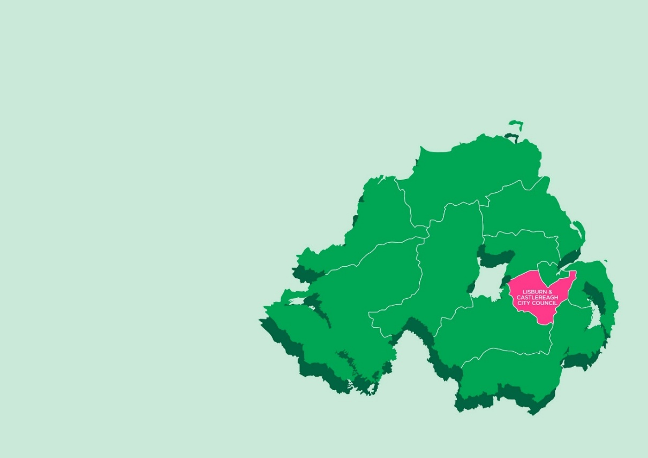an area of 504 km2 (195 m2)
* a population of more than 149,915

(9.8% increase since 2012) and more than

60,000 households

(12% increase since 2011)

* 20% of our population are aged

0-15 years old

* 40 Primary, 9 Post Primary and

5 Special Schools

* 3 Hospitals
* tourism offerings including Royal

Hillsborough

* home to the Eikon Exhibition Centre
* around 5,000 active businesses in 2022
* business make up of 66% in services, 8% in construction, 12% in agriculture and 14% production / manufacturing
* the lowest rate of unemployment in NI

*Statistics taken from LCCC Performance Improvement Plan 2025/26

**Our vision for sustainability in Lisburn & Castlereagh City Council**

A civic and inclusive leadership style working to embed and safeguard future social, economic, and environmental sustainability.

**Our goal for Lisburn & Castlereagh City Council**

**Lisburn & Castlereagh City Council’s goal is to become a net zero, resilient council by 2050.**

LCCC will achieve this goal by:

* reducing energy consumption across council facilities
* exploring and progressing viable renewably generated energy sources
* training all staff and Elected Members in climate awareness
* becoming a civic leader by promoting sustainability and climate action
* protecting and enhancing native biodiversity
* promoting environmental protection
* developing a council policy to give sustainability direction to council services and functions
* developing and delivering a Climate Action Plan
* developing and delivering a Climate Adaptation Plan.

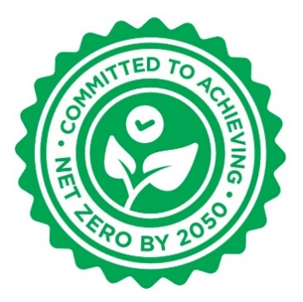LCCC is committed to playing its part in a just transition to achieving Net Zero by 2050 and central government interim targets related to:

* greenhouse gas emission reduction targets for

2030, 2040 and 2050 as set by DAERA

* collaboration with central government ‘Sectoral Plans’

and ‘Carbon Budgets’ as set by DAERA

* reporting local authority progress to DAERA

in compliance with the Climate Change (Reporting Bodies)

Regulations (NI) 2024.

**What is climate change?**

Climate change is the long-term shift in average weather patterns across the world. Since the mid-1800s, humans have contributed to the release of carbon dioxide and other greenhouse gases into the air causing global temperatures to rise, resulting in long-term changes to the climate.

Over the last decade, the world was on average around 1.2°C warmer than during the late 19th Century with recent global temperatures exceeding a 1.5°C rise (driven by human-caused climate change and boosted by the natural El Nino weather phenomenon) and 2023 being declared the hottest on record.



**Human impact on climate change?**

Whilst natural factors have influenced climate change across the Earth's history, natural causes cannot explain the particularly rapid warming seen in the last century. According to the UN's climate body, the IPCC this is mainly from the widespread use of fossil fuels, such as coal, oil and gas in homes, factories and transport2.

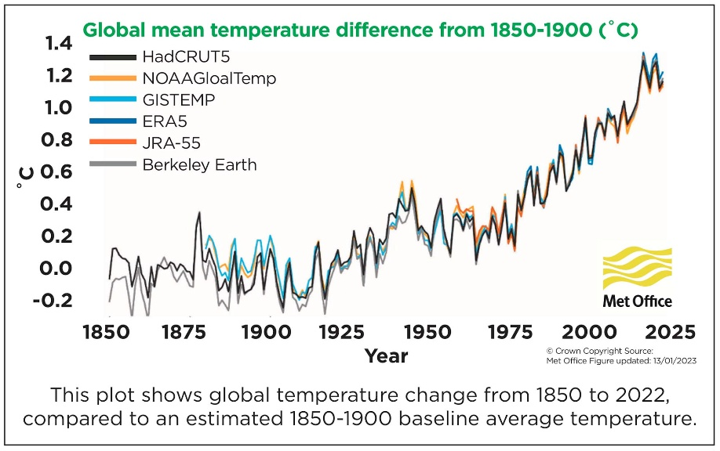

When fossil fuels burn, they release greenhouse gases, mostly carbon dioxide (CO2). This traps extra energy in the atmosphere near the Earth's surface, causing the planet to heat up.

﻿2 With this link: https://www.ipcc.ch/report/ar6/wg1/resources/climate-change-in-data/

**What are the effects of climate change so far?**

The global average temperature increase of 1.2°C in the past decade has resulted in:

* more frequent and intense extreme weather, such as heatwaves and heavy rainfall
* rapid melting of glaciers and ice sheets, contributing to sea-level rise
* huge declines in Arctic sea-ice
* ocean warming.

**Can there be further impacts?**

According to the IPCC limiting long-term average global temperatures to a 1.5°C rise is crucial. Any rise above this temperature will be the ‘tipping point’ where irreversible damage is likely to occur.

**What are governments doing about climate change?**

In a landmark agreement signed in Paris in 2015, almost 200 countries pledged to try to keep global warming to 1.5°C.

To achieve this, net zero CO2 emissions should be reached by 2050. Net zero means reducing greenhouse gas emissions as much as possible and removing any remaining emissions from the atmosphere.

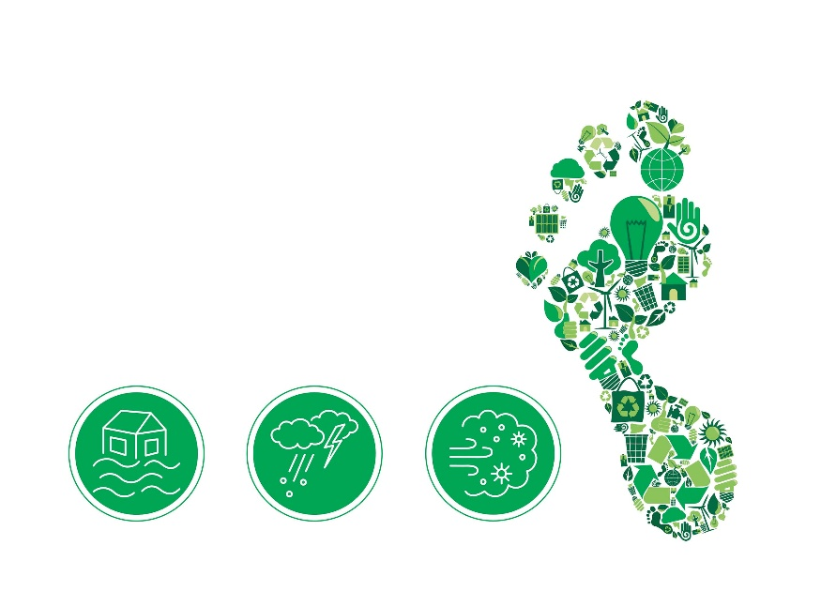However, greenhouse gas levels are still rising quickly, and the world is 'likely' to warm beyond 1.5°C, according to the IPCC.

**Impacts and Risks of Climate Change on LCCC**

The predicted climate change impacts on LCCC, based on UK and Northern Ireland information, forecast an increase in annual temperatures. Projections anticipate increased heavy summer rainfall events and wetter winters. Extreme weather events are predicted to become more frequent and intense, including flash flooding3.

3 https://www.metoffice.gov.uk/weather/climate-change/effects-of-climate-change

**Climate Change Risks**

The Met Office report ‘UK Climate Projections Headline Findings, August 2022’4, estimates that in a high emission scenario5 by 2070 Northern Ireland could see: If the climate changes as projected, there will be impact risks on all sectors of the LCCC area.

This may include flash flooding affecting buildings and land, and river flooding, impacting on farming crops, food supply and biodiversity. These associated risks for the council will be captured in the LCCC Climate Adaptation Plan.

* 38% drier to 3% wetter summers
* 0.8°C to 4.9°C warmer summers
* 2% drier to 25% wetter winters
* 0.6°C to 3.9°C warmer winters

4 (https://www.metoffice.gov.uk/binaries/content/assets/metofficegovuk/pdf/research/ukcp/ukcp18-infographic-headline-findings-land.pdf) estimates

5 Emissions scenario refers to the Representative Concentration Pathways (RCPs) used in climate models to describe possible futures based on assumptions about greenhouse gas emissions. In RCP2.6 global emissions are strongly mitigated and reduced and global temperature rise is kept below 2°C (low emissions scenario). In RCP8.5 global emissions grow unmitigated and global temperature rise exceeds 4°C (high emissions scenario).

**Strategic context and legal requirements**

In 2021, LCCC passed a Notice of Motion declaring a Climate Emergency. Since then, the council has committed to reducing its impact on the effects of climate change and has committed to developing a Sustainability Strategy and Climate Action Plan.

This position has developed and been directed by the relevant legislative frameworks:

**2006:**

* NI (Miscellaneous Provisions) Act 2006, Section 25 - states that ’A public authority must, in exercising its functions, act in the way it considers best calculated to contribute to the achievement of sustainable development in Northern Ireland’.
* NI Sustainable Development Strategy - presented the first steps towards tackling sustainable development challenges and aimed to achieve a better balance between social, environmental and economic progress.

**2008:**

* UK Climate Change Act (Amended 2019) - Established targets for the UK to achieve net zero emissions by 2050.

**2014:**

* The Local Government Act (Northern Ireland) 2014 – Section 84 Councils must make arrangements to secure continuous improvement in the exercise of their functions and must have regard in particular to the need to improve the exercise of its functions in terms of sustainability.
* Paris Climate Agreement - agreed to limit the increase of the global average temperature to 1.5°C above pre-industrial levels. NI Climate Change Adaptation Programme (NICCAP) 2014-19.

**2015:**

* UN Sustainable Development Goals (2015).
* NI Climate Adaptation Programme (NICCAP2) 2019 - 24.

**2020:**

* NI Declares a Climate Emergency through a Notice of Motion carried by the Northern Ireland Assembly.

**2021:**

* Draft Green Growth Strategy for NI - The Executive long-term vision and framework for tackling the climate crisis, balancing our climate, environment and economy.
* LCCC declared a Climate Emergency with a Notice of Motion carried by Full Council.

**2022:**

* NI Climate Change Act 2022 - sets a target of an at least 100% reduction in net zero greenhouse gas (GHG) emissions by 2050 for Northern Ireland compared to the 1990 baseline.
* Draft Environment Strategy for NI - sets out six strategic environmental outcomes as a guide to how we can preserve, protect and improve our environment.

**2023:**

* Draft Circular Economy Strategy - sets the DfE vision to create an innovative, inclusive and competitive economy, with responsible production and consumption at its core.

**2024:**

* The Climate Change (Reporting Bodies) Regulations (Northern Ireland) 2024 sets dates for Mitigation and Adaptation Report submission and Public Body Reporting.
* The Climate Change (Carbon Budgets 23-27) Regulations (Northern Ireland) 2024.

**2025:**

* Draft NI Climate Change Adaption programme

2024–29 (NICCAP3).

* Draft NI Climate Action Plan 2023-2027.

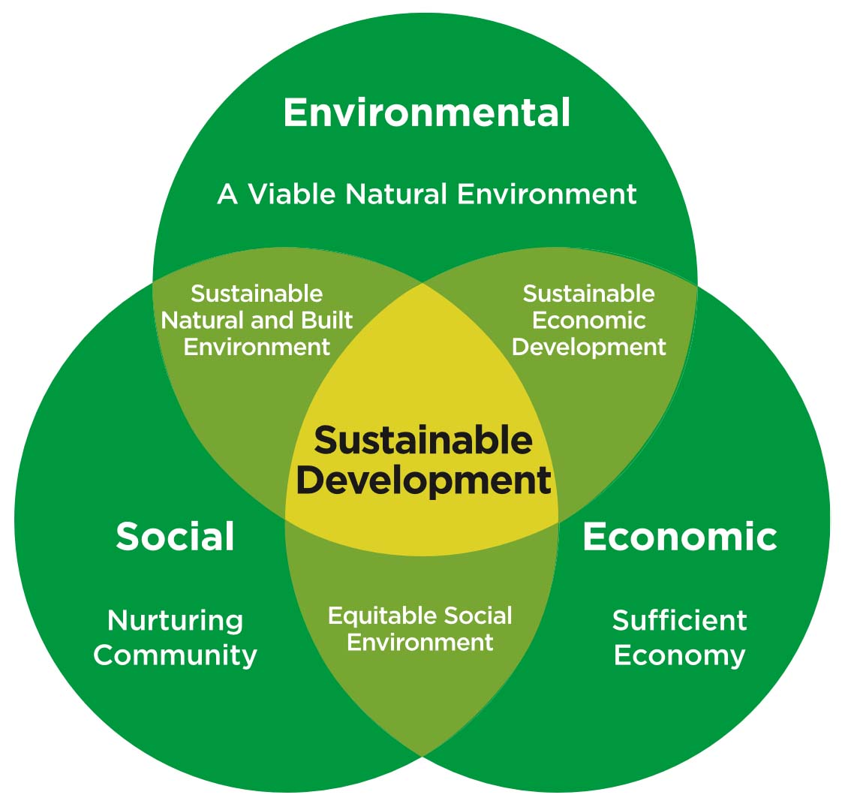**Pillars of Sustainability**

**UN Sustainable Development Goals (2015)**

The 2030 Agenda for Sustainable Development, adopted by all United Nations Member States in 2015, provides a shared blueprint for peace and prosperity for people and the planet, now and into the future.

At its heart are the 17 Sustainable Development Goals (SDGs), which are an urgent call for action by all countries - developed and developing - in a global partnership. It recognises that ending poverty and other deprivations must go hand-in-hand with strategies that improve health and education, reduce inequality, and spur economic growth – all while tackling climate change and working to preserve our oceans and forests.

A chart of United Nations 17 Sustainable Development Goals. These are:
Goal 1: No Poverty
Goal 2: Zero Hunger
Goal 3: Good Health and Wellbeing
Goal 4: Quality Education
Goal 5: Gender Equality
Goal 6: Clean Water and Sanitation
Goal 7: Affordable and Clean Energy
Goal 8: Decent Work and Economic Growth
Goal 9: Industry, Innovation and Infrastructure
Goal 10: Reduced Inequality
Goal 11: Sustainable Cities and Communities
Goal 12: Responsible Consumption and Production
Goal 13: Climate Action
Goal 14: Life Below Water
Goal 15: Life on Land
Goal 16: Peace and Justice Strong Institutions
Goal 17: Partnerships to achieve the goal

**Climate change targets**

**NI Climate Change Act (2022)** GHG

The Climate Change Act (Northern Ireland) 2022 sets a target of an at least 100% reduction in net zero greenhouse gas (GHG) emissions by 2050 for Northern Ireland compared to the 1990 baseline, along with interim targets including at least 48% reduction in net GHG emissions by 2030. The Department for Agriculture, Environment and Rural Affairs (DAERA) have now set updated 2030 and 2040 emissions reduction targets to ensure that they are in line with the 2050 net zero emission target.

The Act also sets sectoral targets on government departments including 2030 targets of:

* Energy - at least 80% of electricity consumption from renewable sources,
* Waste Management - 70% of waste recycled, and
* Transport - a target for a minimum spend of 10% of overall transport budgets on active travel,
* Other Sectoral Plans - include Agriculture, Industrial Process, Infrastructure and Fisheries.

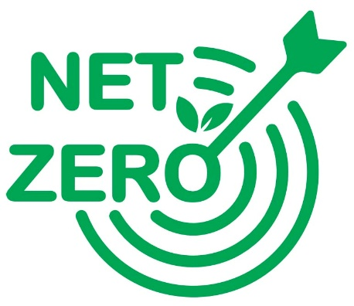

**Public body reporting**

There is a legal requirement on all Northern Ireland Government Departments to exercise their functions (as far as is possible to do so) in a manner consistent with the achievement of the targets of the Act and the carbon budgets set under it.

The Act required DAERA to make new regulations that sets a requirement for specified public bodies to report on climate change.

By working together, we can make these regulations known as The Climate Change (Reporting Bodies) Regulations (Northern Ireland) 2024 specify that the first mitigation reports are due to be submitted to DAERA by 31st October 2025 and then every 3 years after. As a public body LCCC will be required to report to DAERA under these regulations.

* 48% reduction in GHG emissions by 2030
* 80% electricity from renewables by 2030
* Net zero carbon dioxide by 2020
* Net zero emissions by 2050

**Carbon budgets**

**A carbon budget is the maximum total amount of emissions permitted for a budgetary period.**

The Climate Change Act requires DAERA to make regulations that set Carbon Budgets for the ‘net Northern Ireland emissions account’ for each budgetary period. The first budgetary period is 2023-2027 and the subsequent budgetary periods will be every 5 years thereafter.

* The Climate Change (Carbon Budgets 2023-2037) Regulations (NI) 2024 made on 11th December 2024 has legislated for future carbon budgets6.

**Climate budgets and targets**

The legislation sets targets consistent with the Committee on Climate Change (CCC) advice and net zero target for NI as:

* The first Carbon Budget (2023-2027) to be set at levels that have average annual reductions of 33% on 1990 levels,
* The second Carbon Budget (2028-2032) to be set at levels that have average annual reductions of 48% on 1990 levels, and
* The third Carbon Budget (2033-2037) to be set at levels that have average annual reductions of 62% on 1990 levels.

The Climate Change Act (NI) 2022 requires the Department (DAERA) to obtain advice and recommendations from the Committee on Climate Change (CCC) amongst others.

6 ﻿https://www.legislation.gov.uk/nisr/2024/215/made

**Greenhouse gas emissions**

**UK and NI emissions**

In 2023 carbon dioxide, methane and nitrous oxide collectively accounted for an estimated 98% of greenhouse gas emissions in the UK, with fluorinated gases making up the remaining 2%.

At that time, in Northern Ireland, 98% of GHGs were from carbon dioxide, methane and nitrous oxide with a higher percentage attributed to methane here than in the rest of the UK.

**NI Greenhouse Gas Statistics 1990 - 2023**

|  |  |
| --- | --- |
| **Total Greenhouse Gas Emissions** | **Carbon Dioxide Emissions** |
| 2023 emissions MtCO2E  18.2 | 2023 emissions MtCO2e  11.2 |
| 2022 – 2023 7% Reduction | 2020 – 2023 10% Reduction |
| 1990 – 2023 31% Reduction | 1990 – 2023 39% Reduction |

Emissions across Northern Ireland have reduced by 31% since the 1990 baseline. In order to be on track to reach the targets set out in the NI Climate Change Act Northern Ireland needs a further 17% reduction in GHG emissions in the next eight years from the 2023 measured levels.

**Composition of Greenhouse Gas Emissions (%) NI and UK 2023**

|  |  |  |
| --- | --- | --- |
| 61% | Carbon Dioxide | 79% |
| 30% | Methane | 15% |
| 7% | Nitrous Oxide | 5% |
| 1% | Fluorinated and Other Gases |  |
| **NI**  **(18.2MtCO2e)** |  | **UK**  **(384.9 MtCO2e)** |

https://www.daera-ni.gov.uk/articles/northern-ireland-greenhouse-gas-inventory

**LCCC area GHG emissions**

The Department for Business, Energy and Industrial Strategy (BEIS) provides data on the estimated total GHG emissions in local authority areas. Between 2005 and 2023, BEIS estimates that total GHG emissions generated within Lisburn & Castlereagh council area has reduced by just over 20%, however the speed of reduction has reduced over the last few years.

Further reductions in GHG emissions can be achieved through a combination of a decarbonised electricity supply, structural change in the economy and gradual adoption of more efficient buildings, vehicles and business.

(source: A summary carbon roadmap for LCCC, University of Leeds, 2022).

**BEIS – Local Authority Territorial Greenhouse Gas Emissions Estimates 2005-2023 (ktCO2e)**

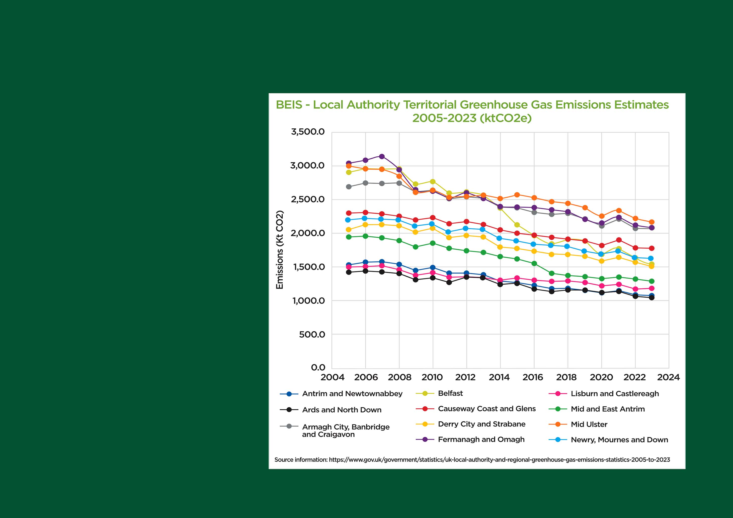

**LCCC area emissions 2023**

The local data for the LCCC area has been extracted from the 2023 UK Local Authority GHG Emissions (UK LA GHG Emissions) database published by the Department for Business, Energy and Industrial Strategy (BEIS). It is a combination of the UK’s Greenhouse Gas Inventory with data from several other sources, including local energy consumption statistics, to produce a nationally consistent set of greenhouse emissions estimates at the local authority level from 2005 to 2023.

The grand total of emissions in the LCCC area indicates that LCCC area produced 1,200kt CO2e of GHG emissions in 2023. This clearly shows that LCCC area needs to co-ordinate GHG reduction plans with central government to meet net zero targets by 2050.

**2023 emissions in the LCCC area by sector**

|  |  |
| --- | --- |
| **Kt CO2e 2023** | |
| Waste | 18% |
| LULUCF | 3% |
| Transport | 23% |
| Domestic | 19% |
| Public Sector | 4% |
| Commercial | 3% |
| Industry | 10% |
| Agricultural | 20% |
| **Total GHG emissions was 1,200kt CO2e in 2023** | |

**Council emissions from operations and functions**

In order for the council to benchmark and track its progress in meeting the Climate challenge, it must first understand what its current Greenhouse Gas (GHG) emissions are.

In 2024 the council carried out a GHG emissions exercise to identify the Scope 1 and Scope 2 emissions baseline for council facilities.

Our carbon footprint for 2023-2024 was measured at 6087.74 tCO2e (scope 1 and 2).

The council will be tracking its Scope 1 and Scope 2 emissions on an annual basis and will be working to understand its Scope 3 emissions in the coming years.

**LCCC Emissions**

|  |  |
| --- | --- |
|  | **GHG Emissions** |
| Fossil Fuels – Scope 1 | 3,082.49 tCO2e |
| Transport Fuel – Scope 1* | 1,746.04 tCO2e |
| Electricity – Scope 2 | 1,259.21 tCO2e |
| **Total Scope 1 & 2** | **6,087.74 tCO2e** |

* Assumed that transport fuel is split 50% DERV, 50% Gas Oil.

NOTE: Figures based on scope 1 and 2 emissions produced from 45 council facilities. Fugitive gases have not been included in the GHG emissions data at this time.

**Energy Consumption 2022 (year end March 2023) Vs 2023 (year end March 2024)**

|  |  |  |
| --- | --- | --- |
|  | 2022 | 2023 |
| Transport Fuel (kWh) | 6,507,810 | 6,995,470 |
| Kerosene Oil (kWh) | 59,601 | 43,141 |
| LPG (kWh) | 496,900 | 485,569 |
| Natural Gas (kWh) | 16,135,999 | 16,224,828 |
| Renewable (kWh) | 69,132 | 48,832 |
| Main Electric (kWh) | 6,158,485 | 6,080,972 |
| Emissions (tCO2e) | 5,887 | 6,088 |

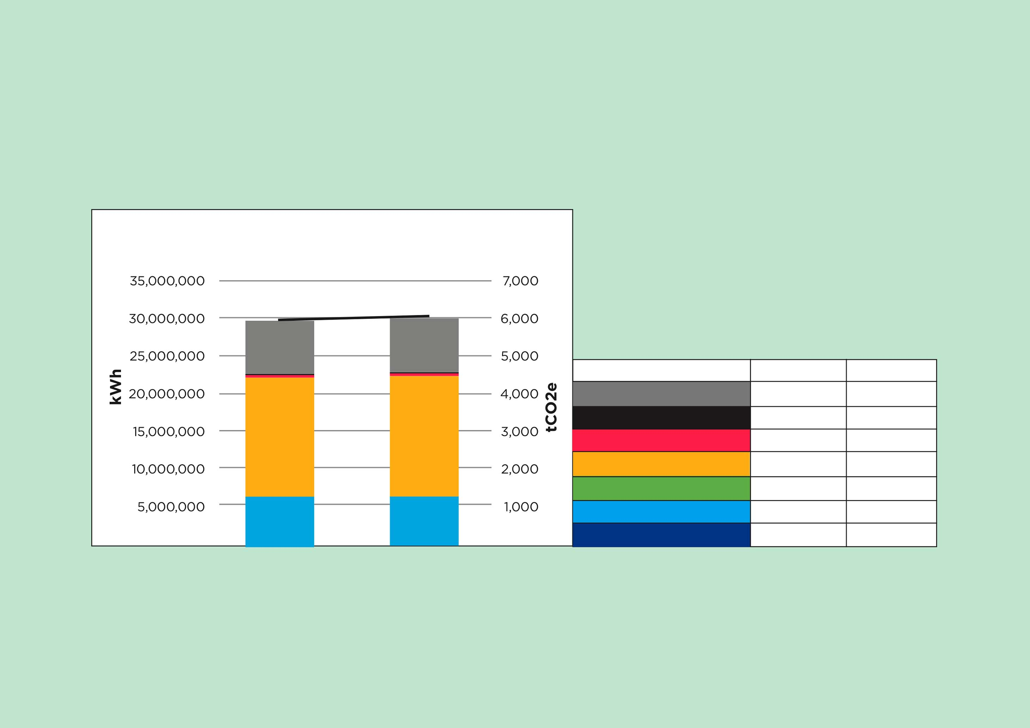

Baseline of carbon emissions was carried out on 45 council buildings, the top 5 energy consumption facilities and their associated emissions are as follows:

|  |  |  |  |  |
| --- | --- | --- | --- | --- |
| **Lagan Valley LeisurePlex** | | | **% of Total Scope 1 & 2** | **% of Site Scope 1 & 2** |
| Fossil Fuels – Scope 1 | 1670.98 | tCO2e | 27.4% | 85.4% |
| Electricity – Scope 2 | 286.20 | tCO2e | 4.7% | 14.6% |
| **TOTAL** | **1957.18** | **tCO2e** |

|  |  |  |  |  |
| --- | --- | --- | --- | --- |
| **Lough Moss Leisure Centre** | | | **% of Total Scope 1 & 2** | **% of Site Scope 1 & 2** |
| Fossil Fuels – Scope 1 | 108.80 | tCO2e | 1.8% | 72.5% |
| Electricity – Scope 2 | 41.33 | tCO2e | 0.7% | 27.5% |
| **TOTAL** | **150.15** | **tCO2e** |
| **Emissions Avoided**  **(renewables)** | **10.11** | **tCO2e** |

|  |  |  |  |  |
| --- | --- | --- | --- | --- |
| **Central Services Depot** | | | **% of Total Scope 1 & 2** | **% of Site Scope 1 & 2** |
| Fossil Fuels – Scope 1 | 87.12 | tCO2e | 1.4% | 70.1% |
| Electricity – Scope 2 | 37.21 | tCO2e | 0.6% | 29.9% |
| **TOTAL** | **124.33** | **tCO2e** |

|  |  |  |  |  |
| --- | --- | --- | --- | --- |
| **Lagan Valley Island Centre** | | | **% of Total Scope 1 & 2** | **% of Site Scope 1 & 2** |
| Fossil Fuels – Scope 1 | 349.08 | tCO2e | 5.7% | 67.1% |
| Electricity – Scope 2 | 171.23 | tCO2e | 2.8% | 32.9% |
| **TOTAL** | **520.31** | **tCO2e** |

|  |  |  |  |  |
| --- | --- | --- | --- | --- |
| **Dundonald International Ice Bowl** | | | **% of Total Scope 1 & 2** | **% of Site Scope 1 & 2** |
| Fossil Fuels – Scope 1 | 442.00 | tCO2e | 7.3% | 48.2% |
| Electricity – Scope 2 | 474.40 | tCO2e | 7.8% | 51.8% |
| **TOTAL** | **916.54** | **tCO2e** |

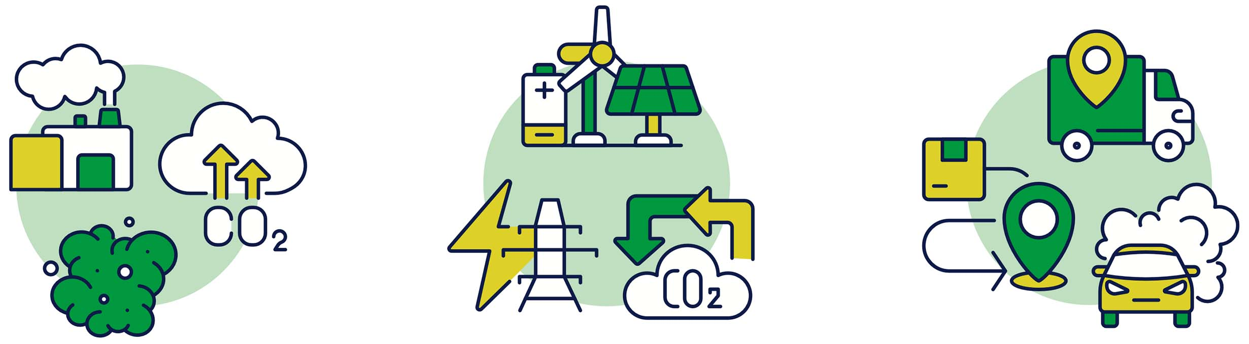**Definitions**

**Scope 1 Emissions**

Emissions come from fuel (petrol, diesel or gas) that is directly used within an area or from other sources such as landfill or industry within the area.



**Scope 2 Emissions**

Emissions come from electricity used within the area.



**Scope 3 Emissions**

Emissions are associated with goods and services that are produced elsewhere but imported and consumed within the area.

**To mitigate against the projected climate changes and associated risks, and to meet targeted reductions within the Climate Change Act, LCCC must take action to reduce emissions immediately.**

**What is the council doing?**

In September 2021 LCCC declared a Climate Emergency with the following Notice of Motion carried by Full Council:

“This council notes with concern the findings of the IPCC (2021) report regarding climate change. This latest report shows the science on climate change is clear and the climate emergency is real. We as a council therefore resolve to play our part and do what we can to work towards the targets set by the governments of the UK and Ireland of net zero carbon emissions and declare that this is a climate emergency”.

In order to be best placed to challenge the effects of climate change LCCC will develop action plans with two approaches:

1. **Climate Change Mitigation** – working to remove and preventing the causes of further climate change, where possible. This Sustainability Strategy and Climate Action Plan will outline the council’s proposed and ongoing mitigation measures.
2. **Climate Change Adaptation** – planning and responding to the impacts and risks associated with the current changes to our climate. A Climate Adaptation Plan will be produced by LCCC to enable the council to build resilience and adapt to current and future climate change.

The two documents will be intrinsically linked with a purpose to:

* Set out the council’s commitment to our environment, society and economy by addressing climate change.
* Help its employees and the local community to understand and effectively respond to climate change impacts.
* Help to transition to a low-carbon, competitive and just economy at local, regional and national levels.
* Ensure LCCC is making its fair contribution towards national and global climate targets under the Paris Agreement, Climate Change Act and the Sustainable Development Goals.
* Position the area on the map for green investment.
* Demonstrate climate leadership as a responsible and fair Council.
* Ensure that the benefits of climate action are equitably distributed.
* Create a framework to measure, monitor and reduce emissions

Sustainability and Climate Action is embedded into the culture of LCCC through the council’s strategic plans:

**Community Plan (2017-32)**

community_plan_2017-2032_email-pdf_(lisburncastlereagh.gov.uk)

**Local Development Plan 2032**

local_development_plan_2032_-_part_1_plan_strategy_(lisburncastlereagh.gov.uk)

**Corporate Plan (2024-2028)**

lccc-corporate-plan-2024-2028-web_(lisburncastlereagh.gov.uk)

**What have we done so far and what are we going to do?**

Whilst the preparation and development of the strategy documents has been ongoing, Council service units have not stood still in progressing with actions that will mitigate or adapt to Climate Change.

**Examples of these are:**

**1. Local Biodiversity Action Plan**

**2. Local Development Plan**

**3. Performance Improvement Plan**

**4. Tree and Woodland Strategy**

**5. Internal Waste Management Plan**

**6. Open Spaces Strategy**

**LCCC Climate Action Plan**

LCCC has developed a Climate Action Plan (CAP) appendix 1 that sets out the steps to be taken by Council that will guide all council service unit actions towards the goal of **becoming a net zero, resilient council by 2050**.

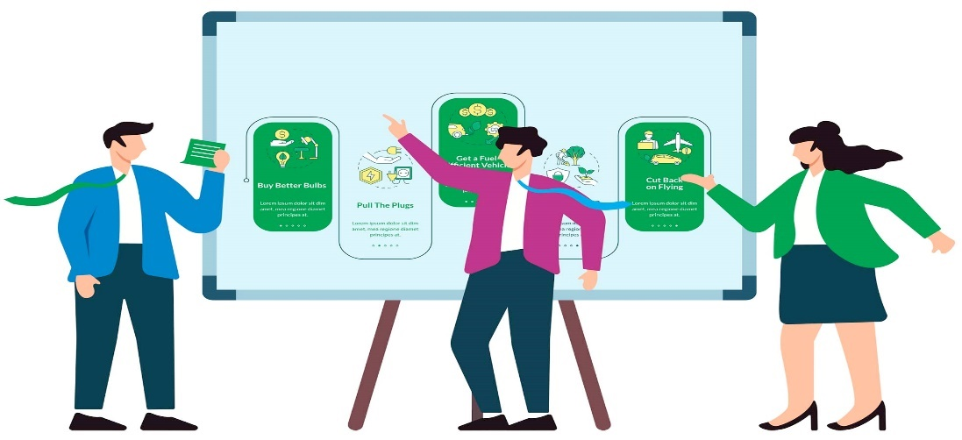An evidence-based process has been followed to produce the CAP in which an assessment of existing data, policies, programmes, commitments and strategic priorities (at local and national levels) was carried out. This was followed by evidence gathering for quantitative and qualitative assessment and modelling to build a strong evidence-based action plan. Council officers have identified, prioritised and refined climate action for the CAP through a series of workshops and technical meetings since May 2022.

The Climate Action Plan is a live document and will be reviewed, updated and reported on annually.

This annual assessment will enable the council to monitor progress and adapt or amend actions where appropriate to ensure continual progression towards the interim and eventual 2050 targets on net zero.

Actions have been cross referenced against the Council’s Community Plan, Local Development Plan and Corporate Plan, they are presented as a high level summary in the Climate Action Plan attached.

**Monitoring and evaluation**

The Sustainability Strategy and Climate Action Plan is a live document that will be reviewed, updated and reported on annually.

Annual reporting will be made to Elected Members through an annual progress report which will be made publicly available on the council’s website, a paper copy can also be supplied when requested. Annual assessment will enable LCCC to monitor progress and adapt or amend actions where appropriate.

Lisburn & Castlereagh City Council will remain open and transparent on its progression towards its goal of net zero by 2050.

**Glossary**

**CCC**

The Climate Change Committee, which advises the government on emissions targets and reports to Parliament on progress made in reducing greenhouse gas emissions.

**Climate adaptation**

Refers to the actions, strategies, and measures taken to reduce the vulnerability of ecosystems, communities, and individuals to the current and anticipated impacts of climate change. It involves adjusting and preparing for the changing climate conditions to minimise the adverse effects on people, property, and the environment.

**Climate mitigation**

Refers to efforts to reduce or prevent the emission of greenhouse gases (GHGs) into the atmosphere to limit global warming and its associated impacts. Mitigation strategies aim to lower the drivers of climate change, primarily through reducing GHG emissions and enhancing carbon sequestration.

**CO2e - CO2 equivalent**

 This is a metric measuring all greenhouse gases, including carbon dioxide, methane, and nitrous oxide, allowing them to be expressed as a single number for simplicity.

**DAERA**

Department of Agriculture, Environment and Rural Affairs.

**DfE**

Department for Economy.

**El Niño**

El Niño is a naturally occurring climate pattern associated with warming of the ocean surface temperatures in the central and eastern tropical Pacific Ocean. It significantly influences weather patterns, ocean conditions, and marine fisheries worldwide. El Niño occurs on average every 2 to7 years.

**Greenhouse gas GHG)**

These are the gases in the atmosphere that raise the surface temperature of our planet contributing to the greenhouse effect. These Gases include carbon dioxide, methane, nitrous oxide and fluorinated gases.

**IPCC**

Intergovernmental Panel on Climate Change - the UN's climate body established in 1988 to advance scientific knowledge about climate change caused by human activities.

**Mitigate**

To make something less harmful, unpleasant, or bad.

**Net zero**

Net zero means no longer adding to the total amount of greenhouse gases in the atmosphere.NI Climate Change Adaptation Programme.

**Scope 1 emissions**

These are the Green House Gas (GHG) emissions that a company makes directly, for example while running its boilers to heat a building or using petrol or diesel to power vehicles.

**Scope 2 emissions**

These are the emissions being produced from electricity use and electricity production.

**Scope 3 emissions**

Scope 3 emissions are all indirect emissions, not included in Scope 2, that occur in the value chain of the Councils activities. Examples are business travel, employee commuting, waste generation, purchasing of goods and services etc.

**UN Sustainable Development Goals (SDGs)**

The Sustainable Development Goals (SDGs) are 17 global goals set by the United Nations in 2015, and adopted by 193 countries, to address major challenges like poverty, inequality, climate change, environmental degradation, peace, and justice. They aim to create a better and more sustainable world by 2030.